WEB-BASED QR ENABLED PET REGISTRATION, VACCINATION AND TRACEABILITY MANAGEMENT SYSTEM WITH PAYMENT MONITORING AND DATA ANALYTICS FOR THE CITY VETERINARY ANIMAL CLINIC IN CABUYAO CITY, LAGUNA.

A Capstone Project Proposal
Submitted to the Faculty of
The College of Computing Studies
PAMANTASAN NG CABUYAO
City of Cabuyao, Laguna

In Partial Fulfillment
of the Requirements for the Degree:
BACHELOR OF SCIENCE IN INFORMATION TECHNOLOGY

By:
Catalonia, Zyrus M.
Ocharan, Mark Lawrence C.
Parala, Andrei Vincent S.
Trinidad, Kaizen Brix A.

May 2026

TABLE OF CONTENTS

Title Page i
Recommendation Letter ii
Table of Contents iii
List of Tables v
List of Figures vi
List of Appendices ix

CHAPTER

I | THE PROBLEM AND ITS BACKGROUND | Page
 | Introduction | 1
 | Objective of the Study  Conceptual Paradigm | 2  4
 | Scope and Limitation | 6
 | Significance of the Study | 8
 | Definition of Terms | 10
II | REVIEW OF RELATED LITERATURE AND STUDIES
 | Conceptual Literature  Standard Features  Guidelines for Developing the System  Requirements for a User-Centric Design  Testing Procedure | 15  16  16  17  18
 | Research Literature  Review of Related Literature  Web-Based Veterinary Information and Record Management Systems  QR-Enabled Identification and Traceability in Veterinary and Health Information Systems  Integrated Digital Service Functions in Veterinary Clinics  Review of Related Studies  Web-Based Veterinary Appointment and Information Management Systems  QR Code Authentication and Traceability in Information Systems  Digital Payment Monitoring and Transaction Verification Systems | 21  23  21  22  22  23  23  24  24
 | Theoretical Framework | 25
 | Synthesis | 27

III | METHODS AND PROCEDURES
 | Methods and Procedure |  | 28
 | Research Design |  | 28
 | Respondents of the Study |  | 29
 | Research Locale |  | 29
 | Population of the Study |  | 30
 | Sample Size Determination |  | 30
 | Sampling Technique |  | 31
 | Sample Distribution Table |  | 33
 | Sample Distribution Method |  | 34
 | Data Gathering Procedure |  | 35
 | Type of Data to be Used |  | 37
 | Needs Assessment |  | 38
 | System Performance Evaluation |  | 40
 | System Development Methodology |  | 41
 | Ethical Consideration |  | 133
LITERATURE CITED
APPENDICES

LIST OF TABLES

Table |  | Page
1 | Sample Distribution of Respondents | 33
2 | Verbal Interpretation of Mean Scores | 40

LIST OF FIGURES
Figure |  | Page
1 | The Conceptual Paradigm of the Study | 5
2 | Use Case for Pet Owner and Pet Registration | 51
3 | Use Case for QR-Enabled Identification and Traceability | 54
4 | Use Case for Vaccination Monitoring | 57
5 | Use Case for Clinic and Medicine Record | 60
6 | Use Case Diagram for Payment Monitoring using OR number | 64
7 | Use Case Diagram for Analytics and Reporting | 67
8 | Use Case Diagram for Admin / Staff Management | 71
9 | Activity Diagram for Pet Owner and Pet Registration | 74
10 | Activity Diagram for QR-Enabled Identification and Traceability | 77
11 | Activity Diagram for Vaccination Monitoring | 80
12 | Activity Diagram for Clinic and Medicine Records | 82
13 | Activity Diagram for Payment Monitoring Using OR Numbers | 84
14 | Activity Diagram for Analytics and Reporting | 87
15 | Activity Diagram for Admin / Staff-Side Management | 90
16 | Sequence Diagram | 93
17 | System Architecture Diagram | 96
18 | Data Flow Diagram | 100
19 | Entity Relationship Diagram | 104
20 | Homepage | 107
21 | Pet Owner Login | 108
22 | Pet Owner Dashboard | 109
23 | Pet Registration | 110
24 | Draft Registration | 111
25 | My Pets | 112

26 | QR Records | 113
27 | Vaccination History | 114
28 | Clinical and Medicine Records | 115
29 | Payment Status | 116
30 | Record Request | 117
31 | Clinic Staff Log In | 118
32 | Staff Dashboard | 119
33 | Pet Records | 120
34 | Verify Registration | 121
35 | Vaccination Monitoring | 122
36 | Clinical Records | 123
37 | Medicine Records | 124
38 | Payment Verification | 125
39 | Issue Requested Record | 126
40 | Admin Login | 127
41 | System Overview | 128
42 | Barangay Dashboard | 129
43 | User Directory | 130
44 | Registration Records | 131
45 | Traceability | 132
46 | Payment Monitoring | 133
47 | Analytics and Reports | 135

LIST OF APPENDICES

 | APPENDIX TITLE | Page
A | Confidentiality and Non-Disclosure Agreement | 78
B | Validated Research Instrument/s | 81
C | Informed Consent Form | 85
D | Research Ethics Review Committee Evaluation | 89
E | Short Report of Plagiarism Software | 100
F | Report of Language Software | 104
G | Curriculum Vitae of Student Researchers | 106

CHAPTER I

THE PROBLEM AND ITS BACKGROUND

Introduction

In this connection, the City Veterinary Animal Clinic of Cabuyao City, Laguna serves an essential function in maintaining animal health, public safety, and pet owner responsibility. With the steady rise in the number of pet owners and pets registered at the facility, one expects the latter to handle the process of registration, vaccine management, payments, and documentation in a precise manner. Nevertheless, the facility remains plagued by inefficiencies including the use of traditional methods for handling registrations, problems identifying which clients have made payments and those that have not, poor tracking of vaccinations, lengthy waiting lines for registration, and insufficient data [1]–[5].

The current method of registering pet owners and pets is mostly manual, hence causing delays, inconsistencies, and difficulties in accessing any data. Since all the pets must have their IDs properly recorded, the lack of a proper system makes it hard for the clinic to offer efficient services. Also, since the payment process involves the use of Official Receipt Numbers provided by the treasury for the purpose of tracking payments, a proper way to match the payments made with pet owners' and pets' IDs is needed [1]–[4].

Accuracy of data tracing and analysis is yet another area where the clinic must be concerned. Reliable data such as number of pets registered, distribution in terms of gender of pets, vaccinated status, and payment status is essential not just for documentation purposes but also for planning and improving services. Internet disruptions can impact registration done via the internet; hence, the necessity for an arrangement where the provision of services can continue despite the internet instability.

To mitigate these issues, the researchers would like to suggest the implementation of a Web-Based QR-enabled Pet Registration, Vaccination, and Traceability Management System with Payment Monitoring and Data Analytics at the City Veterinary Animal Clinic of Cabuyao City, Laguna. This system will ensure a more efficient system to monitor and track pets through their respective owners and generate an individual QR code per registered pet, while keeping track of vaccinations, treasury payments, and data analytics [2]–[8].

Objectives of the Study

This research study was made to solve the issues experienced by the City Veterinary Animal Clinic of Cabuyao City, Laguna, which include issues related to pet registration, vaccination, billing, tracking, and record keeping. To address this issue, the researchers have created an online platform with QR codes that would be helpful in managing the records and services of pets.

General Objective
The general objective of this study is to design an integrated Web-based system, called Pet Registration, Vaccination, and Traceability Management System with Payment Monitoring and Data Analytics for the City Veterinary Animal Clinic of Cabuyao City, Laguna.
Specific Objectives
- Develop a Web-Based QR-Enabled Pet Registration, Vaccination, and Traceability Management System that will provide users an efficient platform to undertake the following processes:
1.1 Registering pet owners and pets through a web-based application;
1.2 Generating a unique QR code for each registered pet to improve identification and traceability;
1.3 Recording and monitoring the vaccination history of registered pets;
1.4 Tracking the registration, payment, and vaccination history of each pet through traceability;
1.5 Linking treasury-issued Official Receipt numbers to the corresponding pet owner and pet registration records;
1.6 Managing owner profiles, pet profiles, payment details, vaccination records, clinical records, and medicine records in one system.

2. Implement a centralized online system that would be able to:
2.1 Maintain a unified database for owner profiles, pet profiles, payment details, and vaccination records;
2.2 Allow QR scanning for faster access to the corresponding pet record and history;
2.3 Support vaccination monitoring, payment verification, and pet traceability;
2.4 Provide search and filter functions for efficient retrieval of records;
2.5 Allow online pre-registration of pet owners to minimize long queues in the clinic;
2.6 Support offline-capable draft registration and synchronization once connectivity is restored;
2.7 Generate data analytics and reporting summaries such as the number of registered pets, sex distribution, vaccination status, and payment status;
2.8 Provide administrative and staff-side management features for monitoring clinic operations and records.

3. Determine the level of performance achieved by the proposed system on the basis of the ISO/IEC 25010 Software Quality Model according to the following groups of evaluators:

3.1 For End-Users:

3.1.1 Functional Suitability

3.1.2 Performance Efficiency

3.1.3 Usability

3.2 For IT Experts:

3.2.1 Functional Suitability

3.2.2 Performance Efficiency

3.2.3 Usability

3.2.4 Reliability

3.2.5 Security

Conceptual Paradigm

The paradigm under which the research is developed will be Input-Process-Output. The input of this study will focus on the operational issues and data needs of the clinic. Examples include fragmented registration, difficulty in tracking both paid and unpaid patients, inadequate vaccine tracking, long waiting lines, the need for analytical tools, owner

and patient details, the use of Treasury-issued Official Receipt numbers, and other operational issues within the clinic.

The process will include the process involved in designing the system. This will be through conducting requirements analysis, system planning and design, database design, system development, QR codes, payment monitoring integration, and vaccination, clinical, and medicine records. Other supportive components such as the web-based tool, QR code, database management system, analytic dashboard, and other record modules will be incorporated to address the needs of the clinic.

The result output or deliverable product of the research will be the development of Web-Based QR-Enabled Pet Registration, Vaccination, and Traceability Management System with Payment Monitoring and Data Analytics for the City Veterinary Animal Clinic in Cabuyao City, Laguna. These systems can perform various functions such as web-based registration of pets and owners, QR-enabled pet identification, monitoring and documentation of pet vaccination and history, payment monitoring through OR number, pet traceability, clinical and medication records monitoring, and finally data analysis and reporting.

In general, according to the conceptual framework, it is shown that the current problems and information needs of the clinic act as inputs, where several processes take place that eventually lead to the formation of the digital system proposed as output.

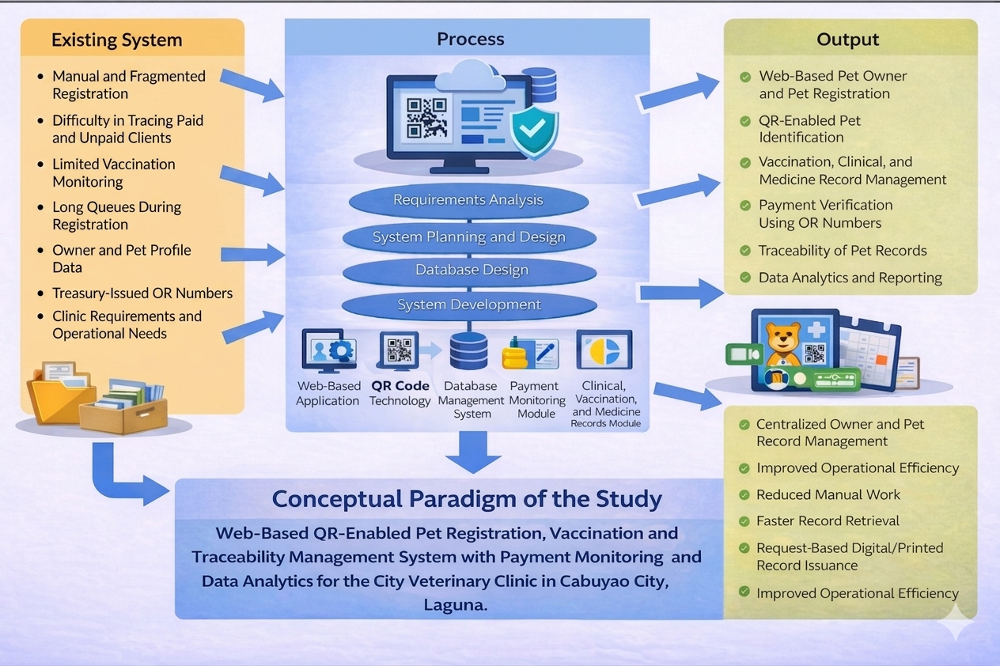
Figure 1. Conceptual Paradigm on the Study

Scope of the Study

This research aims at designing and developing a web-based and QR-enabled system that manages the pet registration, vaccination, and traceability with payment and data analytics for the City Veterinary Animal Clinic of Cabuyao City, Laguna. The new system is designed and developed to improve the major operations in the City Veterinary Animal Clinic, particularly on pet owner registration, pet registration, vaccinations monitoring, traceability, payment verifications, record keeping and data analysis. The major objective of the system is to minimize the manual processes and make sure that the system is efficient and user-friendly.

The scope of the research covers the following features. First, it entails web-based pet owner registration and pet registration. The process

covers the encoding and management of the data of the pet owner and the pet. Second, it involves the generation of the QR code for each of the registered pet. Third, the scope also includes vaccination management of the registered pets which cover the process in monitoring the vaccination records of the pets.

The research will also focus on the implementation of a traceability feature to allow the clinic to keep track of the registration process, payment process, and the vaccination record of each animal. On the issue of financial monitoring, the system being implemented will include the payment monitoring system that will connect the official receipt number provided by the treasury to the respective pet owner as well as the registration record of the said animal.

Additionally, the study will involve setting up a central database for owner profile, pet profile, payment records, vaccine records, clinical records, and medicine records. The database will include QR scanning for quick access to the relevant record of the particular pet along with its history. Search and filter functionalities will be included in order to access registration records, payment records, vaccine record, and related records of pets in a convenient manner. For the convenience of the client, an online pre-registration facility will be added to enable clients to register their pet in advance prior to visiting the clinic and this can potentially reduce queues and processing time at the registration desk.

The suggested system would also have data analysis capabilities which can produce summaries, such as the total number of pets registered, their genders, their vaccinations, and their payment statuses. The suggested system would also have administrative functions on the staff’s side which can be used by administrators to manage the records, check

transaction details, and view relevant summaries of operations. In all, the scope of this study would only cover the operational requirements and record management requirements of the City Veterinary Animal Clinic in Cabuyao City, Laguna.

Limitations of the Study

It should be noted that the research is constrained by design, development, implementation, testing, and evaluation of the Web-Based QR-Enabled Pet Registration, Vaccination, and Traceability Management System with Payment Monitoring and Data Analytics in the City Veterinary Animal Clinic located in Cabuyao City, Laguna. Though the proposed solution involves modules like pet owner registration, pet registration, QR identification, vaccination management, traceability, payments monitoring, record management, and data analytics, the system itself is limited only to operational requirements specified in the scope of the study.

It must also be stressed that the system will be available only through a web portal and does not involve the development of native apps either for Android or iOS platforms. While the proposed solution can be accessed using any device featuring Internet connectivity, its access via mobile application is not included in the current study. Additionally, the QR codes generated by the system are applicable exclusively to identification, traceability, and records management and cannot be used in any external identification solutions.

The system proposed in this study has a vaccination management feature. However, it is only limited to the recording and tracking of the pet's vaccination history. It does not involve other veterinary medical services like laboratory testing, confinement tracking, surgery, and even external

treatment management. Similarly, while the system proposes clinical records and medicine records, these records are only limited to the tracking of relevant clinic record information within the proposed system framework. This study does not incorporate any other pharmacy management processes, including medicine stock management of the clinic.

In terms of payment management, the proposed system has a payment tracking feature wherein the Treasury-issued official receipt numbers can be associated with the registered pet owners and their pet's record in the system. Nevertheless, the proposed system does not provide the issuance of OR numbers; hence, there will be no direct connection between the proposed system and the Treasury system.

Despite having a unified database, search and filtering capability, and data analysis and reporting tools, all of these are confined only to the data inputted and maintained in the proposed system. Hence, the efficiency and accuracy of traceability, retrieval, summarization, and reporting will be limited by the extent of data completeness, correctness, and timeliness, which will ultimately rely on the inputted data by the designated users. In terms of data analysis and reporting, the system will only provide summary statistics such as the total number of registered pets, sex ratio, vaccination status, and payment status based on the recorded data in the database.

Online pre-registration capability is limited only to the preliminary registration process but will not be able to replace the verification, approval, and on-site processes in the clinic that might still be necessary for the actual implementation. Likewise, despite having an offline-capable draft registration function, the limitation is confined only to the ability to temporarily store the registration data in the event of internet disruptions. The information will only be saved in the centralized database after

synchronization once internet connection is restored. Thus, the study will not fully explore real-time offline database management capabilities.

Lastly, the study will be conducted using the City Veterinary Animal Clinic in Cabuyao City, Laguna as the subject of the study and the venue for implementation. As such, the conclusions, test results, and evaluation will be exclusive only to the mentioned institution and may not necessarily hold true for other veterinary clinics and institutions which are different from each other in terms of workflow, policies, and operational processes.

Significance of the Study
The significance of this study lies in its aim of solving operational problems of the City Veterinary Animal Clinic in Cabuyao City, Laguna through the implementation of a web-based pet registration, vaccination and traceability management system with payment monitoring and data analytics. It is hoped that the said management system will offer a better process for registering pets, monitoring and updating the records of pet vaccinations and payments, and managing other related data.
City Veterinary Animal Clinic
It is expected that this system can benefit the City Veterinary Animal Clinic since there will be improved efficiency and effectiveness in terms of managing pet owners and pets' registration, vaccination records, and payment verification and tracing records. There will be little manual labor and minimal delays in all procedures. This will help keep track of records and data accurately and reliably.

Pet Owners
Pet owners will highly benefit from this study as the management system will help them register and monitor their pets without having to deal with queuing and doing transactions in person with the clinic.
Clinic Staff and Personnel
This suggested method is highly useful for the employees in properly organizing and searching for records. Moreover, it will enable them to monitor payments as well as other related information such as vaccinations and pet information.
Local Government Unit
The study can be valuable for the local government since the technology-based nature of this approach in the operation of veterinary services would prove to be quite significant for them. The reports and analysis generated from the study can be utilized in planning, monitoring and evaluating programs that are being implemented within the community such as registration, vaccination, and responsible pet ownership.
Future Researchers
The study can provide a good base for future researchers to conduct a similar study regarding issues like Veterinary Information System, QR Traceability, Payment Monitoring, Web-Based Public Service System, and Data Analysis in the Operation of Local Government.

Researchers
Moreover, the study can be helpful to the researchers because of the contribution that it can make towards increasing their knowledge, experience and skills in the areas of system analysis and design, website development and database management.

Definition of Terms
Conceptual Terms
Analytics Dashboard - An application on a computer used in creating reports or visualizations which display key indicators or metrics in a visual way.
Database Management System (DBMS – Database Management System) - It refers to a software application system that creates, manages, protects, accesses, modifies and deletes data from a database.
Data Analytics - A structured procedure for collecting, processing, analyzing, and interpreting data to gain knowledge about it and use such knowledge to make decisions.
Official Receipt (OR – Official Receipt) Number - The number that is officially used in an organization as evidence that something has been paid.
Offline-Capable Draft Registration - In registration, there is usually an act of entering something into a register, while a web application refers to an application program delivered through a web browser.

Payment Monitoring - Paying close attention to something for a particular purpose; especially in payment activities.
Pet Registration - Registration involves registering, recording, or enrolling information within the register.
Quick Response (QR – Quick Response) Code - This is a two-dimensional barcode whose code carries encoded data that is readable by computers.
Record Management - This entails systematic management, maintenance, storage, and retrieval of records within their entire lifecycle.
Traceability - This implies the capacity of tracing or tracking information about the origin, status, or history of an item.
Vaccination Management - Entails managing the record keeping of the relevant vaccinations and vaccination status.
Web-Based System - Web Application is defined as application software located remotely and accessible via browser interface whereas Information System comprises integrated components for collection, storage, and processing of data and provision of information.
ISO/IEC 25010 Software Quality Model (International Organization for Standardization/International Electrotechnical Commission 25010) - An International software quality model defining the characteristics used in determining software product quality and giving framework for assessment of software products based on quality characteristics.

Functional Suitability - Refers to the level of functional capabilities offered by a software product to satisfy the expressed and implied requirements in specified circumstances.
Performance Efficiency - The ratio of system performance against its resource utilization in given circumstances.
Usability - refers to the extent to which a particular system can be operated effectively and efficiently to attain goals in the specified context of usage.
Reliability - refers to the extent to which the functions performed by the system meet expectations when performed under specified conditions of time and environment.
Security - Security refers to the extent to which the confidentiality of information or data is protected such that people or systems have proper data access according to the types and levels of their authorization.
Operational Terms
Analytics Dashboard - This refers to the feature in the proposed system where summarized information on the number of pets registered, sex distribution, vaccinations, payment status, among others, is shown.
Database Management System (DBMS – Database Management System) - This software stores all records relating to the pet owners, pets, payments, vaccination, clinic, medicines, etc.
Data Analytics - This entails evaluating the data recorded in the system to generate reports or summaries pertaining to registered pets, gender, vaccinations, and payment status, among others.

Official Receipt (OR – Official Receipt) Number - This refers to the Official Receipt number generated by the treasury and recorded in the system associated with the pet owner/pet registration.
Offline-Capable Draft Registration - This involves recording data inputs even if there is a lack of internet connectivity until the time it stabilizes and the record is successfully filed.
Payment Monitoring - This pertains to tracking the payment status based on the receipt number from the treasury.
Pet Registration - This involves the process of gathering information from pet owners in relation to the services provided.
Quick Response (QR – Quick Response) Code - This is the code that will be generated for all pets that have been registered using the digital pet record, making it easier to extract the details of the pet.
Record Management - It refers to the process through which the system will effectively manage the owners, pets, payment details, and vaccination records.
Traceability - It is the ability of the system to trace and manage the registration, payments, vaccinations, and other services offered to each individual pet by using digital records and QR codes.
Vaccination Management - It is the ability of the system to trace and manage the registration, payments, vaccinations, and other services offered to each individual pet by using digital records and QR codes.

Web-Based System - It is the web application that will enable all functionalities, including pet registration, vaccination management, payments, among others, to be undertaken using the proposed system.
ISO/IEC 25010 Software Quality Model (International Organization for Standardization/International Electrotechnical Commission 25010) - Software quality model to use in assessing the functionality, performance, usability, reliability, and security of the proposed system.
Functional Suitability - Quality of Model of Software that Will Be Used to Test the Proposed System Considering Its Functionality, Efficiency, and Security.
Performance Efficiency - Efficiency and effectiveness of the proposed system in relation to the management of records, searching of data, generating of QR codes, and reports.
Usability - User-friendliness and usability of the proposed system considering its users – pet owners and staff of the veterinary clinic.
Reliability - The robustness, reliability, and consistency of the proposed system in record registration, payment tracking, vaccinations, and record retrieval.
Security - It will assist the researchers to determine the level of safety of the proposed system regarding the confidentiality of important data such as payments, information related to owners of pets, and other information.

CHAPTER II

REVIEW OF RELATED LITERATURE AND STUDIES
This chapter will contain the literature review and relevant studies which form the basis of the current research project titled “A Web-Based QR-Enabled Pet Registration, Vaccination, and Traceability Management System with Payment Monitoring and Data Analytics for the City Veterinary Animal Clinic of Cabuyao City, Laguna.” The sources considered include literature associated with web-based systems, QR code technology, pet registration, vaccination tracking, payment tracking, traceability, clinical records, and medicine records, among others. This chapter will provide insights into the related concepts, characteristics, findings, and other aspects of previous literature and studies concerning the proposed system to identify research gaps and directions for the study.
Conceptual Literature
The use of computerized veterinary systems in practice is increasingly acknowledged by researchers as effective mechanisms in streamlining the process of management by integrating registration, recording, monitoring, and services into one system [1]–[8].
The importance of linking and tracking records of owners and their animals using features such as QR identification, payment, and analytics to make the veterinary systems work effectively is a recurring theme in the literature [1]–[8].

These concepts form the theoretical foundation of this current study, whose main objective is the design and implementation of a computerized veterinary management system that will be used by the City Veterinary Animal Clinic of Cabuyao City, Laguna.

Standard Features
Common standard functionalities of web-based veterinary systems include the following: registration of pet owner/pet; appointment/registration coordination; record management; vaccination management; electronic identification; and information retrieval to save time and make the process easier [1]–[8]. Systems developed by government agencies which have pet registration functionalities have also proven the significance of having both pet owner information and pet information available on the same system [1]–[5].

As regards the suggested research, the standard functionalities of the system would include the following: web-based pet owner/pet registration; QR-coded pet identification; vaccination management; payment monitoring via the use of the OR number from the treasury; clinical and medicine records management; pet record traceability; and data analytics/reporting. These would be useful in addressing the needs of the City Veterinary Animal Clinic in Cabuyao City, Laguna in relation to the organization of their record management and other relevant activities [1]–[8].

Guidelines for Developing the System
Before starting the development of the veterinary and pets' registration information systems, it is important to make sure that there is adequate planning done, as well as the use of a systematic approach to

make sure that the developed system will be both functional and user oriented. The evaluation of the currently used digital animal-service platforms has revealed that the most effective systems have these functions combined and included in a single web-based information platform.
Furthermore, some research studies have shown that the most effective approach to implementing an information system in terms of its effectiveness for veterinarians is developing a system that has all essential components including workflow management, record management, and service control. Therefore, in relation to the current research study, it can be suggested that the most efficient approach to the design of the mentioned information platform is making sure that it will include the abovementioned functions in addition to pet owners' registration and vaccination monitoring and traceability in general [1]-[8].
Requirements for a User-Centric
The inclusion of the features of the user-centric design strategy should be evaluated in terms of the web-based veterinary application since the usability of the system plays a vital role in the adoption and utilization of the web-based veterinary system for the clinic staff and pet owners. The experience with the existing computerized veterinary and pet registration systems reveals that the users prefer the platforms that provide easy navigation, record keeping, and accessibility to services [1]-[5].
In the field of veterinary medicine, the web-based booking and information management system is expected to eliminate manual work, simplify record keeping, and facilitate transactions using the user-friendly interface [6]-[8]. In this case, the requirements of the user-centric design include the streamlined registration process for the pet owners and pets,

structured presentation of information about vaccinations and payments, organized access to records based on QR codes, and the user interface that satisfies the needs of both pet owners and the clinic staff.
Testing Procedure
The proposed Web-based Pet Registration, Vaccination and Traceability Management System using QR-codes and Payment Tracking & Data Analytics would undergo specific tests for determining the system's ability to meet the required functional capabilities efficiently and successfully. Testing is needed since, as expected from veterinarian and pet management systems, they must be capable of managing various tasks and processes efficiently and effectively, including pet registration, scheduling of appointments, record keeping, tracking and payment transactions [1]-[5]. Similarly, various studies concerning veterinary information systems indicate that testing is necessary for ensuring that the system meets the needs of the users and facilitates efficient daily transactions [6]-[8].
Testing will start with functional testing. This process involves checking all modules in the system to establish their efficiency in working according to the required specifications. Some of the major modules to be checked for include pet owner registration, pet registration, Quick Response (QR) code generation, record keeping on vaccination, tracking of payments using official receipts numbers issued by treasury, pet record traceability, and report generation using analytics. Functional testing needs to be carried out since the system is composed of various processes that must be completed efficiently. Several studies of veterinary and management systems indicate that digital clinic systems are supposed to work efficiently in handling records, scheduling services, and performing other core activities [6]-[8].

After passing all the tests, the software will then undergo integration testing to confirm that the individual parts can operate as one whole unit. This is because of the correlation between the functionalities and parts of the system under discussion, namely owner profile, pet profile, vaccinations, QR codes, payments, and analytics. It is, therefore, important to establish smooth communication between the parts of the system and ensure that data flows seamlessly between the modules. Integration testing takes a great deal of importance here as the efficiency of a veterinary management system depends on interactions between its records and processes [1]-[5], [7], [8].

As part of the testing of the system, the researchers will conduct the evaluation of its performance. This involves ensuring that the system properly processes the input data, accesses the records, creates the QR codes, maintains the records of vaccinations, and reflects the payment status and generates reports accordingly. During this phase, the researchers will also check how efficient the system works and if the workflow is practical for use within the context of the operations of the City Veterinary Animal Clinic. Previous studies indicate that web-based systems used in veterinary clinics become more effective if evaluated according to their operational functionalities [6]–[8].

Once the system passes the tests related to the technical aspects of its performance, the process of user acceptance testing should follow. The users may include some employees from the clinic, as well as the evaluators, who will examine the usability and user friendliness of the system for the purpose of applying it in practice at the clinic. The necessity of the mentioned stage of testing is explained by the fact that despite the complete functionality of the system from the technical perspective, if it fails to assist users in certain issues, then it will not meet users'

expectations. Web-based veterinary information systems and pet registration software show how important usability and workflow are in choosing the feasibility of such a system [2]-[8].

In addition, the ISO/IEC 25010 Software Quality Model will be considered to analyze the proposed system based on **functional suitability, performance efficiency, usability, reliability, and security**. This analysis is required as it pertains to the type of system being developed, since it is associated with the collection and storage of information about the account details of the owner of a particular pet, the pet's profile, vaccination details, payments, and traceability using QRs. The importance of the evaluation of software quality has already been proven by numerous studies regarding digital management systems [7]-[10]. Finally, the results obtained during the test procedure shall be the basis for improving the system. In case there are certain issues identified during the functional testing, the integration testing, the system testing, and even the user acceptance testing, it must be resolved before deploying the proposed system in order to ensure that the latter is viable and reliable for the use at the City Veterinary Animal Clinic of Cabuyao, Laguna.

Finally, the results obtained during the test procedure shall be the basis for improving the system. In case there are certain issues identified during the functional testing, the integration testing, the system testing, and even the user acceptance testing, it must be resolved before deploying the proposed system in order to ensure that the latter is viable and reliable for the use at the City Veterinary Animal Clinic of Cabuyao, Laguna.

Research Literature

Review of Related Literature
This part discusses the background literature related to the study conducted about the Web-Based QR-Enabled Pet Registration, Vaccination, and Traceability Management System with Payment Monitoring and Data Analytics for the City Veterinary Animal Clinic in Cabuyao City, Laguna. It highlights the scientific papers about the application of web-based systems in veterinary practices, pet registration, documentation, QR coding, appointment booking, and efficient clinic management. This is significant because these studies highlight the importance of technology integration in improving veterinary practices through proper systems [1]–[6].
Topic 1: Web-Based Veterinary Information and Record Management Systems
Web-based veterinary information systems and record management systems are becoming increasingly important as useful aids in ensuring better management in clinics. According to Rosmani and Mokhtar, the implementation of a web-based system in veterinary appointments had made it easy for appointment scheduling and for the transaction process to become smoother between customers and clinic staff [6]. In another study, Cachuela et al. pointed out that the introduction of an online system to manage the information in the veterinary clinic had been successful in enhancing the management process in the veterinary clinic through record management and information communication [7]. Other studies related to veterinary management systems have highlighted the significance of integration of registration, patient data, and clinic management [8].

Topic 2: QR-Enabled Identification and Traceability in Veterinary and Health Information Systems
Moreover, research studies also emphasize the possible advantages related to the use of digital identification systems for better information search and tracking. Even though there is much research done concerning the application of QR code information systems in healthcare information systems, the same concept can also be applied in the veterinary field. Studies on veterinary management systems emphasize the importance of interconnectedness and accessibility of record information. Digital record systems demonstrate that the use of QR code identification contributes to a more structured search and tracking of information [2]–[5].
Current veterinary management systems such as TerraVet and VETelgeuse also show that modern digital systems are dependent on advancements in connecting owners, veterinary clinics, and record information within one system [4], [5]. Therefore, the use of QR code-based pet identification in the present research paper is quite reasonable since it allows linking vital pet information within one record system.
Topic 3: Integrated Digital Service Functions in Veterinary Clinics
The other critical theme emerging from the literature is the adoption of integrated digital platforms to offer veterinary services rather than using individualized digital devices. Based on recent studies, it has been established that there is efficiency in veterinary services when there is integration of various activities in one single platform, which includes customer registration, booking, animal management, record management, and service management [1]–[6].

The TerraVet system uses both mobile and online integrated platforms between the pet owner and the veterinary services centers, while the VETelgeuse system focuses on integrating management services among small and medium veterinary clinics [4], [5].
In addition, such a system has been observed in the development of a website-based system among veterinary clinics in Medan, where the need for integrated systems for service delivery and record maintenance have been emphasized [6]. Such systems provide an easier way to manage the clients and animals, as well as to maintain records, making it possible to efficiently offer veterinary services.
Review of Related Studies
Topic 1: Web-Based Veterinary Appointment and Information Management Systems
The veterinary clinic management system that operates online has been established to increase efficiency within veterinary clinics regarding scheduling, maintaining records, and communication. Rosmani and Mokhtar came up with an internet-based appointment scheduling for vet visits, and they found out that using this appointment system on the internet improved the process of scheduling [6]. Similarly, Cachuela *et al.* built a web-based Veterinary Information Management System at the Animal’s Choice Clinic that would help resolve issues relating to scheduling conflicts, missing paperwork, and poor communication. The researchers found out that scheduling and maintaining records electronically made work easier and the users satisfied [7]. In similar fashion, **investigation into the Veterinary Clinic Management System** showed that it was necessary for registration, maintenance of medical records, billing, and vaccine administration to happen through the same system [8]. This study is

relevant to the current study in the way that it promotes the development of a web-based veterinary clinic management system including registration, vaccines, and other documentation.
Topic 2: QR Code Authentication and Traceability in Information Systems
Application of QR Code Technology in Information Systems
The application of QR code technology in information systems is focused on improving the identification process, authentication process, and easy retrieval of the records. For instance, from the research conducted by Malbataan et al., entitled "MMPIMS: Patient Information Management System with QR Authentication for Metromedics," the use of QR code technology for authentication in this study helps to speed up workflow processes, ensure easy access to patient information, and ensure record security [9]. Even though this research study was carried out within the healthcare sector, the application of QR code technology in this study is almost like the one in the current research because the QR code technology was used in the same manner as in the present study.
Topic 3: Digital Payment Monitoring and Transaction Verification Systems
This relation between payments and records management in the context of digital payment systems has also proved that there must be a connection between these two factors in terms of improving the process of verification and control. Palmones and Maravilla carried out a review of an online payment system with QR codes, highlighting the beneficial effects of the digital relationship between payment operations on efficiency and improved management of monitoring efforts [10]. Although this case involved a scenario from the transport sector, it can still be relevant to the

present research, as it illustrates how payment-related information can be registered and verified in the digital environment. About the proposed research, a connection will also be needed when performing monitoring activities based on official receipts from the treasury.

Theoretical Framework
The present study is based on the Technology Acceptance Model, DeLone and McLean Information Systems Success Model, and Systems Theory. These theories become the foundation for the justification of the methodology to be applied for evaluating the acceptance, quality, and effectiveness of the implementation of Web-Based QR-Enabled Pet Registration, Vaccination, and Traceability Management System with Payment Monitoring and Data Analytics at the City Veterinary Animal Clinic of Cabuyao City, Laguna.
First, the Technology Acceptance Model introduced by Davis claims that acceptance and use of the new technology will depend on its usefulness and easiness of use for users. In other words, TAM becomes one of the theoretical grounds of the present study because owners and employees of the clinic will be engaged in interaction with this web-based information system. Therefore, the fast process of pet's registration, convenient access to data, monitoring payments, and traceability of vaccines become the features making the web-based system useful and increasing the chances of its adoption. Secondly, the user-friendly interface becomes another important characteristic making it possible for users to accept and use the web-based system [16].
A second theoretical framework underpinning this study is Information Systems Success Model which was put forth by DeLone &

McLean. According to this theory, the success of information systems depends upon variables such as system quality, information quality, service quality, use, user satisfaction, and net benefits. This theory applies to this study because apart from the success of the system, the new application aims to provide high-quality information as well as service to the clinic. In this case, the system quality would include the effectiveness and ease of using the system. On the other hand, the information quality would include the accuracy of information related to pets' vaccinations, payments and analytics generated by the software. Lastly, the net benefits would be achieved through lower labor costs and increased efficiency of the clinic operations [17].
The second reason why this study uses a system theory is that the system is an object composed of various elements or sub-elements working harmoniously toward the realization of a common goal. Systems theory is applicable in this case because the City Veterinary Animal Clinic operates in an environment that involves various processes like owner and pet registration, payments processing and validation, vaccine registration, and document processing. In the proposed new system, all these processes will be combined into one system where every individual process module relies upon other processes. As an example, pet registration is dependent on QR code generation, vaccine registration is dependent on pet registration, while payments registration is dependent on owner and pet registrations. According to the systems theory, improving the processes results in improved overall efficiency [18].
Collectively, the theories make a solid basis for the current research. The TAM theory is useful in explaining why the users accept the proposed system. In contrast, the DeLone and McLean framework will help explain the expected quality and success of the system. Finally, the systems theory provides an explanation of why related clinic processes must be integrated

into one platform. Collectively, the theories provide a solid basis for the development of the proposed system [16]-[18].
Synthesis
In this chapter, the results of the literature study will be summarized, particularly the trends and problems associated with the proposed system. Based on the literature review, it is noted that there are current systems for pets and veterinary services that mainly involve web-based registration, scheduling appointments, centralizing file management, monitoring through electronic devices, and improving the coordination of the service delivery process. It must also be highlighted that the use of QR code technology and digital payments will contribute significantly to the efficient identification and tracking process.

Nevertheless, based on the results and conclusions derived from the literature reviewed, there are limited functionalities, such as scheduling, managing patient medical records, validating QR codes, and conducting payment transactions, among others. As such, there is a need for the creation of a web-based application that covers all functionalities of vet services, which include pet registration, vaccine programs tracking, QR code implementation for traceability, payment monitoring using official receipt numbers issued by the treasury and analyzing collected data. This study is considered relevant due to the identified gaps, as it will help establish a complete system that will improve the operations of the City Veterinary Animal Clinic, Cabuyao City, Laguna.

CHAPTER III

METHODS AND PROCEDURES

In this chapter, the techniques and processes used in conducting the research entitled “Web-based QR-enabled pet registration, vaccination, and traceability management system with payment monitoring and data analytics for the City Veterinary Animal Clinic in Cabuyao City, Laguna” will be discussed. Specifically, the description of the research design, research setting, respondents of the study, sampling method, data sources, data collection method, system development process, system testing process, system evaluation process, data analysis process, and ethical considerations will be included. These elements help to clarify how the study was conducted and how the proposed system was developed and evaluated.

Research Design

Developmental research design shall be employed in conducting this research study. The choice of the design is justified since the primary objective of the study is the design and development of the Web-Based QR-Enabled Pet Registration, Vaccination, and Traceability Management System with Payment Monitoring and Data Analytics for City Veterinary Animal Clinic in Cabuyao City, Laguna. The developmental approach in systems-oriented studies done within veterinary clinics centers on the identification of problems that are related to the operations within the

institution, creation of digital solutions to these problems, development of the system, and acceptance and usability evaluation of the system in practice [1]–[3].
Respondents of the Study

The target population for the survey participants will be people who are directly concerned with the procedures done at the City Veterinary Animal Clinic. They could be the City Veterinarian himself or the person responsible for managing the clinic, the clinic staff or employees, and pet owners who will serve as users of the system being proposed. This is the best target group since evaluation of information systems within a veterinary setting will be more significant if it is carried out by the actual or intended users of the system.

Research Locale

This research would be carried out in the City Veterinary Animal Clinic in Cabuyao City, Laguna, serving as the client/beneficiary for the suggested system. The place is ideal since the clinic deals with registering the owners of the pets, registering the pets themselves, monitoring vaccinations and payments, and managing records, which are the key areas the suggested system seeks to address. There exist similar digital veterinary systems, and government websites for pet registrations which indicate that these service areas are important in modern veterinarian information flows [4]–[6].

Population of the Study

The target population for the study will be those people who are directly related to or are affected by the functioning of the City Veterinary Animal Clinic located in Cabuyao City, Laguna and who fall under the category of actual or potential users of the proposed system. The target population includes the City Veterinarian or the head of the clinic, the clinic staff, and some selected pet owners who visit the clinic for their registration and vaccination activities. The selected target population will be suitable for the proposed Web-Based QR-Enabled Pet Registration, Vaccination, and Traceability Management System with Payment Monitoring and Data Analytics as this proposed system aims at facilitating the internal management of the clinic as well as supporting the external needs of pet owners in terms of the services offered by the clinic [1]-[5].
Similarly, research on veterinary management also highlights that online veterinary applications are targeted towards veterinary clinic managers, employees, and customers or pet owners, as these groups have direct involvement in activities such as registration, record keeping, and transaction procedures [6]–[8]. Consequently, it is justified to consider these groups as the target population of the research study.
Sample Size Determination
The sampling size in the study will be determined according to the respondents that will have direct influence on or be affected by the operation of the City Veterinary Animal Clinic of Cabuyao City, Laguna. As the proposed system would actually be used by the clinic personnel and pet owners, the respondents would be selected from both of these groups in order to assess the proposed Web-Based QR-Enabled Pet Registration, Vaccination, and Traceability Management System with Payment

Monitoring and Data Analytics. Studies related to veterinary systems usually assess the developed platform using intended users such as the clinic personnel, its administrators, and clients, because these people possess necessary skills to evaluate the practicality and applicability of the system in real life [1]–[3].
For the requirements validation phase, the respondents could include the City Veterinarian, clinic personnel, and other evaluators experienced in the process of registration, vaccinations, payments, and record-keeping. In the context of the system evaluation, the sample will include a group of selected clinic personnel and pet owners who constitute the target audience for the development of this system. The rationale behind such sampling is aligned with veterinary information systems research where participants have been selected due to their involvement in the clinic environment and potential ability to provide a useful assessment of the proposed system [1]-[3].
As the research will concentrate on a particular client organization rather than a broader population, the number of participants in the final sample may be calculated using purposeful sampling methods since the aim is to collect valuable input on the functionality of the proposed system by those people who are related to its use [1]-[3].
Sampling Technique
For this research, purposive sampling will be employed for the selection of the respondents. Purposive sampling is ideal since the respondents should have firsthand knowledge, experience, or participation in the activities of the City Veterinary Animal Clinic in Cabuyao City, Laguna, and in the utilization of the Web-Based QR-Enabled Pet Registration, Vaccination, and Traceability Management System with

Payment Monitoring and Data Analytics. The respondents may be composed of the City Veterinarian or the head of the clinic, the staff members of the clinic, and selected pet owners who are either actual or potential users of the system. In veterinary appointment and management system researches, it has been observed that the intended users of the system were often selected as evaluators since they are the best people to judge if the system is functional [1]–[3].
Purposeful sampling is justified as the sampling method since the study does not need random samples from the general public population. Rather, it needs subjects who have the capacity to provide information concerning pet registration, vaccination, payments, tracking, documentation, and evaluation of the designed system from their personal experience. In case of system development studies, it is advisable that the sampling technique used be purposeful, and subjects selected are relevant to the system context and its evaluation [1]–[3].

Purposeful sampling is justified as the sampling method since the study does not need random samples from the general public population. Rather, it needs subjects who have the capacity to provide information concerning pet registration, vaccination, payments, tracking, documentation, and evaluation of the designed system from their personal experience. In case of system development studies, it is advisable that the sampling technique used be purposeful, and subjects selected are relevant to the system context and its evaluation [1]–[3].

Table 1: Sample Distribution of Respondents
Classification | Population
End-user | 50
IT Experts | 5
Total | 55

Table 1: Sample Distribution of Respondents
The distribution of the respondents used for the study is illustrated in Table X below. From the table, it can be observed that the respondents have been grouped into two categories. End-users and Information Technology (IT) specialists. There are 50 end-users who are considered to be the real or potential users of the proposed system. The 50 end-users may comprise clinic staff and some chosen pet owners of the City Veterinary Animal Clinic located in Cabuyao City, Laguna. The involvement of these end-users is significant since they are the main users who will use the proposed Web-Based QR-Enabled Pet Registration, Vaccination, and Traceability Management System with Payment Monitoring and Data Analytics during their dealings at the clinic [1]–[3].
On the contrary, inclusion of the five IT professionals will be done with the intention of conducting an analysis of the technical aspects of the system developed. This is critical since the IT experts can make a technical evaluation of the system proposed in relation to its functionalities, efficiency, reliability, and the quality of the entire software. As much as the

end users will analyze the practicality of the system, the IT experts will conduct a technical evaluation of whether the system is well developed [1]–[3].

In total, there are 55 participants in the sample, including both user and expert opinions. Such composition of participants is suitable for this research due to the fact that the analysis will be carried out taking into account both the application of the system in the City Veterinary Animal Clinic and its technical suitability as a veterinary management system online. The combination of the two types of opinions will help make a more accurate estimate of the quality of the developed system [1]–[3].

Sample Distribution Method
Sampling of the study shall take place based on the classification of respondents that have been associated with the development and assessment of the Web-Based QR-Enabled Pet Registration, Vaccination, and Traceability Management System with Payment Monitoring and Data Analytics. The respondents can be classified into two main categories, which include the end-users of the platform and IT professionals. This form of sampling is ideal since system development research usually needs an opinion from the intended user and also from IT professionals who will assess the quality of the system under consideration [1]–[3].
The end-user includes the users or potential users of the web-based system that are involved in this research, which includes clinical staff and some pet owners of the City Veterinary Animal Clinic in Cabuyao City, Laguna. It is necessary to involve the end-users in this sample because they will be the ones using the platform after its development. These people will be able to give an opinion concerning the functionality, usability,

relevance, and efficiency of the system in carrying out the desired tasks [1], [2].

However, on the other hand, the inclusion of the IT experts is necessary as they play a major part in evaluating the system using a technical point of view. These are the individuals who have the responsibility of examining the system in order to evaluate its quality in terms of functionality, usability, reliability, and efficiency. The inclusion of IT experts plays a vital role in improving the evaluation process because they are able to evaluate if the system is well-developed and designed in line with the existing standard processes of designing software and information systems [2], [3]. With the aid of such sample distribution technique, the system will be able to receive evaluations based on the users’ side and technical side.

Data Gathering Procedure
Systematic approaches will be conducted by the researchers in collecting the required data in developing the web-based pet registration, vaccination, and traceability management system with payment monitoring and data analytics. These approaches will start with an initial interview or consultation with the City Veterinary Animal Clinic in Cabuyao City, Laguna to understand the current issues that need to be addressed by the system, including its requirements and functions. Requirement gathering must first be done by thoroughly studying the existing process of clinics before performing any design or development of a new veterinary information system.
Following the initial consultations, the researchers will observe the procedures being employed by the clinic regarding the registration,

vaccination tracking, billing, and recordkeeping process. The observation will enable the researchers to study the existing procedures and determine inefficiencies in the current process. Various research studies concerning veterinary system have identified that observation of existing procedures is essential in order to determine shortcomings within the manual process as compared to the functions performed using computerized systems [12] – [14].

Then, the researchers will use secondary data by doing research from related literature and studies and available online veterinary information platforms associated with the study. Related literature includes those about online veterinary information platforms, pet registration systems, QR code-enabled access to records, vaccination records, and overall veterinary platform. The main objective of conducting this part of the research is to find the theoretical, conceptual, and technical basis for the new system proposed by the research and determine if there are any practices that can be applied by the City Veterinary Animal Clinic. There are a number of literature related to online veterinary and mobile platforms, which state the importance of studying related systems [11]–[14].

Ultimately, after development, the research team will conduct an evaluation using a questionnaire survey and user evaluation. The selected users who will provide feedback will be end-users and IT professionals. These users will assess the system on the grounds of software quality and usability. It is essential to note that studies on related veterinary information systems have indicated that user and expert opinions are required to determine whether a designed system is comprehensible and implementable [12]–[14].

Type of Data to be Used
In the study, qualitative data and quantitative data shall be utilized for the purpose of supporting the design, development, and evaluation of the Web-Based QR-Enabled Pet Registration, Vaccination, and Traceability Management System with Payment Monitoring and Data Analytics. It is fitting to use both qualitative data and quantitative data in this study because descriptive information and results of evaluation in terms of quality and acceptability are needed in developing a system [1]–[3].
Qualitative data shall be collected through interviews, consultations, and observations on the operation of the City Veterinary Animal Clinic of Cabuyao City, Laguna. Qualitative data will involve information about the existing processes and problems associated with the registration procedure, the process of vaccine monitoring, the method used in confirming payments, record management problems, and the problems encountered by the clinic staff and owners of pets. Qualitative data are significant as they provide insights into the present process and serve as a basis in determining the functional and non-functional requirements of the system [1], [2]. Input from users of veterinary clinics and other client institutions in web-based management systems is crucial in determining the proper features of the system [1]–[3].

Quantitative data will, on the other hand, be sourced from the findings of evaluating the performance of the proposed system. The said quantitative data will be acquired using a survey questionnaire distributed among selected respondents which include users and IT experts. This data will reveal respondents' perceptions and reactions towards the system based on certain software quality characteristics such as functional suitability, performance efficiency, usability, reliability, and security [2]–

[4]. Such measurable feedback will then be used in determining the acceptability and quality of the proposed system. As can be seen, the use of quantitative data is necessary since it will provide numerical data about the effectiveness, usability, and suitability of the proposed system.

In general, the combination of qualitative and quantitative data will allow the researchers to design and create an animal information management system that is relevant and realistic in terms of the clinic’s requirements and that can be objectively evaluated for software quality and user acceptability.

Needs Assessment
The needs assessment of the study will be performed to identify the specific operational challenges, user needs, and system capabilities required in order to design the proposed Web-Based QR-Enabled Pet Registration, Vaccination, and Traceability Management System with Payment Monitoring and Data Analytics for the City Veterinary Animal Clinic in Cabuyao City, Laguna. This process is important since the proposed system should be designed according to the needs of the client and the end-users to ensure that the system's capabilities meet their requirements. Research findings in veterinary information systems indicate that it is important to identify the needs of the users and clinics before designing such systems [1]-[4].
For the current study, the needs assessment will be performed using consultations, interviews, and observations with the City Veterinarian, the staff members of the clinic, and selected users of the clinic. During the process, the research team will discover the current procedures used at the clinic in registering the pets' owners, the pets themselves, vaccinations,

payment, and recordkeeping. This stage will also recognize the actual challenges faced by the clinic, including manual and fragmented registration, inability to trace both paying and non-paying clients, poor tracking of vaccination records, long waiting lines in making payments, and better data analytics, among others. According to relevant studies on veterinary system development, consultations with the actual users and current operations are essential in recognizing actual challenges that should be addressed using the proposed digital system [1]–[4].

Needs assessment should also determine the functional requirements needed in the proposed system. Among these are the web interface, account registration for the owners of the pets, use of the QR code technology to identify the pets, checking of vaccine and medicine record, payment tracking through the issuance of Official Receipt numbers by the Department of Treasury, traceability of the record of the pets, and analysis-driven report generation. It can be seen in the case of user-centered veterinary systems and services information system that digital technology becomes more useful when its requirements are based on the real tasks of the clinic and the information needs of its users [1], [2], [4].

Furthermore, the needs assessment will determine the non-functional requirements of the system including, usability, accessibility, reliability and security. This is because the veterinary management system should not only be functional but also be user-friendly, reliable and have the ability to secure all the critical data concerning the owner and pets. Usability and accessibility are key factors when it comes to mobile and web based veterinary systems according to various sources [1], [3]. Therefore, the output from the needs assessment will form the foundation for the identification of the complete set of requirements of the system being proposed.

System Performance Evaluation
The system to be developed will be tested based on the ISO/IEC 25010 Software Quality Model. More specifically, the system that will be designed will be tested in terms of functional suitability, performance efficiency, usability, reliability, and security. These attributes of testing models are relevant to the system under development since it will involve handling information such as pet owner record information, pet profile information, vaccination history, traceability through QR code, payment information, and data analysis, which should be accurate, efficient, stable, and secure [19].
Scale | Range | Verbal Interpretation
5 | 4.21 – 5.00 | Strongly Agree
4 | 3.41 – 4.20 | Agree
3 | 2.61 – 3.40 | Neutral
2 | 1.81 – 2.60 | Disagree
1 | 1.00 – 1.80 | Strongly Disagree

Table 2. Verbal Interpretation of Mean Scores
In Table 2 below is presented the verbal interpretation of the means scores that will be employed in the analysis of the respondent’s evaluation of the proposed system. It shows the respective scale, numerical range, and interpretation of the mean scores for all possible means of scores generated from the questionnaire for evaluating the system. In the present study, the application of a five-point scale will be employed in determining

the respondents’ level of agreement with the proposed Web-Based QR-Enabled Pet Registration, Vaccination, and Traceability Management System with Payment Monitoring and Data Analytics in terms of the quality and acceptability of the system. Such an approach is fitting since software evaluations typically utilize rating scales and mean values [1]-[3].
Firstly, a mean score of between 4.21 and 5.00 shall be interpreted to mean Strongly Agree, which signifies a very high level of acceptance or approval of the system. The range of mean scores of between 3.41 and 4.20 shall indicate Agree, meaning that the subjects accept the system. The third classification is Neutral, for those mean scores that fall within the range of 2.61 and 3.40, meaning that the subjects either do not approve or disapprove of the system under a given criterion. In addition, the Disagree category consists of those mean scores that fall within the range of 1.81 and 2.60, meaning that the respondents do not have any favorable impression of the system. Lastly, the mean scores that fall within the range of 1.00 and 1.80 shall be considered Strongly Disagree.

The significance of the table lies in its ability to serve as the starting point for converting the computed weighted average into verbal interpretations that can easily be understood and explained. As the proposed software system will be assessed using the ISO/IEC 25010 Software Quality Model, the verbal interpretation of the mean ratings will enable the determination of whether the system can pass the assessment in terms of functional suitability, performance efficiency, usability, reliability, and security.

System Development Methodology
The application of the selected methodology in this research will conform to the tenets of Agile Scrum methodology wherein the development

of the system is accomplished using iterations and increments rather than by using a linear approach in building up the entire system. In Scrum methodology, there is an emphasis on continuous feedback, delivery of working solutions, and refining of the product according to the requirements of the stakeholders [1]. Such a methodology is highly applicable for the present research because the proposed Web-Based QR-Enabled Pet Registration, Vaccination, and Traceability Management System with Payment Monitoring and Data Analytics involves several related modules that need to be designed systematically but flexibly. Being a system that is meant for the City Veterinary Animal Clinic in Cabuyao City, Laguna, it is important that the design of the system be refined according to the real-world activities of the clinic, client's specifications, and test results [2], [3].
In this research, the process of employing Agile Scrum will be embodied in the system’s design stages. These design stages are not considered as separate processes but rather as interconnected and iterative processes that will be constantly revisited and perfected as the development of the system proceeds. These design stages are Requirement Analysis and Backlog Creation, User Interface and Workflow Design, Database Design, Module Design and Integration Plan, Sprints Development, Review and Revision, and Final System Refinement for Deployment. Each of these stages plays a crucial role in producing a system that will be not only technologically sound but also user-friendly and operationally practical for the clinic [1], [2].

Requirement Analysis and Product Backlog Definition
The first design-oriented stage in the implementation of the methodology shall involve Requirement Analysis and Product Backlog Definition. During this stage, the researchers shall find out the existing issues, necessary system attributes, processes, and record-management

requirements at the clinic through interviews, consultations, and observations. After getting the data from the client, the researchers shall document all the findings in a Product Backlog, which shall be a prioritized set of features, modules, and enhancements that need to be included in the system [1].
In this case, the Product Backlog shall include pet owners registration, pets registration, generation
of QR codes, tracking vaccinations, verifying payments using Treasury’s Official Receipt numbers, incorporating clinical/medicine record management, and providing dashboards/analytics for record management according to requests. This stage is crucial in the development process since the end result of the project relies on how well the researchers have identified the existing issues of the clinic. According to other studies in the field of veterinary management, requirement identification is key to designing practical systems that incorporate clinic processes [2]–[4].

Interface and Workflow Design
After establishing the requirement, the next phase that comes into play would be the Interface and Workflow Design Phase. During this phase, the designers will establish the general interface design, including menu design, input form design, dashboard, etc. With respect to the users being multiple stakeholders, from the clinic staff to the pets’ owners, it will be vital that the interface is easy to understand.
For instance, the designers will create distinct yet interrelated interfaces for registering pet owners, managing records at the clinic, registering vaccinations, using QR to access records, and verifying payments. The workflow design will influence the flow of data within the system. Specifically, the flow will include how the pet owner will register,

how details regarding pets will be entered, how QRs will be issued, how vaccination history is updated, how the payment status can be linked with the records, and how reports can be generated. This stage is in line with the Agile Scrum approach since the interface and workflow can be assessed at the end of each sprint and improved accordingly [1], [2]. Research studies related to veterinary information systems have indicated that the design of the user interface is a critical issue when digitalizing veterinary clinics [2], [3].

Database Design
The following phase in the development process will be the Database Design phase. Here, the researchers need to design the database needed in order to run the whole system. The database design will include designing of the entities, attributes, relationships, and constraints for storing and managing information related to pet owners, pets, vaccinations, clinic records, medicine records, payments, QR codes, and report creation. In the current research, the database design is particularly crucial since the system relies heavily on centralization and connectivity among records. Specifically, the database will enable the researchers to connect all the related records such as pet profile to their corresponding owners, their registration status, their payments and vaccination history.
Moreover, the database design will be in line with the new direction of the system wherein the clinical and medicine records are included meaning that their health-related data can also be connected to their same pet record. In related studies concerning veterinary clinics' information systems, it is highlighted that database design is the most crucial aspect of the whole project [3], [4]. Under Scrum methodology, database design might start as early as the beginning sprints [1].

Module Design and Integration Planning
After the database structure is prepared, the researchers shall proceed to Module Design and Integration Planning. In this phase, the system is divided into functional components or modules, and the connections among these modules are clearly planned. For the present study, the major modules may include:
• Pet Owner Account Module
• Pet Registration Module
• QR Code Generation and Retrieval Module
• Vaccination Monitoring Module
• Clinical and Medicine Records Module
• Payment Monitoring Module
• Analytics and Reporting Module

Each module shall be designed according to its specific purpose, but all modules must still operate as part of one integrated platform. This means that the researchers must define how one module interacts with another. For instance, the Pet Registration Module must connect with the QR Code Module, the Vaccination Module must connect with the pet profile, and the Payment Monitoring Module must connect with both owner and pet records. Integration planning is important because the effectiveness of the proposed system depends not only on the presence of individual features but also on the smooth interaction among all modules [3]–[5]. In Agile Scrum, these modules may be designed and developed across different sprints, with each sprint contributing a usable increment of the full system [1].

Sprint-Based Development of Design Outputs
After the planning of the requirements, interface, database, and modules, the implementation of the proposed methodology will begin with the Sprint-Based Development. In this stage, the researchers will build the required features based on the set sprint objectives. Specifically, each sprint will target a certain aspect of the software. For instance, the first sprint will deal with the registration of patients, the second with the QR codes, the third with the vaccinations and medicines, and the last with the tracking of payments.

The selected phase is consistent with the Agile Scrum because the development of the product happens progressively rather than in one go. Each sprint has to produce a working increment that can then be tested [1]. This strategy offers significant advantages to this research project since it will allow the researchers to examine early whether the designed features correspond to the requirements of the clinic. Furthermore, such an incremental approach will prevent the construction of an extensive system whose functionality would be incompatible with its purpose after completion. Studies on veterinary information systems prove that a similar strategy is effective when creating a system for the clinic's operation [2], [3], [5].

Final Refinement and Preparation for Deployment
The last phase in applying the methodology would be Final Refinement and Preparation for Deployment. After the successful completion of the different modules of the system, the researchers will ensure that the final product is cohesive in the sense that it will be integrated together as a whole. In this phase, the researchers will ensure

that the user interface of the system is refined, that there is consistency in the records and modules, that the data flow is finalized, and that the system is ready for testing.

It is important for this phase to take place as it will ensure that not only does the system fulfill the requirements in terms of technical design but also that the system is consistent, reliable in its functionality, and fit for the clinical facility. From the literature review on the deployment of veterinary management systems, it is best practice to conduct iterative refinement and module validation before conducting the deployment [3]-[5].

Use case diagram of “Pet Owner and Pet Registration” is what will offer the most interactivity with respect to the registration-related functions that can be performed by the Web-Based Pet Registration, Vaccination, and Traceability Management System with Payment Monitoring and Data Analytics. In particular, this use case diagram focuses on how the Pet Owner, the Clinic Staff, and the Admin/Veterinarian cooperate when it comes to registering the pets into the system, making the latter capable of performing certain tasks such as creating, registering, verifying, approving, generating QR code, updating, and viewing profiles. The use case design is significant since pet registration is one of the main functions of the proposed system. With an incomplete and inaccurate registration process, the vaccination monitoring, payment monitoring, traceability, and analytics modules of the proposed system will not be able to function properly. This is consistent with recent findings from veterinary information system literature regarding the importance of registration and record management [20], [32].

The first main use case depicted in the diagram is Register Pet Owner Profile. The fact that Register Pet Owner Profile use case pertains to Pet Owner means that this particular use case starts once the pet owner registers his or her profile within the system. It is worth mentioning that this step is critical since the system requires the pet owner profile creation prior to registering any other pet. In a typical veterinary registration software, the owner data will not be separate from the processes related to service operations but rather the main point of reference in regard to pet registration, financial transactions, and other activities. The creation of the pet owner profile allows making sure that each record will have a certain reference person attached to it [20], [31].

The following is also an important use case, called Register Pet. It is linked to the Pet Owner entity. This use case describes the submission of the pet's details to the database in accordance with the required criteria of the clinic. In the light of the proposed study, pet registration is not only for storing data about pets. On the contrary, it should be noted that it is needed to construct a basis of records which will help to track vaccinations, payment statuses, QR codes, and consultations. In addition, it should be pointed out that the Generate QR Code use case is included in this one. In other words, QR generation is considered an integral part of pet registration. Such a link is justified since after the completion of the registration process, the generation of the QR code becomes necessary. It will provide an opportunity to use it in the further identification and storage of the record. Studies related to digital veterinary services and QR-code technologies state that the correlation between identifiers and animal records makes the process more efficient [20], [23], [31].

Another scenario illustrated in the diagram is that of updating information about the pets, which has the entity of the Pet Owner

associated with it. This suggests that the owner will have the capability to make requests for updates on the already existing data about the pet. It is quite a logical and necessary scenario as pet-related data may change over a period of time. The inclusion of this scenario within the module of registration acknowledges the fact that registration does not happen only once, but repeatedly. A web-based management system becomes more effective when it allows authorized users to maintain current and accurate records instead of leaving outdated information permanently stored in the database [20], [32].

The use case Verify Registration is also related to the Pet Owner but simultaneously to both Clinic Staff and Admin/Veterinarian, indicating that verification cannot be controlled by users alone. This is particularly critical for the diagram, since the involvement of the owner only shows that the verification procedure needs to be completed, while institutional verification is required to confirm the correctness and completeness of registration information entered. In a clinic setting, verification is needed to confirm whether the entered registration data is valid and fits clinic procedures. Approval from another actor is thus required, confirming the inclusion relationship between Verify Registration and Approve Registration use cases, which makes clear that registration can only be verified by means of being approved. The need for such a controlled verification process fits the veterinary practice of digitalizing processes, where both automation and supervision are crucial [20], [31], [32].

The Approve Registration use case is mainly related to Clinic Staff and is also associated with Admin/Veterinarian. This association demonstrates the need for the clinic to verify whether a registered data submission can be considered an official part of the database. The significance of this administrative process lies in the distinction between

the data that needs verification from the one that has been already verified and accepted. From a practical perspective, this means that the verified registrations become active and valid only when the process of approval is completed. This process enhances the validity of the registration feature and makes it possible for further processes like payment management, vaccination management, and QR-code management to function.

View Pet Profile use case is used by Pet Owner, Clinic Staff and Admin/Veterinarian, meaning that there are multiple actors that can potentially access the stored data. In case of Pet Owner, this use case allows ensuring transparency, as it gives him/her an opportunity to verify that all data in the registration process is correct. For the actors such as Clinic Staff and Admin/Veterinarian, it helps in service provision, as it allows accessing data that needs to be verified or approved, adjusting records and providing services. This shared access to the pet profile indicates that the proposed system will be integrated, as data will not be isolated; rather, it will be accessible to the relevant parties. Integrated, centralized and accessible profiles are essential components in any digital system, as they improve efficiency of work and avoid reliance on searching [20], [24], [31].

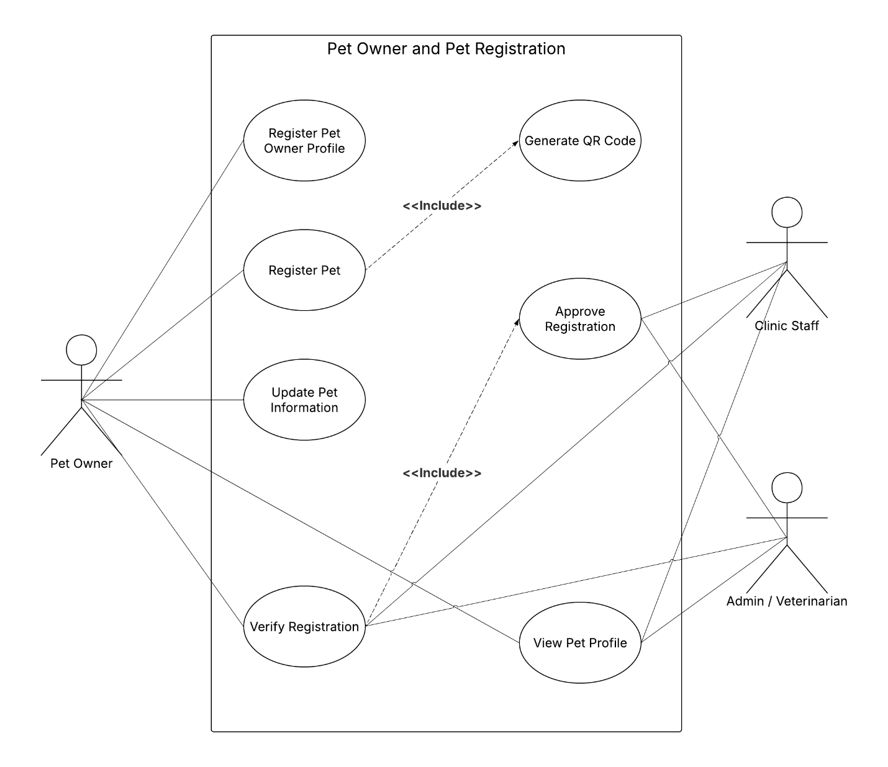
Figure 2. Use Case for Pet Owner and Pet Registration

Use Case Diagram for Identification and Traceability Using QR Technology provides a visual representation of the process by which the proposed system will facilitate quick identification and accessibility to the records related to pets using QR technology. The use case diagram will emphasize on the interaction among three main actors; Pet Owner, Clinic Staff, and Admin/Veterinarian, along with the various functions of the system involved in traceability, accessibility, and monitoring of the pet-related records. This use case diagram is significant since it is an example of how the system will convert registered pet records into a traceable record [20], [31].

The key process here is the use case of Scanning QR Code, which relates to all three stakeholders. It implies that QR scanning is not confined only to one participant but can be carried out by pet owners, clinic representatives, and veterinarians, based on the specific circumstances. A pet owner can scan the QR code to verify the details of their pet, whereas the clinic workers can do so during service provision. This feature highlights the versatility and efficiency of the proposed design. Scanning QR Codes involves Retrieving Pet History, thus implying that scanning itself is not the ultimate objective of the system but merely a trigger, allowing the user to view the information stored in the database. This connection is particularly important because it demonstrates the potential of using QR codes as an entry point for accessing the database and retrieving pet information efficiently [23], [31].

After retrieving the pet's history, there are various use cases which can be performed regarding viewing. For example, use cases such as Viewing Vaccination History, Viewing Clinical and Medicine Record, and Viewing Payment Status are available. Such use cases are possible to be accessed by different actors, especially Clinic Staff and

Admin/Veterinarian, as they deal with the management and evaluation of pet services. Such use cases show that traceability does not only involve identification but also access to all data. Having immediate access to vaccination, clinical, and payment information makes the process of providing pet services much more effective due to the absence of necessity for manual data search [20], [24], [31].

The use case Trace Pet History signifies the general operation of the system in which all pieces of retrieved information would form an unbroken history of interactions between a pet and the clinic. The history of the animal may include vaccine history, consultation logs, and financial transactions. It is critical for a system to generate such a use case as traceability provides the possibility to keep track of all operations performed and make necessary reports and plans for future activities. It is especially crucial in the veterinary industry as it allows keeping track of all past events related to the pet [20], [31].

The other use case that is relevant in this regard is Generate QR Code. In particular, it is associated with Clinic Staff and Admin/Veterinarian as it signifies that QR codes are generated during the registration or approval process of a pet and controlled by the authorized actor. The assignment of such actions as generation of QR code to clinic-side actors guarantees the quality, control, and accuracy of QR codes. According to several studies on the identification processes in a digital environment, such practices ensure higher performance and reliability of the system in question [23], [31].

The involvement of various actors that interact with the same use case indicates a cooperative approach to the process. Where the Pet Owner makes use of the QR code for viewing the information, the Clinic

Staff and Admin/Veterinarian make use of it for operational reasons to check the records, ensure that the vaccination is up-to-date, analyze clinical history, and check payment information. The use case shows the centralized approach of providing the required information to the users. This characteristic of web-based application is quite common, as it increases the effectiveness and efficiency of operation within the company [20], [24], [32].

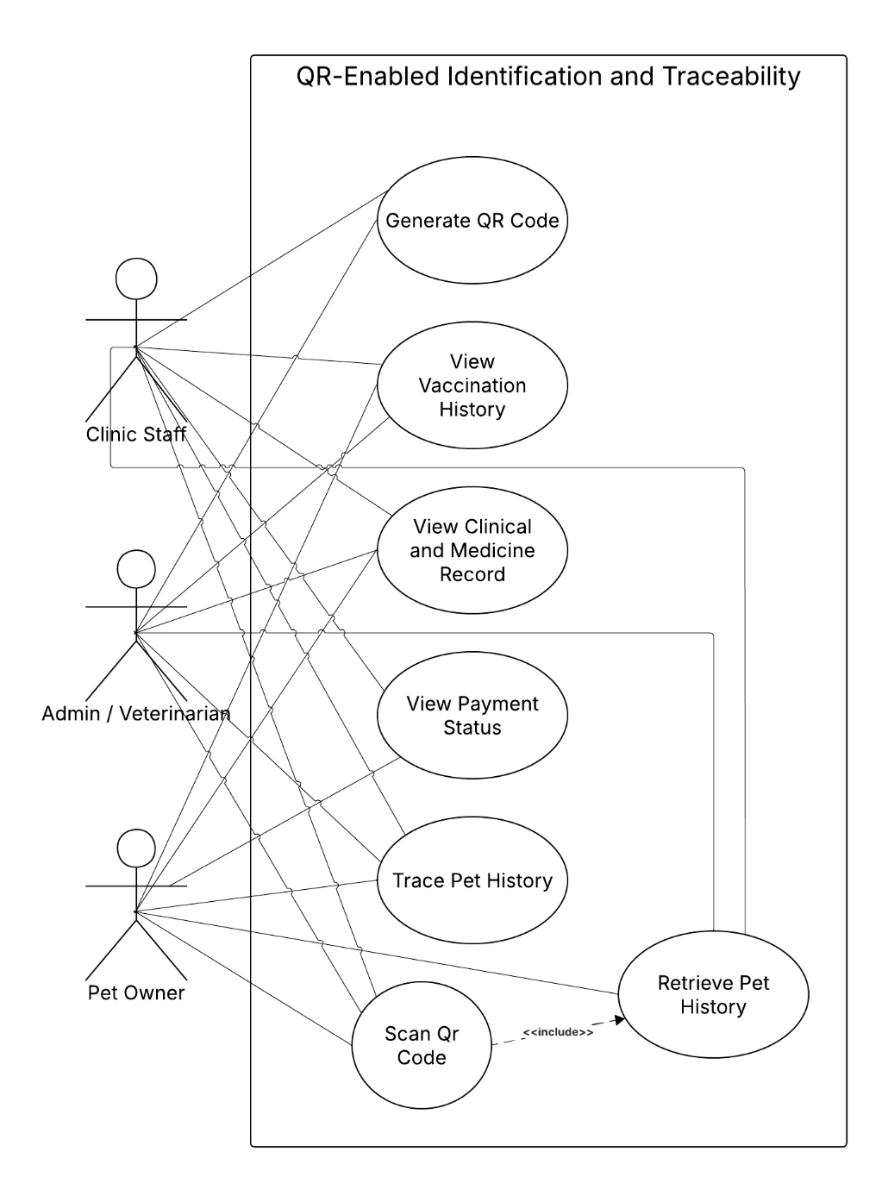

Figure 3. Use Case for QR-Enabled Identification and Traceability

Use Case Diagram – Vaccination Monitoring demonstrates how the suggested system will manage, monitor, and update any data regarding pet vaccinations. In this module, the priority is to make sure that the data about vaccination is correct, updated, and easy to access both for pet owners and clinic staff members. Three main actors, who will be involved in this process, include Pet Owner, Clinic Staff, and Admin/Veterinarian. It is necessary to note that this module is very important, as the vaccination monitoring is the main service of veterinary clinics and can be done efficiently using computer technologies [20],[31].

In the center of the figure is the use case Check Vaccination Status, serving as the key decision making component within the module. This is relevant since all vaccination processes require knowledge about the existing state of the animal’s vaccination process. Thus, from the presented diagram, one can see that such use cases as Read Vaccination, Update Vaccination Record, Monitor Vaccination Due involve the said use case. This suggests that prior to any other operation, including update, read, or monitoring, the system has to check the vaccination status. Such a design corresponds to the process of decision making based on existing facts rather than assumptions. In the field of e-health, status checks serve to prevent medical errors [20], [24].

Use case Update Vaccination Record belongs to the actor Admin/Veterinarian, suggesting that the ability to make changes in official records is reserved solely for authorized personnel. This is a crucial aspect of the software design since records of pet vaccinations represent its health history that has to be handled properly. Thus, it should be made possible for only qualified specialists to modify the data. This principle is typical for secure digital record management when sensitive information can be managed according to the user role [20], [31].

In turn, Read Vaccination use case makes it possible for clinic staff members to obtain an overview of current vaccination data. This step is essential for further consultation, confirmation, and additional procedures if needed. For example, before suggesting new vaccinations or modifying existing data, clinic workers have to read the current records and analyze them accordingly.

Use Case Monitor Vaccination Due should be associated with Clinic Staff, as it emphasizes their responsibility of keeping track of upcoming or due vaccinations. Such functionality is extremely important as it turns the application from just a storage into a monitoring one. With the implementation of the use case, it will not be necessary to wait for the clients' visits to check whether their animals need vaccinations; the clinic staff will be able to identify the list of pets requiring immunization services and take proactive measures to deliver them [31], [32].

The other important use case to discuss is Notify Vaccination Requirement as it involves the use of the system as well as Pet Owner. It means that if there are some pets that need either due or overdue vaccination, then the system will be able to notify the pet owner about it. This will increase interaction between the clinic and its clients; besides, notification is considered to be an effective method for modern web applications [32].

The use case View Vaccination Record is associated with the Pet Owner, indicating that owners can access their pet’s vaccination history. The process enables pet owners to choose from two different methods which they can use to check their pet's vaccination status. Through this system, pet owners gain knowledge about vaccination requirements which enables them to take charge of their pets' health. Modern digital systems

establish user trust through their record access feature, which enables users to access their personal records.

The diagram showcases two types of relationships which include the mandatory <> links to Check Vaccination Status that function as essential components for multiple operational processes. The design establishes a vaccination system which depends on a single verified data point to conduct all vaccination activities. The system uses a primary status-checking function as its main module which creates uniformity and precise control over all vaccination processes.
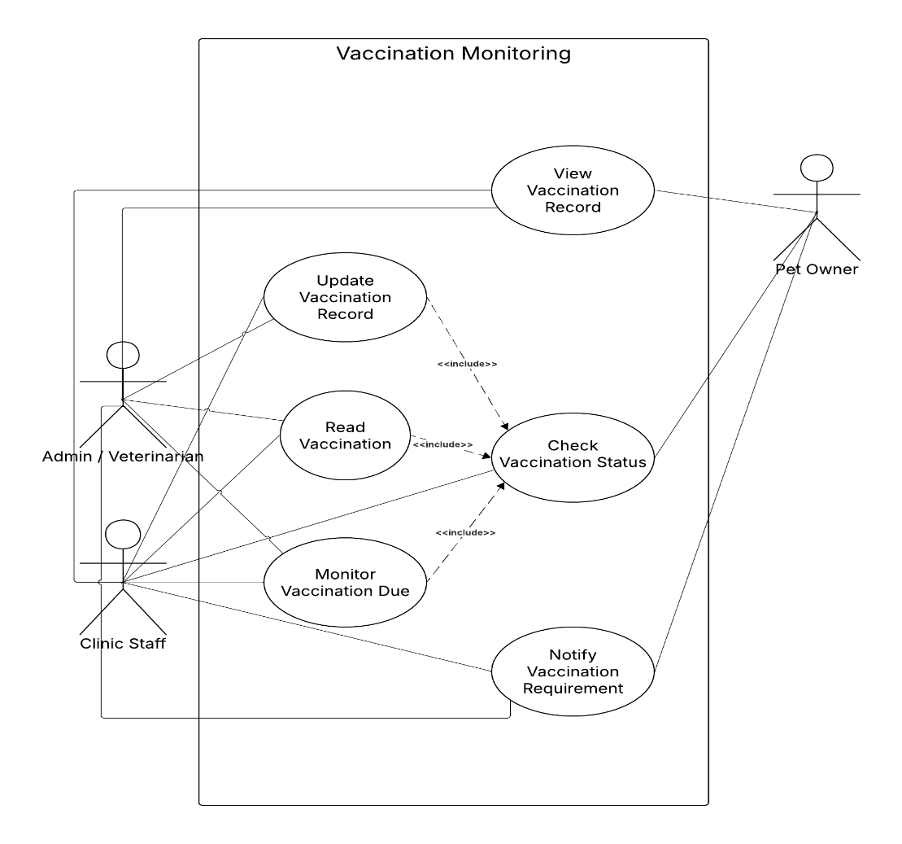

Figure 4. Use Case for Vaccination Monitoring

Use case diagram of the clinical and medicine record helps show how the system will handle the process of generating, modifying, and retrieving of records related to clinical work and medicine prescriptions of the pets registered in the system. The main aim of this module is to ensure that all medical activities involving diagnosis, treatment, and medication of any kind are correctly documented, archived and associated with the right pet account. Three major actors will be involved in this module namely: Clinic Staff, Admin /Veterinarian and Pet Owner [20], [31].

The figure above depicts two major classes of system functionalities, namely clinical records and medicine records. The use cases “Create Clinic Record” and “Create Medicine Record” fall under both “Clinic Staff” and “Admin/Veterinarian,” which means that individuals who are authorized to create the respective data records should encode new information into the system. It is important to note that the above mentioned use cases differ from each other due to the following reason. The first class comprises clinical records, which include the doctor’s findings, diagnosis, and consultation record. In its turn, the second class consists of medicine records, which include medication prescribed by a veterinarian (drugs, dosage, and instruction). Such differentiation provides better organization of medical information stored in the system since all records become more structured and usable during future consultations [20],[32].

The use case "Link Record to Pet Profile" is one of the notable characteristics of the diagram because it occurs in each creation and modification process. It shows that all records related to the clinical and medicinal practices need to have some specific connection to one pet profile before becoming part of the storage system. It is important to link records and a pet profile because only such action allows making the records meaningful and relevant. Otherwise, all records will be irrelevant

since they will be isolated from any patient profile. In the world of digital technology used by veterinarians, it becomes especially important to make links between a patient profile and its record [20], [31].
The Use Cases Update Clinical Record and Update Medicine Record have also been allocated to Clinic Staff and Admin/Veterinarian, as there may be situations where existing records will have to be changed. This is an essential operation, as medical records are not fixed and cannot remain the same all the time. They can be corrected, modified, or updated depending on any new discovery or consultation. The ability to change medical records in case of need is a vital component of any health care or veterinary system. Nevertheless, limiting this possibility to certain roles guarantees the accuracy of the data contained in the system [20], [31].

Both use cases, View Clinical Record and View Medicine Record, can be accessed by all three actors, including the Pet Owner. This means that while the creation or alteration of these records is restricted to authorized persons only, the pet owner has access to the medical and medication history of his pet. This fosters transparency and helps him keep himself abreast of the status of his pet and its treatment regime. The use of web applications in modern times stresses the importance of giving users access to their own medical records [24], [32].

According to the figure below, all the use cases for creation and update involve the step of linking. The reason behind this design is that the entire system is a centralized, integrated record management system. It is not only storing all information in separate modules but also making sure that each and every entry about the clinical and medicine information is related to the profile of the pet itself. It helps in supporting the identification

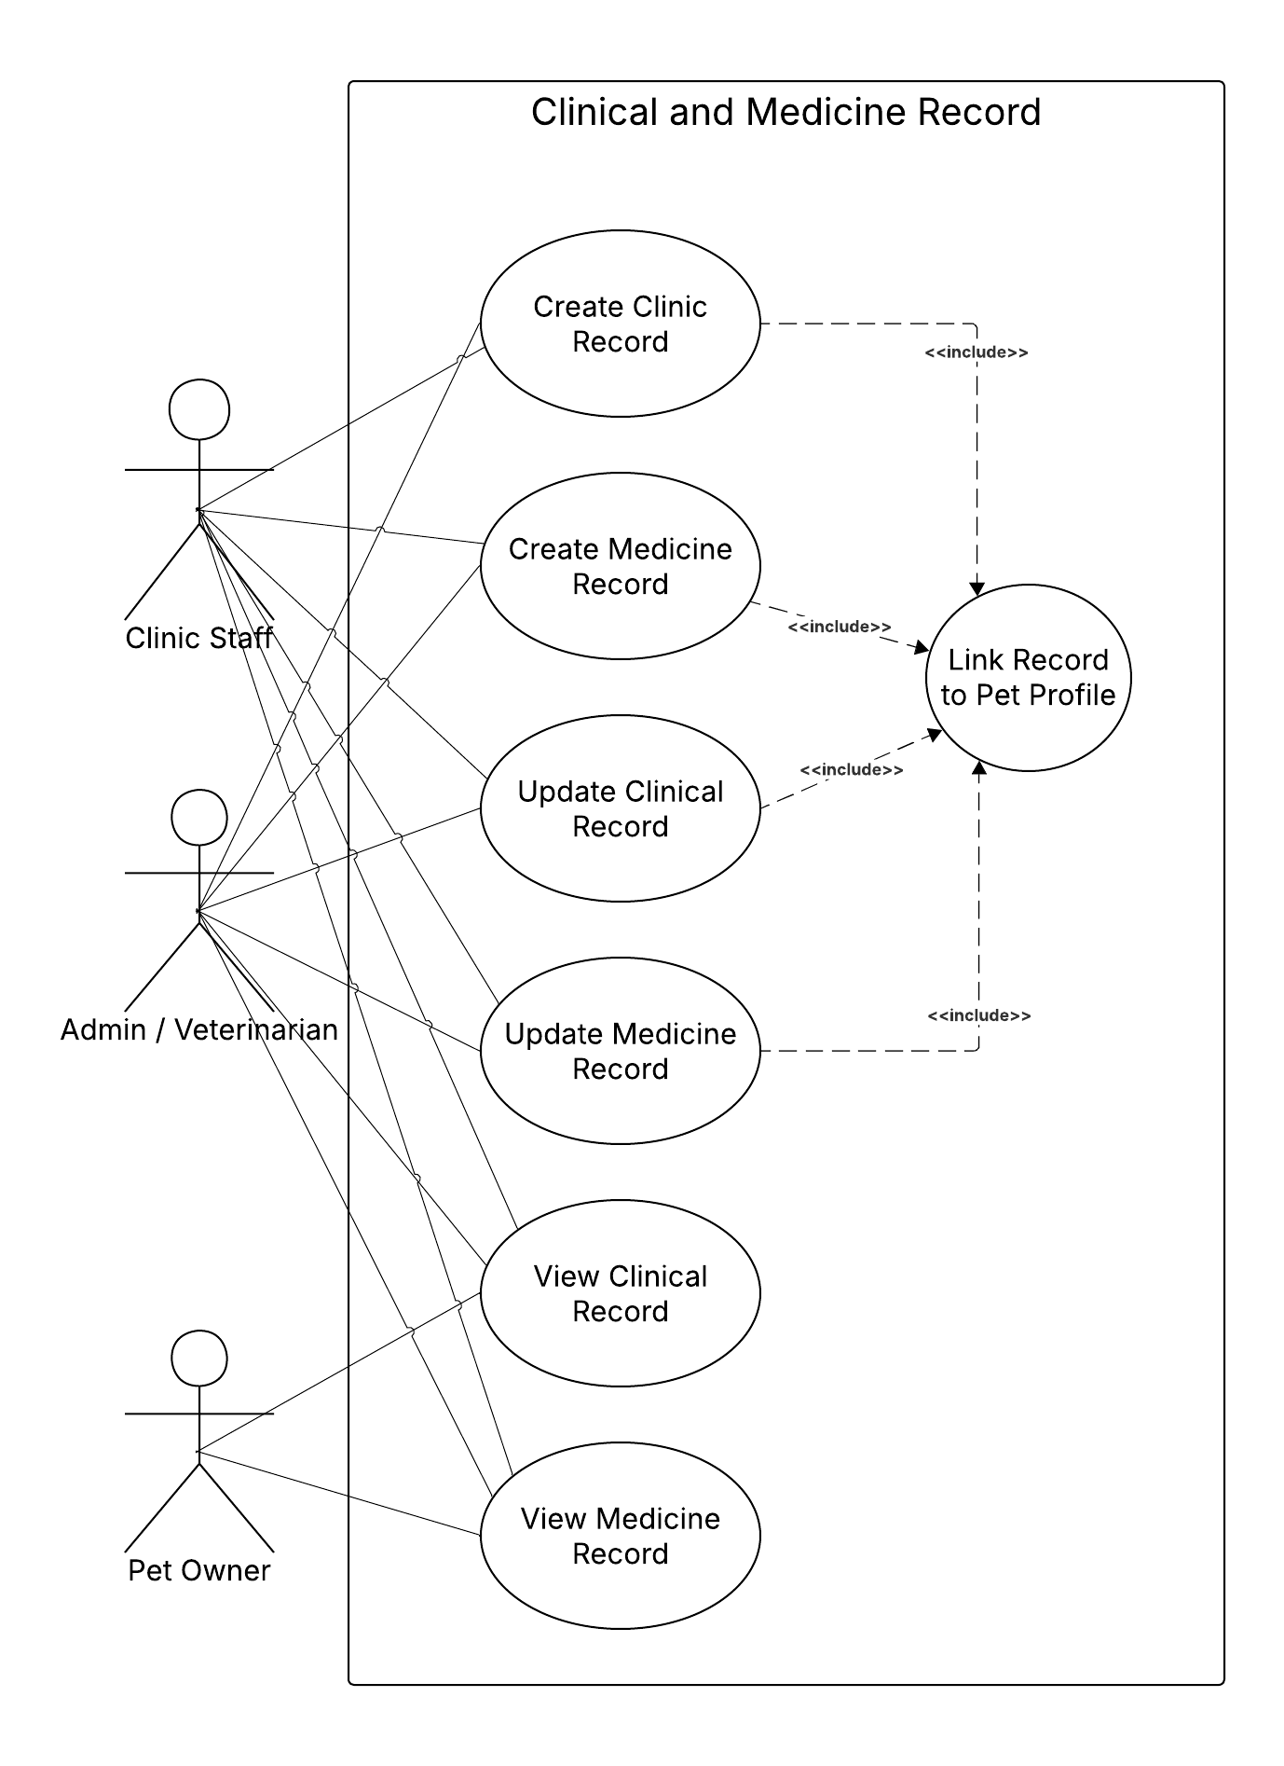
as well as the reporting function, which has been discussed in other modules such as QR identification [20],[31],[32].
Figure 5. Use Case for Clinic and Medicine Record

The Admin/Staff-Side Management Use Case Diagram depicts the key internal processes executed by the authorized members of staff within the suggested Web-Based Pet Registration, Vaccination, and Traceability Management System with Payment Monitoring and Data Analytics. Within this module, Admin/Staff acts as the key player since both the administrative and operational processes within the clinic take place using the system. This use case diagram comprises of six main processes, which include Manage Registration, Manage Payment, Manage QR Code, Manage Vaccination, Manage Records, and Generate Reports. These use cases constitute the key responsibilities of the internal users in managing the operation of the system within the daily activities of the clinic. The use case diagram design follows the requirements set by the research objectives, which entail pet registration, payment monitoring, QR traceability, vaccination management, record management, and data analysis reporting.

Use Case 1, Manage Registration, covers managing the pet owner and their pet through the process of registration. This use case is vital since it allows the clinic to manage information relating to the pet owner and the pet through the database management system. Current research shows that using digitized registrations and clinic records improves efficiency, eliminates fragmented data handling, and makes information access fast and accurate [20], [21]. For the proposed system, registration management is a critical process since it supplies basic data necessary for the tracking of payments, creation of QR codes, and vaccinations.
Use Case II, Namely, Manage Payment, involves keeping track of payments made using OR numbers provided by the treasury department. This is aligned with the purpose of the study that focuses on the relationship between OR numbers and their respective owners and pets. Manage Payment is critical as it helps determine the state of payment for

a particular client, confirming whether or not the process is complete. The literature employed by the researchers in conducting this study indicates that digital transaction environments and transaction monitoring systems help ensure proper traceability and validation of transactions particularly when the transactions are properly connected to the service transactions [22], [23].

Thirdly, the third use case, Manage QR Code, relates to the creation and management of the QR code-based identifiers that link to the pet’s profile records. This use case helps achieve the research objective of traceability since it enables quick tracing of the pet’s identity based on its QR code identifier. In today’s modern veterinary and digital service delivery systems, QR code-based identification makes record retrieval convenient and effective by ensuring that necessary information can be retrieved easily using one linked reference [20], [21]. In this study, it is important to note that the function helps integrate the two functions into an identification process.

Lastly, the fourth use case is known as Manage Vaccination. The use case entails viewing and managing the vaccination records of pets who have been registered in the veterinary clinic. It will help the personnel at the clinic keep records up-to-date regarding the vaccination and other relevant aspects. Literature indicates that digital systems play an important role in service record management like the vaccination history, among others, by making service delivery easier without much manual intervention [20], [21]. Therefore, this use case relates to the development of a module that helps track the vaccination history of pets.

Lastly, the Manage Records use case entails managing the system's records. While registration, payments, QR codes, and vaccination all deal

with a specific process, the manage records use case pertains to the general management and retrieval of the information that is stored in the system. The management of the system's records is critical since it will ensure that the effectiveness of the system is guaranteed through efficient and reliable records management. Several RRL have identified the integration of records as a strategy to ensure effective and efficient operations [20], [21].

Generate Reports use case refers to the generation of outputs and analytics from the stored data. The generation of reports and analytics corresponds to the purpose of generating summaries such as the number of pets that have been registered, their sex, the state of their vaccinations, and their payments. From prior studies, the generation of analytics and reporting are crucial components in allowing organizations to understand and measure the trends and performance levels of the various processes involved [24]–[27]. Therefore, generating reports is essential in allowing the analysis of the generated data.

All in all, it can be said that the Admin/Staff-Side Management Use Case Diagram shows that the suggested system offers an integrated suite of functionalities to internal staff at the clinic. In terms of functionalities provided by Manage Registration, Manage Payment, Manage QR Code, Manage Vaccination, Manage Records, and Generate Reports, it helps with operations and monitoring necessary for successful veterinary clinic management. Furthermore, the Admin/Staff-Side Management Use Case Diagram is consistent with the Level 1 DFD for the system, whose main operations are registration, payment monitoring, QR code managing, vaccination updates, and reports/analytics. This is one more reason why the whole research design should be considered effective [20]–[27].

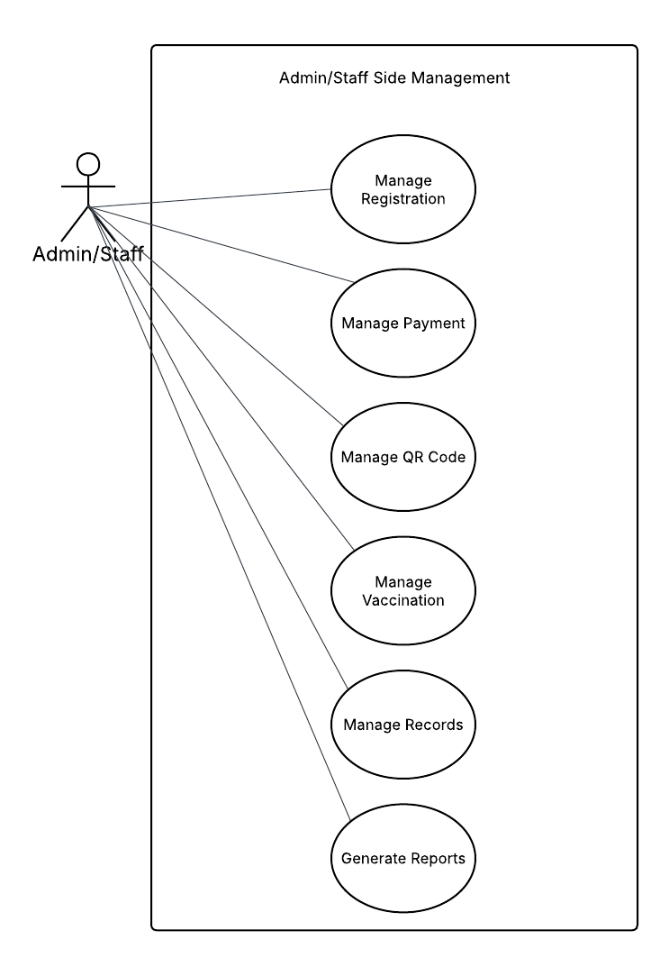

Figure 6. Use Case Diagram for Payment Monitoring using OR Number

The Analytics and Reporting Use Case Diagram shows how the system gives Admin and Staff users access to complete structured decision-making content which they can extract from system data. The Admin and Staff members function as main actors in this module because staff members at the clinic handle both tracking operational data and creating reports which document clinic operations.

The study goal needs data analytics and reporting solutions which can create summary reports that include numbers of registered pets and their gender distribution and vaccination records and payment information.

The main use case in this module is View Analytics, which represents the process of accessing the dashboard and reviewing key data in summarized form. The use case comprises View Registration Report, View Vaccination Report, View Payment Report, and View Pet Demographics Report because these reports function as fundamental analytical tools which provide clinics with essential monitoring capabilities through their analytics dashboard. The analytics-viewing process needs these elements as required components which developers modeled through <> relationships. The structure mirrors recent research which demonstrates that dashboards deliver their highest value when they show relevant information which users can turn into action through their organized presentation [24], [25].

The module implements the bulk of its functionality in the form of the Generate Report use case, where the Admin and Staff users can generate structured results out of the system database data. The generation of reports is made possible when the user filters the data according to certain criteria. This is because the user must filter according to certain categories

and dates in order to receive the desired result. Filtering is essential for the implementation of this feature since filtered reports are necessary for better tracking of information. Recent studies on dashboards and reporting systems emphasize that usability, purpose-driven content, and context-sensitive reporting improve the practical value of information systems for stakeholders and decision-makers [24]–[26].

The use case Export/Print Report is modeled as an <> relationship to Generate Report because exporting or printing is an optional action that occurs only when the user needs a sharable or documented copy of the report. The distinction matters because system users can view the report through the system for current needs while export and print functions become active only under specific requirements. Research on dashboard design and implementation highlights that information systems should not only display data clearly but also support real-world use by allowing stakeholders to act on, share, and document the information generated by the system [24], [25].

On the whole, based on the Analytics and Reporting Use Case Diagram, it can be seen that the proposed system does not only provide a way of storing the veterinarian record but also provides a way of turning the record into useful information for the operation of the clinic. This is made possible through the use of the View Analytics function, Generate Report function, Filter Data function, and Export/Print Report function. It should be noted that this approach follows current research in digitalization of veterinary clinics and dashboard-based information systems [24]–[27].

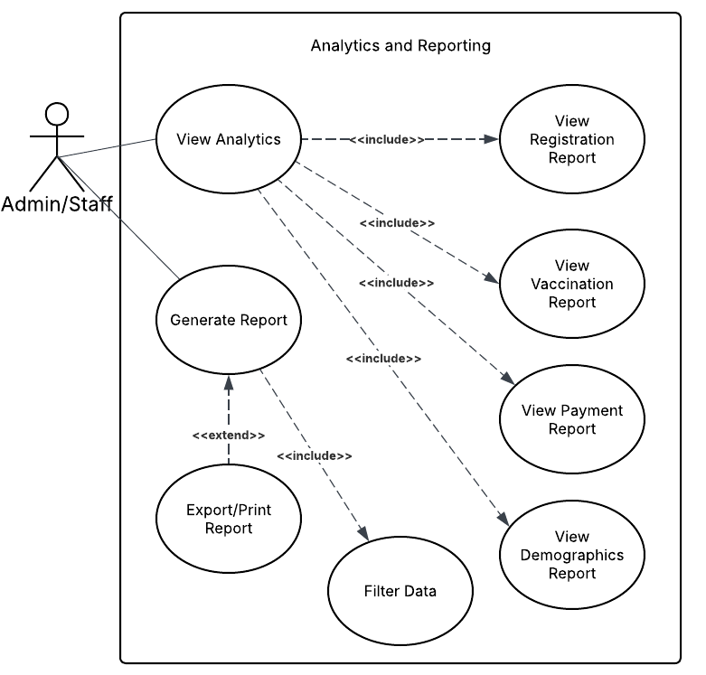

Figure 7. Use Case Diagram for Analytics and Reporting

The Admin/Staff-Side Management Use Case Diagram depicts the key internal processes executed by the authorized members of staff within the suggested Web-Based Pet Registration, Vaccination, and Traceability Management System with Payment Monitoring and Data Analytics. Within this module, Admin/Staff acts as the key player since both the administrative and operational processes within the clinic take place using the system. This use case diagram comprises of six main processes, which include Manage Registration, Manage Payment, Manage QR Code, Manage Vaccination, Manage Records, and Generate Reports. These use cases constitute the key responsibilities of the internal users in managing the operation of the system within the daily activities of the clinic. The use case diagram design follows the requirements set by the research objectives, which entail pet registration, payment monitoring, QR traceability, vaccination management, record management, and data analysis reporting.

Use Case 1, Manage Registration, covers managing the pet owner and their pet through the process of registration. This use case is vital since it allows the clinic to manage information relating to the pet owner and the pet through the database management system. Current research shows that using digitized registrations and clinic records improves efficiency, eliminates fragmented data handling, and makes information access fast and accurate [20], [21]. For the proposed system, registration management is a critical process since it supplies basic data necessary for the tracking of payments, creation of QR codes, and vaccinations.
Use Case II, namely, Manage Payment, involves keeping track of payments made using OR numbers provided by the treasury department. This is aligned with the purpose of the study that focuses on the relationship between OR numbers and their respective owners and pets. Manage Payment is critical as it helps determine the state of payment for

a particular client, confirming whether or not the process is complete. The literature employed by the researchers in conducting this study indicates that digital transaction environments and transaction monitoring systems help ensure proper traceability and validation of transactions particularly when the transactions are properly connected to the service transactions [22], [23].

Thirdly, the third use case, Manage QR Code, relates to the creation and management of the QR code-based identifiers that link to the pet’s profile records. This use case helps achieve the research objective of traceability since it enables quick tracing of the pet’s identity based on its QR code identifier. In today’s modern veterinary and digital service delivery systems, QR code-based identification makes record retrieval convenient and effective by ensuring that necessary information can be retrieved easily using one linked reference [20], [21]. In this study, it is important to note that the function helps integrate the two functions into an identification process.

Lastly, the fourth use case is known as Manage Vaccination. The use case entails viewing and managing the vaccination records of pets who have been registered in the veterinary clinic. It will help the personnel at the clinic keep records up-to-date regarding the vaccination and other relevant aspects. Literature indicates that digital systems play an important role in service record management like the vaccination history, among others, by making service delivery easier without much manual intervention [20], [21]. Therefore, this use case relates to the development of a module that helps track the vaccination history of pets.

Lastly, the Manage Records use case entails managing the system's records. While registration, payments, QR codes, and vaccination all deal

with a specific process, the manage records use case pertains to the general management and retrieval of the information that is stored in the system. The management of the system's records is critical since it will ensure that the effectiveness of the system is guaranteed through efficient and reliable records management. Several RRL have identified the integration of records as a strategy to ensure effective and efficient operations [20], [21].

Generate Reports use case refers to the generation of outputs and analytics from the stored data. The generation of reports and analytics corresponds to the purpose of generating summaries such as the number of pets that have been registered, their sex, the state of their vaccinations, and their payments. From prior studies, the generation of analytics and reporting are crucial components in allowing organizations to understand and measure the trends and performance levels of the various processes involved [24]–[27]. Therefore, generating reports is essential in allowing the analysis of the generated data.

All in all, it can be said that the Admin/Staff-Side Management Use Case Diagram shows that the suggested system offers an integrated suite of functionalities to internal staff at the clinic. In terms of functionalities provided by Manage Registration, Manage Payment, Manage QR Code, Manage Vaccination, Manage Records, and Generate Reports, it helps with operations and monitoring necessary for successful veterinary clinic management. Furthermore, the Admin/Staff-Side Management Use Case Diagram is consistent with the Level 1 DFD for the system, whose main operations are registration, payment monitoring, QR code managing, vaccination updates, and reports/analytics. This is one more reason why the whole research design should be considered effective [20]–[27].

Figure 8. Use Case Diagram for Admin / Staff Management

The Activity Diagram of Pet Owner and Pet Registration captures the sequence of activities that occurs once the pet owner registers into the system and inputs their pet details for official registration. This activity starts with the User opening the registration page within the Pet Owner swimlane to fill in their personal and pet information. The significance of this step lies in the fact that the entire process of creating an official record in the clinic relies upon receiving the correct data from the user. For online veterinary clinics, the registration process is one of the most important processes since it forms the beginning for other subsequent transactions like vaccinations, payments, QR code traceability, and consultations [20], [32].

After submission of registration, the process continues to the System swimlane, where the system will check the information that was entered. The importance of the section is that the system does not take any action on the user input automatically; instead, it ensures that the fields that should have information have been populated and that the data entered fits within the stipulated requirements. By ensuring the input data are validated before being accepted, the integrity of the data to be stored will be protected. In case the data are missing or incorrect, then the activity goes back to the Pet Owner for correction of the information. This is important because the system does not want to store erroneous data in the centralized database [20], [33].

Once the data has been validated, there comes another crucial decision in the system – determining whether the owner or the pet has an existing record or not. Such a process is important as one of the most prevalent errors in manually or partially automatically operated systems is the duplication of entry records. According to the activity diagram, in case of duplication, the process is reverted to the Pet Owner, so that the data

could be checked again. The absence of any duplication means that the process goes on. This is an extremely important part of your research project, since one of the objectives of the proposed system is the formation of a consistent database, which will not occur in case of duplicated data remaining within the system [20], [31].

The next step is that the process shifts to the Admin/Staff lane, where the registration information is reviewed and confirmed by staff members at the clinic. This is an essential step since it demonstrates the way in which the clinic controls the registration data. As opposed to systems based on user registrations, our system provides additional verification from the staff side, which guarantees the appropriateness of the stored data and, thus, ensures the reliability of data storage as well as the involvement of administrative authorities. As shown in studies dedicated to the digitalization and management of veterinary clinics, system effectiveness is ensured by the proper supervision of processes [20], [31].

After verification, the System goes back to the System and then saves the record of the pet owner, saves the pet's record, creates the respective QR code, and saves the QR code information. This step is very important in realizing the functionality of traceability and identity management in your system. The QR code does not only decorate your system but serves a purpose of linking the physical pet to its digital information. This helps in ensuring efficient record keeping and tracing over time. Finally, the Process will end once the Pet Owner is notified together with the QR code produced. The production of the QR code confirms that the registration process will not be deemed to have ended without the successful transformation of users' input into a database entry.

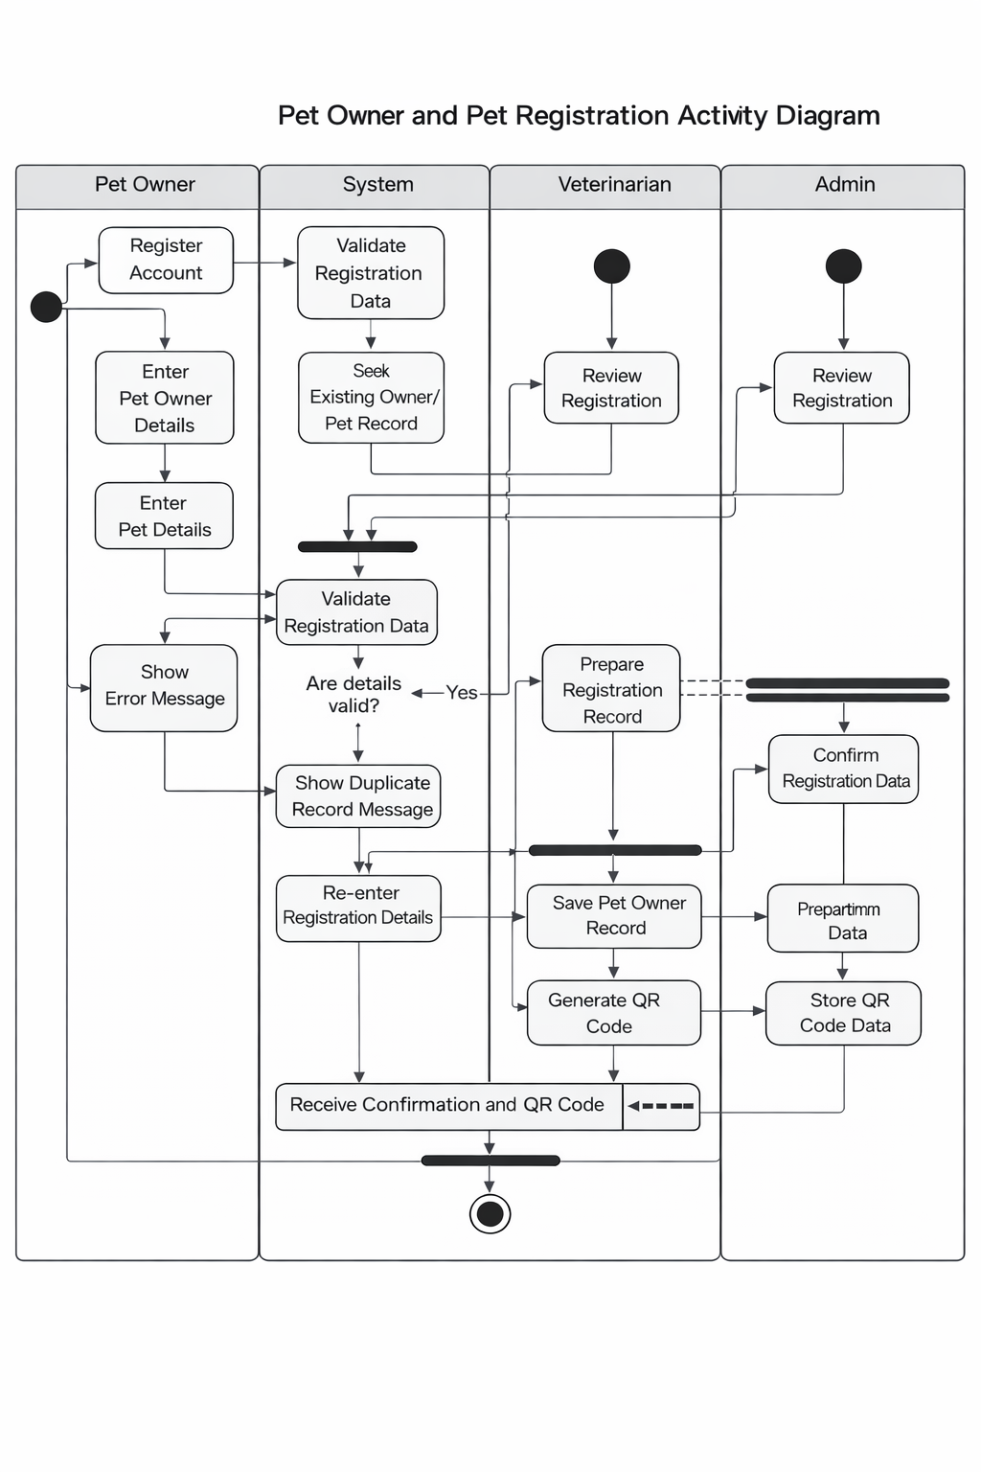
Generally, from the diagram above, it is clear that the registration process by the Pet Owner is one involving data collection and entry, validation, duplication checking, verification by staff members, database saving, and production of QR code. These processes are relevant towards achieving the research objectives as discussed in chapter one [20], [23], [32].
Figure 9. Activity Diagram for Pet Owner and Pet Registration

Activity Diagram of QR-Enabled Identification and Traceability describes the process of using QR technology in order to obtain and track relevant data pertaining to the pet. This typically involves the QR code of the pet being scanned either by the Pet Owner or by the clinic staff. In your research, QR-enabled identification is among the key characteristics since it bridges the gap between the pet's physical presence and the digital records within the system. Therefore, this activity diagram depicts more than just scanning; it depicts the entire workflow involved in retrieving and tracking the records [23], [31].

After the display of the QR code, the next stage involves the System swimlane as the application tries to read the QR code and retrieves the associated pet record. The importance of this step in the process lies in the fact that the QR data will be translated into useful information by the system. According to the activity diagram, the QR code does not form the output; rather, it works as the key that helps retrieve the pet's record of registration, vaccinations, and payments. The advantage of this process is that it becomes easier and faster to search for the pet's data without having to look up manually [20], [23].

It becomes a key point of decision-making: does a matching record exist? This decision is crucial as it divides the success from failure of the traceability process. In case of the lack of records, an error message appears on the screen – “record not found”. It means that the system alerts users or clinical staff members that this particular QR code is not valid or active or even not matched with any record in the database. It is crucial to provide error handling scenarios because an activity diagram should present exceptions as well as ideal cases. Proper error responses are required as part of good system design [23], [31].

In case of matching, the linked information will be displayed on the screen, thus the Vet and Admin/Staff will have access to traceable history such as pet registration details and vaccination history, and all other information available in the system. Here the traceability function works effectively. A QR code becomes helpful by enabling quick access to a record, unlike numerous actions performed manually in search of information about the pet. Traceability is helpful in a digital veterinary/healthcare system.

The importance of this particular activity diagram can be attributed to the fact that traceability is not seen as an independent process, but rather as a method of accessing records in the larger clinical system. The use of QR enables the system to carry out verification, pet history monitoring, and also makes it easier for authorized individuals to go through the details. The activity diagram clearly illustrates how both successful completion of a task as well as failure can be carried out, hence enabling the system to cater to realistic identification processes [20], [23], [31].

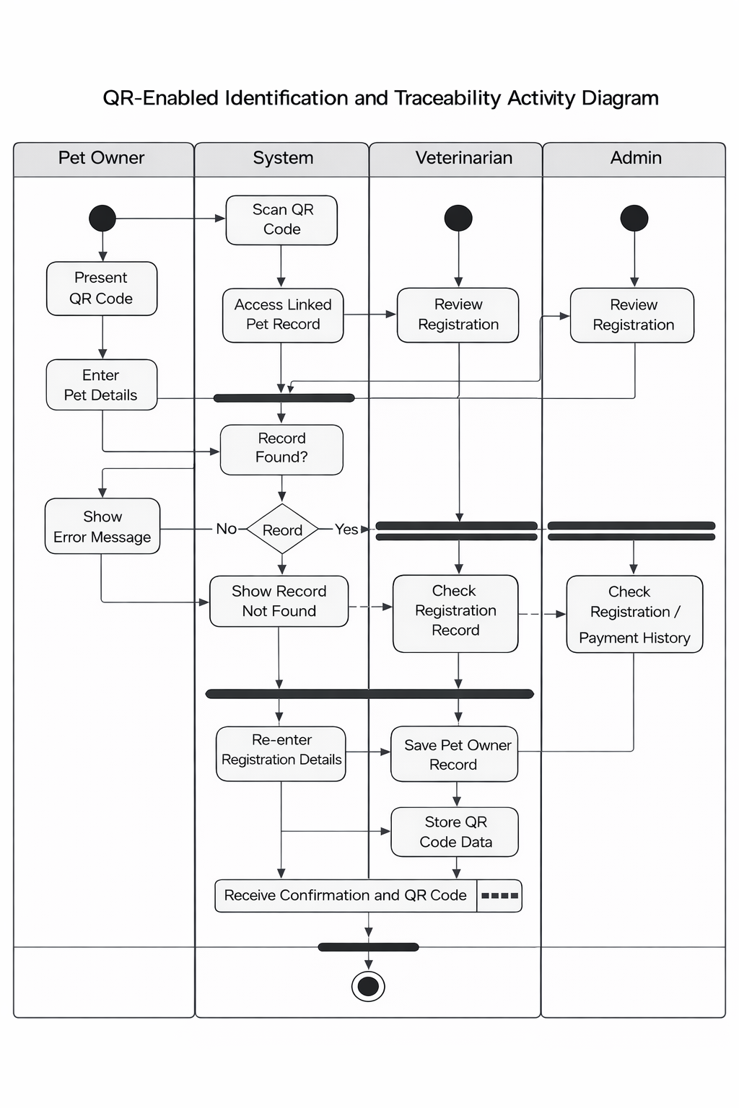
Figure 10. Activity Diagram for QR-Enabled Identification and Traceability

The Activity Diagram for Vaccination Monitoring describes the process of handling all vaccinations-related operations in the proposed system from receiving the pet until logging and modifying the vaccination history. The activity starts in the swimlane of the Pet Owner, where the owner brings their pet for vaccination or requests updating their pet's vaccination record. This activity is critical for associating the process of providing service at the clinic with the computerized monitoring system [20], [31].

Next, the System collects the pet's information and shows the pet's history of vaccines. This part is crucial since it is impossible to manage vaccinations without taking into account the previous vaccination records but only the current one. Any changes regarding the pet's vaccination should be entered after examining their vaccination record that includes previously given vaccinations, due dates, etc. This step helps provide more continuous treatment and prevents double vaccinations. Accessing historical information is crucial in today's computerized systems for more accurate and better monitoring [20], [24].

It is followed by the Veterinarian swim lane, where the veterinarian checks the vaccination history of the pet and inputs the updated vaccine record. This is because of the role of the veterinarian as the authority on record-keeping. The matching activity is the validation of the entered vaccination record. The validation procedure verifies that the input data is complete and logical. In case the entry does not pass the validation process, an error message is generated by the system, and the process is rerouted to repeat itself. The decision rule is vital since it proves that the system does not automatically store the data about the vaccinations [20], [31].

In case of a valid entry, the system stores the newly registered vaccination data, changes the vaccination status of the pet, and sets the next due date accordingly. This is one of the key results from the flowchart because the aim of vaccination tracking is not only to store one data entry, but to keep the immunization history updated over time, which could be referred to later. The need for maintaining a complete and updated immunization history is related to both clinical purposes and reporting, as vaccination history can be used later for creating reports [20], [24], [31].

Conclusion, the flowchart reaches its end point when the newly updated vaccination card appears, which shows that the activity has been performed successfully. The significance of this output cannot be ignored as it proves that not only was the information accepted by the system, but it was also incorporated into the current pet profile. In general, the vaccination monitoring activity chart shows a well-organized procedure with clinical relevance that involves updating, validation, maintenance of vaccination history, and better service tracking within the clinic.

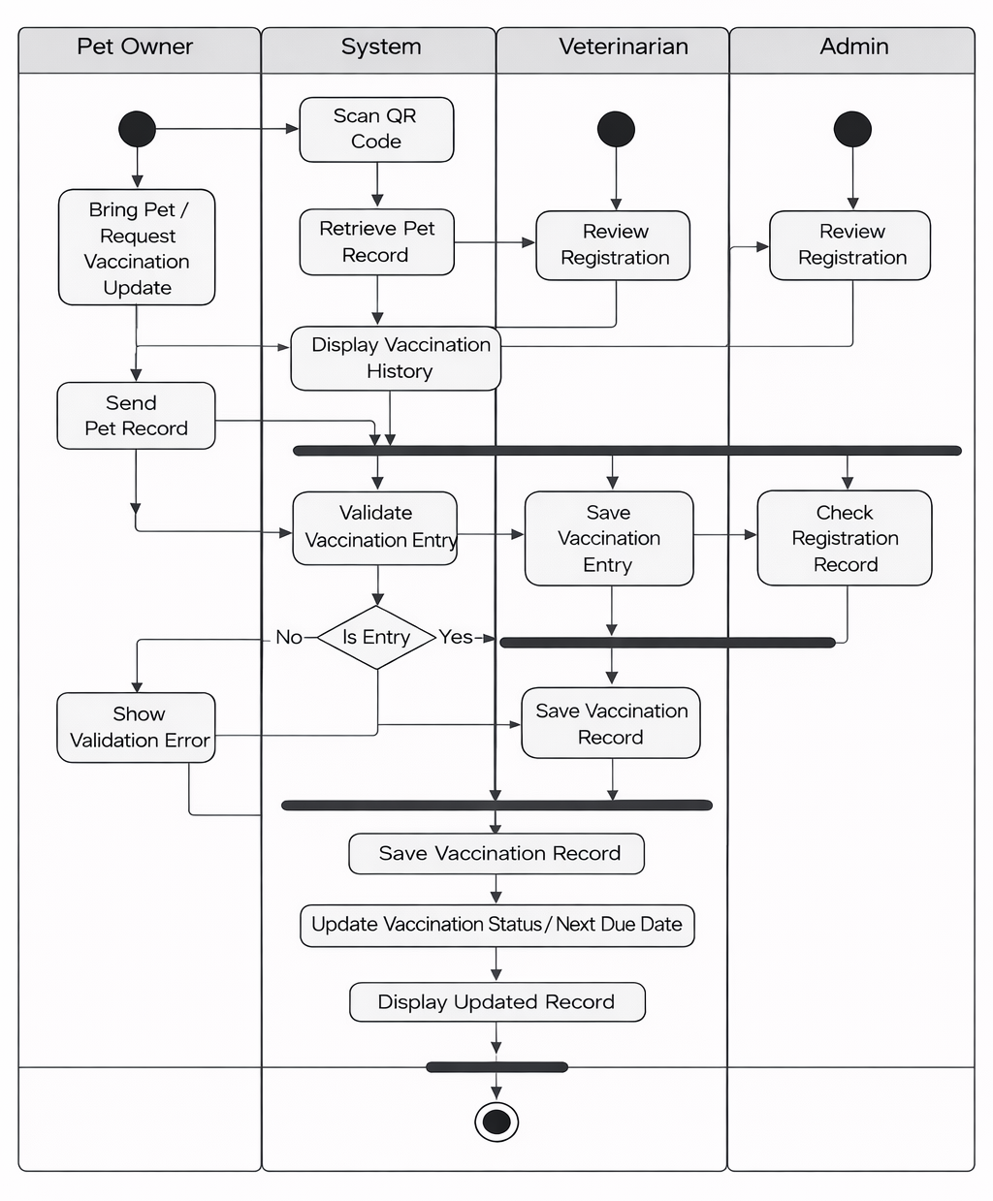

Figure 11. Activity Diagram for Vaccination Monitoring

Clinical and Medicine Records Activity Diagram shows the way the proposed system handles consultation results and medicines prescription. The process starts from the Pet Owner requesting a consultation or taking the pet for the clinical examination. This is consistent with reality as a starting point of the medical documents creation process. Consultation records are critical in a veterinary management system since they record the services rendered to the pet. On the other hand, medicine records store the prescriptions that come with those services [20], [31].

Following the request for a consultation, the System retrieves the pet’s existing medical records so that the Veterinarian can make informed decisions by comparing them against the newly collected data. It is critical to retrieve the medical records before the entry of new findings into the system because the decisions about the consultation depend on the pet's existing record and not the new one.

After this, the veterinarian enters information about the diagnosis, the treatment plan, and the prescription drugs into the System. Some of this information may consist of the name of the drugs, the dosage of the drug, period, frequency of taking the medicine, etc. Validation of these pieces of information is required before saving them in the System. In case of invalid information, a warning message is issued, and the process is repeated. This is important as it ensures that the data is consistent and well formatted [20], [31], [32] .

The System saves the consultation record, saves the prescription record, and saves the associated prescription items or medicines. It is crucial to understand that the records have different purposes. While the former describes the clinical case, the latter records the medications prescribed during this clinical case. Thus, it is necessary to separate them

but maintain links between them for convenience in retrieving information in the future [20], [32].

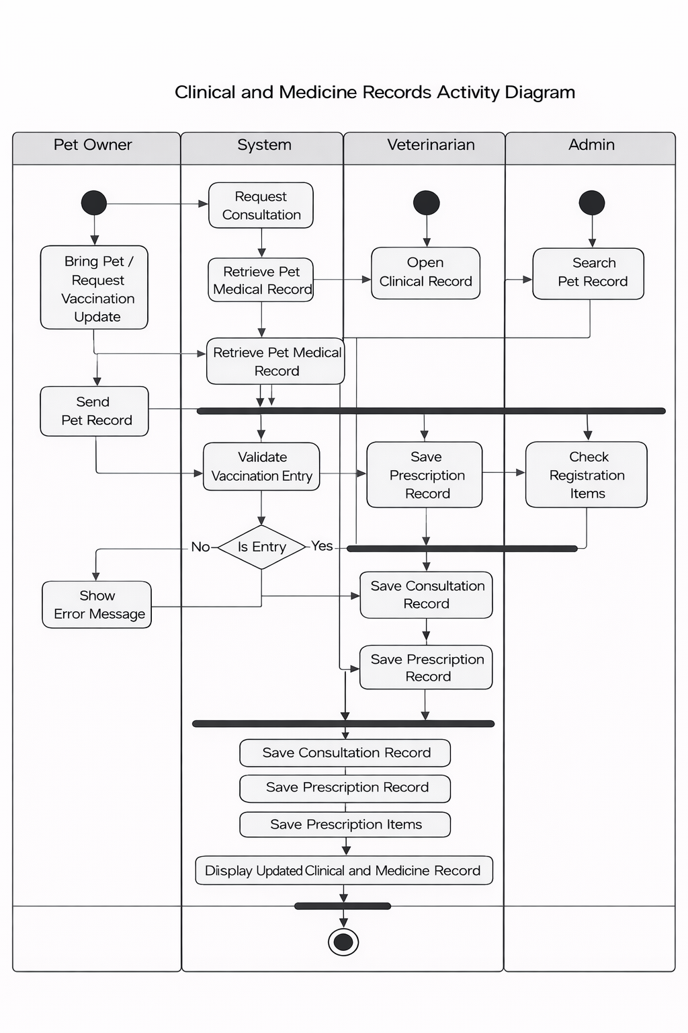
The activity ends when the revised document becomes visible. This shows that the system has effectively incorporated the results of the veterinarian’s analysis within the pet’s digital file. The complete activity diagram clearly illustrates that the suggested system allows for better clinical documentation, treatment documentation, and follow-up management compared to a scattered process [20], [31], [32].

Figure 12. Activity Diagram for Clinic and Medicine Records

Payment Monitoring Using OR Numbers Activity Diagram shows the procedure that is performed whenever the clinic makes its entry for payment transactions using the OR number issued by the treasury. In the first place, the information regarding the payments and the number of OR is collected either from the Pet Owner in case of clinic processing or via the Admin/Staff interface. It is worth noting that the described diagram is based on the actual design of your proposed system in terms of payment monitoring since the system itself does not produce OR numbers but rather registers and validates them.

The next stage takes place at the Application layer where the system receives information about the owner and pet in relation to the payment transaction. This detail is quite important to mention as payment monitoring does not make sense without having the payments associated with the specific registration or clinic procedure. Without the corresponding information about the owner and pet, the payment transaction will lose its traceability. [20], [22].

A critical decision in this process includes the validation of the OR number. In case the OR number is wrong or inconsistent, there will be an error message displayed. The error-handling mechanism in this part of the process is very important since one of the major goals of this module is to increase the reliability of the payments monitoring process. It is necessary to create a difference between a legitimate transaction and a fake one, in order to avoid mistakes and facilitate validation. Numerous studies show that transaction validation and tracing play a key role in maintaining reliable records in digital payment environments [22], [23].

In case the transaction number is valid, it will be attached to its respective owner, and the payment status will change accordingly; then,

the information will be stored in the system for further monitoring purposes. It is important to mention that the monitoring of the payment process is more complicated than just distinguishing between a paid and unpaid transaction. There should be sufficient information available in the record to ensure further monitoring, reconciling and report creating. Once the data have been stored, the payment confirmation screen will appear [20], [22], [23].

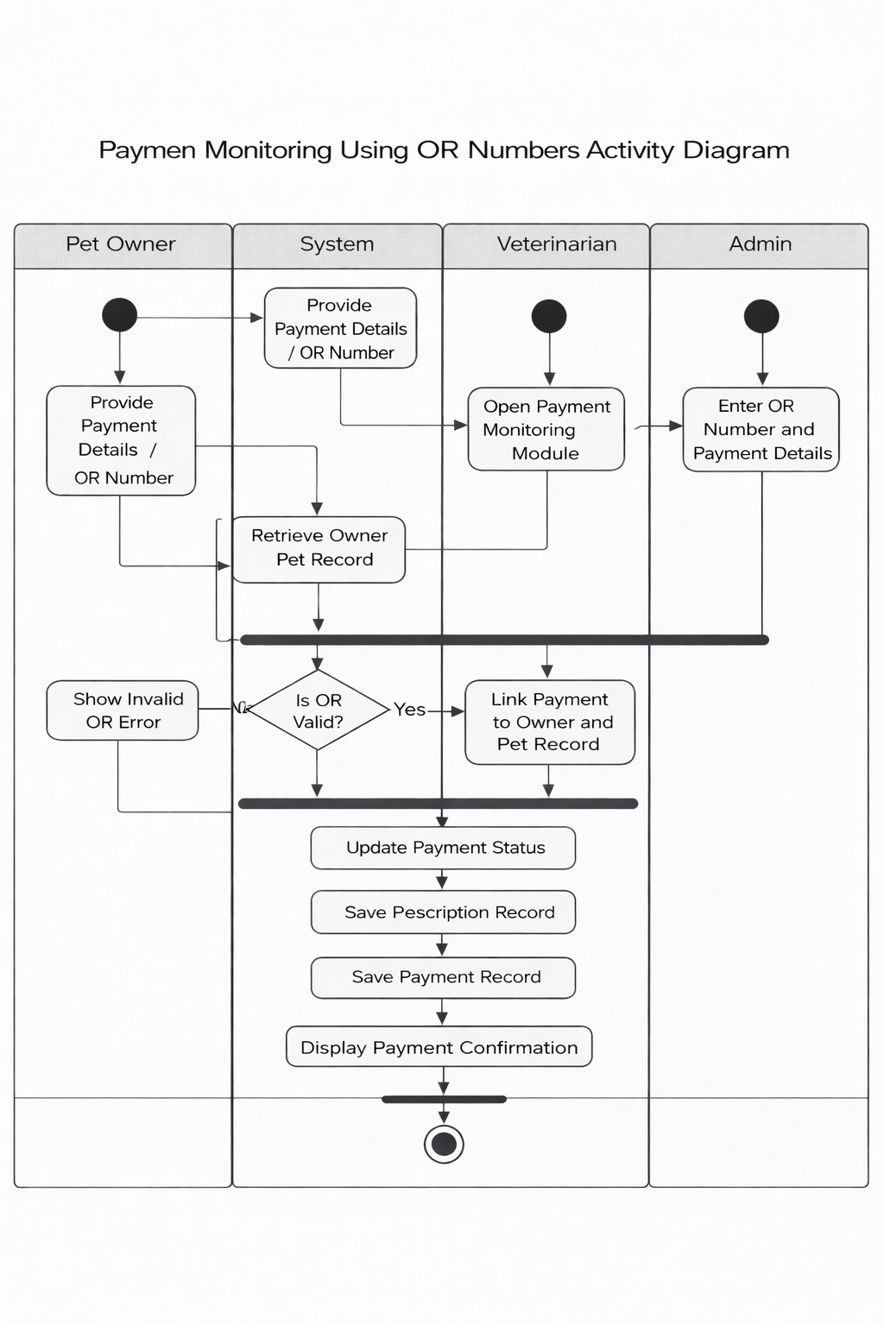
Generally, the payment monitoring activity diagram indicates a well-coordinated financial flow based on data extraction, OR validation, linking, status updates, and verification. This directly contributes to the achievement of the research objective to use the OR numbers issued by the treasury in clinic payments [20], [22], [23].
Figure 13. Activity Diagram for Payment Monitoring Using OR Numbers

Analytics and Reporting Activity Diagram shows how the proposed system converts stored operational data into valuable information by generating summaries, reports, and other analytical results. Usually, the process starts with an action initiated by an authorized person, who most often plays the role of Admin/Staff. In your system, analytics and reporting are critical because they provide for the generation of such summaries as number of registered pets, sex ratio, vaccination status, and payment status.

The next step in the reporting process involves the System that accesses the required data and checks if the report parameters have been entered correctly. At this stage, reporting purposes become critical since a report can be based only on some certain predefined goals, which may include date range, categories, and other criteria. When the report is invalid, the system should inform about errors. However, the correct request leads to further operations with the database. The process you describe is a good example of how systems should handle reports: they should be relevant and purposeful [24], [25].

The following actions are associated with compiling, analyzing, and creating reports and statistics out of the data collected. This stage demonstrates the value of keeping the initial records in registration, vaccination, payment, and other modules as a resource for managerial functions. Instead of being used as a mere record keeper, the system operates as a decision-making tool. According to research findings, dashboards and digital information systems have the potential to provide significant value once they convert the operational records into comprehensible results [24], [25], [27].

After the reports are created, they can be viewed by the person who requested them. Thus, in addition to producing a result in the form of a screen output, the report can also be employed to monitor performance, establish trends, and develop plans for the future. Considering the nature of your investigation, the analytics will allow the clinic to analyze its registration operations, payments, and vaccination monitoring results. From the above considerations, it becomes clear that the activity diagram can be interpreted both technically and strategically [24], [25], [27].

Generally speaking, the analytics and reporting activity diagram shows the way the system ensures data-based management through conversion of existing data from storage into summarized information and reports. This is consistent with contemporary digital service systems where data centralization, usability, and reporting become important components [24], [25], [27].

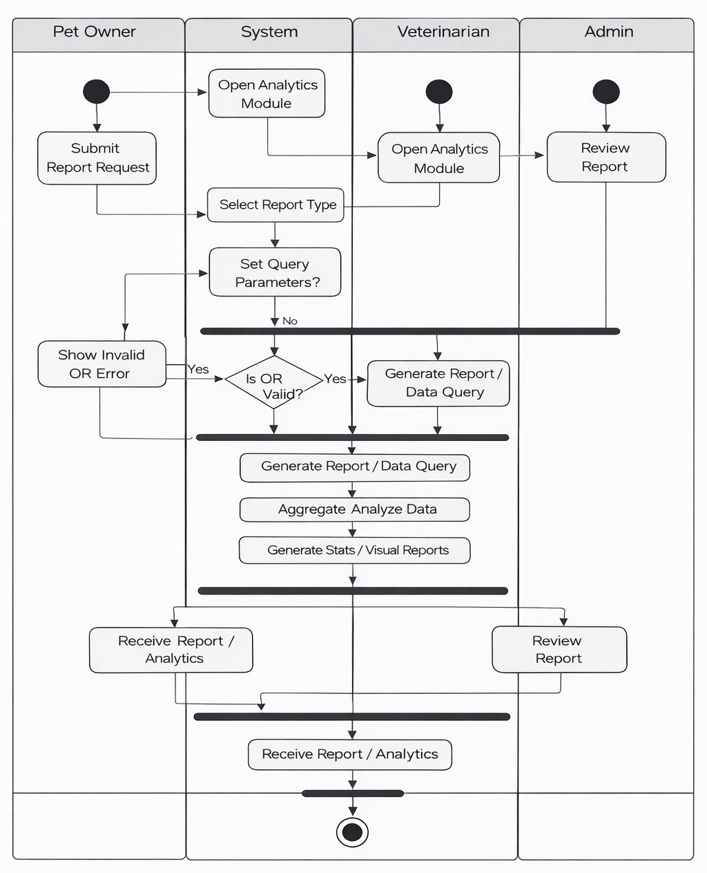
Figure 14. Activity Diagram for Analytics and Reporting

Admin/Staff Side Management Activity Diagram depicts the process through which authorized individuals use the system to manage the processes and activities in the system. In this activity, an individual logs into the system and navigates to the dashboard. It is vital to note that the administration aspect of the system is central in controlling and overseeing various processes including registration processes, data review, payment processing, and report generation [20], [32].

Upon logging into the system, one can navigate through various management processes in the system including reviewing data in the system, managing users or staff in the system, and report generation among others. This shows that the process through which administrators use the system goes beyond performing a single task since the administrator performs various tasks in the system. Depending on the chosen function within the system, the system facilitates the particular process while allowing only authorized processes [20], [32].

Another significant point about this diagram is that administrative actions do not occur automatically. Instead, the system evaluates and processes requests for modification of the records before they are officially implemented. Such a necessity is required because most managerial activities will directly impact either the database, the access rights of users, or reports generated by the system. Therefore, by including such actions like reviewing, editing, disabling, and updating, the activity diagram highlights that the system is capable of supporting operations management and governance processes. This type of model is typical of digital clinics where administrative control is required to ensure data integrity and operational stability [20], [31], [32].

Finally, it should be noted that the process includes functions related to report and analysis. These actions demonstrate how close the administrative component of the system is connected with monitoring and evaluation procedures. It is vital because the roles of Admin/Staff include not only the process of encoding and modifying records but also their analysis, which allows overseeing the operation of the clinic and its system [20], [24], [32].

In summary, it can be said that the activity diagram on the management side shows that the designed system offers a controlled process for conducting administration, maintaining records, and making use of reports. This will help meet the research goal of enhancing the efficiency of clinics via a controlled web-based application.[20], [24], [31], [32].

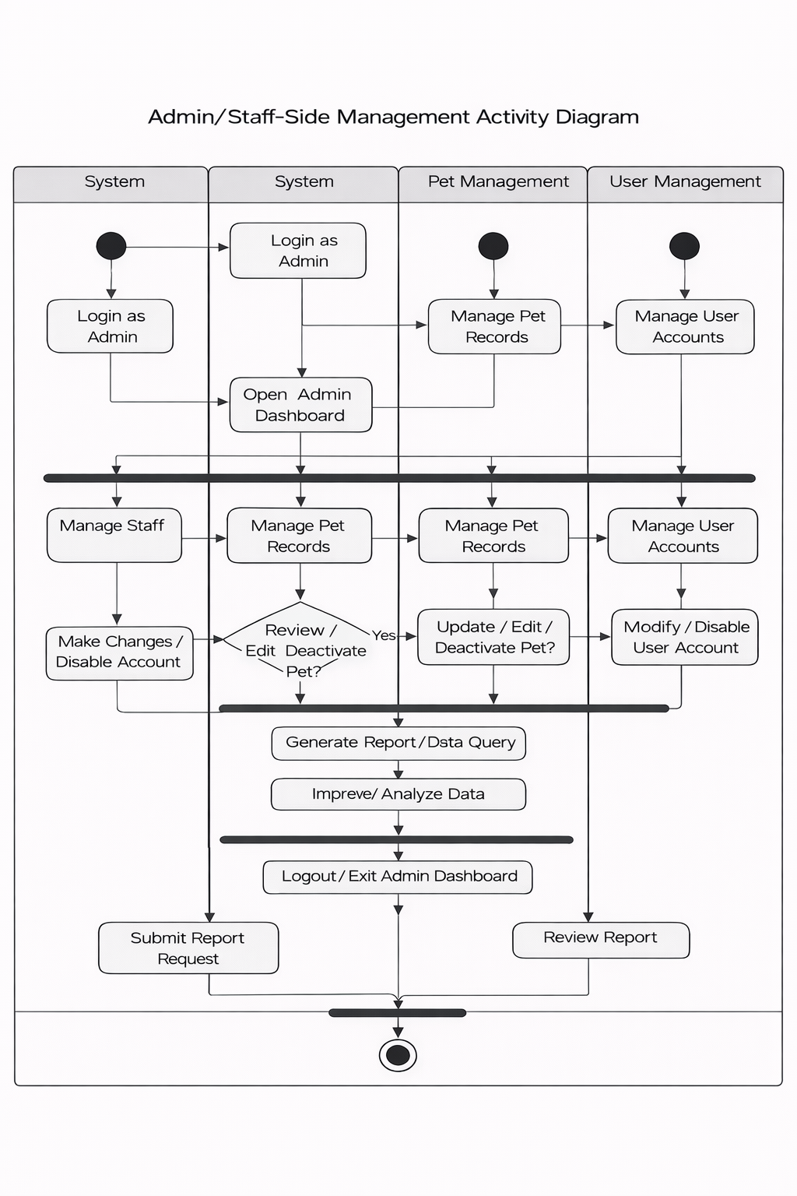

Figure 15. Activity Diagram for Admin / Staff-Side Management

The sequence diagram presents the interactions between the Pet Owner, Clinic Staff/Admin, Web System, Database, QR Code Generator, Treasury Record, and Veterinarian while carrying out the main functions in the proposed system such as pet registration, tracking payment by means of OR numbers, QR code creation, and updating the record of vaccinations. It is clear from the diagram that data will flow through different components of the system in a time-sequenced way for effective processing and record keeping.

The first thing that will happen is that the Pet Owner will submit the details of registration to the Clinic Staff/Admin. The staff will then encode all the submitted information into the Web System and store it in the database. After the completion of this step, there is a confirmation that the pet owner and pet records have been successfully stored into the database. The above process is a usual process followed in most of the online veterinary information systems, improving efficiency [28].

Next, the Clinic Staff/Admin enters the OR number for the payment process. After this, the Web System connects to the Treasury Record to verify the entered OR number. Upon receiving the validation result from the Treasury Record, the Web System validates the OR number of the payment. The validation step is important since it helps in avoiding discrepancies in payments by verifying the validity of payment information. It should be noted that contemporary research suggests that transaction validation mechanisms play an important role in digital payment system processes [29], [30].

Once the validation process has been completed successfully, the payment information gets stored in the Database, and the confirmation about successful storing is made. Further, the QR Code Generator module

activates, and a unique QR code for the respective registered animal is created along with its records. The generated QR code is provided back to the Web System and stored in the Database. This step helps in creating an identifier for the registered pets. Research shows that using QR code based identification methods increases the speed of retrieving records and makes it easy to manage records [30], [31].

Following the creation and storage of the QR code, the system notifies the user about the completion of the procedure together with the QR code, which is delivered to the Clinic Staff/Admin. This is followed by the delivery of the QR code to the Pet Owner. After the completion of the registration and payment process, the system stores the data in the database, linking the payment and identification data. In the second part, the Veterinarian uses the web system to access the records related to the pet. The Web System obtains the pet’s data from the Database and delivers the pet’s record to the user. The Veterinarian executes operations like updating the pet’s vaccination record, storing the updated data in the Database, confirming the update of the vaccination record, and delivering the updated record. This example shows how an integrated veterinary system allows for constant updating of pet records and effective delivery of services through real-time data access and manipulation [28], [31].

On the whole, the diagram illustrates an orderly process of work performed by the system being discussed, starting from user registration and payment verification all the way through QR code production and updating medical records of patients. The diagram emphasizes the combination of different elements of the system which guarantees the accuracy of data and transactions and the convenience of data search. Modern systems used in veterinary medicine follow similar principles of

work which include centralized processing of data, transaction verification, and updating of records [28]–[31].
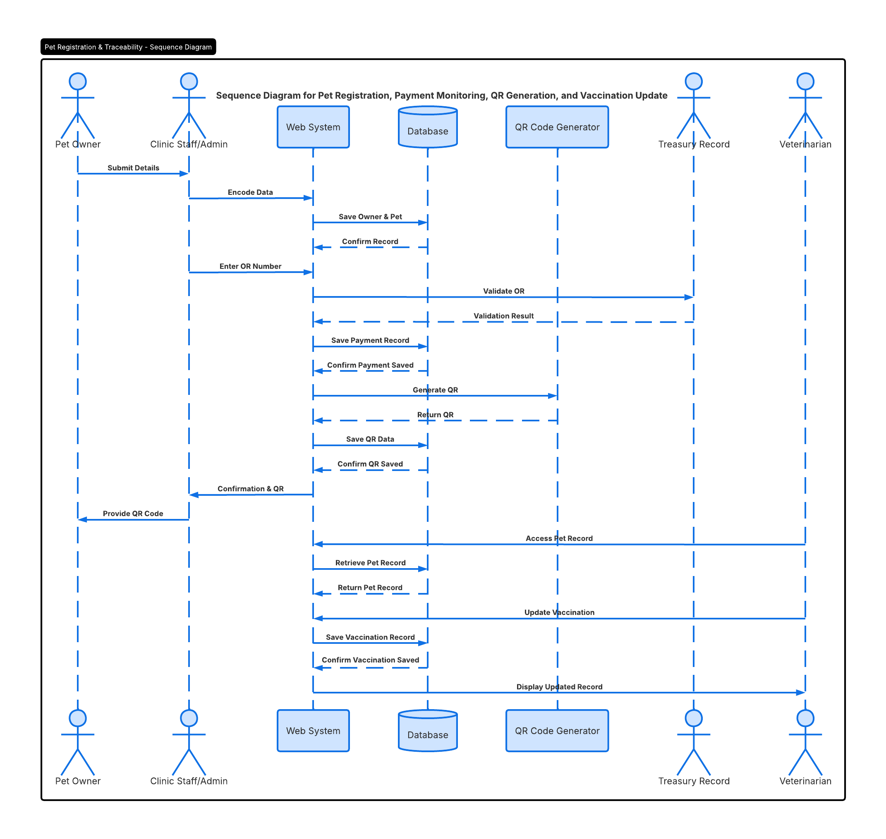

Figure 16. Sequence Diagram

Description of the System Architecture Diagram, the system architecture diagram below gives an overview of the design of the suggested Web-Based Pet Registration, Vaccination, and Traceability Management System with Payment Monitoring and Data Analytics. The proposed web application follows a three-layered architecture including the Presentation Layer, Application Layer, and Data Layer in order to ensure effective processing, data handling, and interaction with users.

Presentation Layer acts as a user interface of the system used by the various types of users such as the Pet Owner, Clinic Staff/Admin, and the Veterinarian in the platform. The web-based Presentation Layer offers a way for users to register, view, monitor payments, and obtain reports in the system. As observed, a web-based user interface enables easy access by users in modern veterinarian information systems aimed at improving the efficiency of service delivery [32].

The Application Layer functions as the processing engine for the entire system in which all the business logic is implemented. The Application Layer includes several modules, which include the Authentication Module, Registration Module, QR Traceability Module, Vaccination Monitoring Module, Payment Monitoring Module, Analytics and Reporting Module, and Offline Draft Registration Module. For example, the Registration Module is responsible for storing data about pets and owners, whereas the Payment Monitoring Module is in charge of logging OR numbers with their respective records. Also, the QR Traceability Module creates unique QR numbers that enable easy access to the information of pets. On the other hand, the Analytics and Reporting Module performs various analyses of the stored data. These features make the application a modular, maintainable, scalable, and efficient system, which are qualities of a modern information system on the Internet [33], [34].

The Data Layer constitutes the centralized repository of data, in which all the needed data will be kept safely and maintained properly. It includes such components as pet owner data, pet data, vaccine data, payment information, QR code information, analytics reports, and draft registrations. Centralized data management plays an extremely important role in modern information systems since it guarantees the high efficiency of data storage and retrieval while providing real-time updates and reducing the risk of data inconsistency and redundancy [33]–[35].

There exists a certain sequence in the communication between the specified layers. In particular, the Presentation Layer is in charge of collecting user input data and sending it further to the Application Layer, which interacts with the Data Layer and performs all necessary actions with it. Finally, the results of this process are transferred back to the Presentation Layer and provided to the user. Such a design makes it possible to achieve effective separation of concerns, thus allowing to keep separate the user interface, business logic, and data management layers [32]–[35].

System Architecture Diagram, from the above diagram, it can be concluded that the proposed system has been structured in a way such that its architecture allows for more than one functionality. These include functions like registration, payment tracking, QR code tracking, vaccine tracking, and analytics. All these components have been integrated within a system that increases efficiency, makes access to data easy, and facilitates better decision-making at the clinic. Such designs have become common place in current developments in the field of web-based information systems [32]-[35].

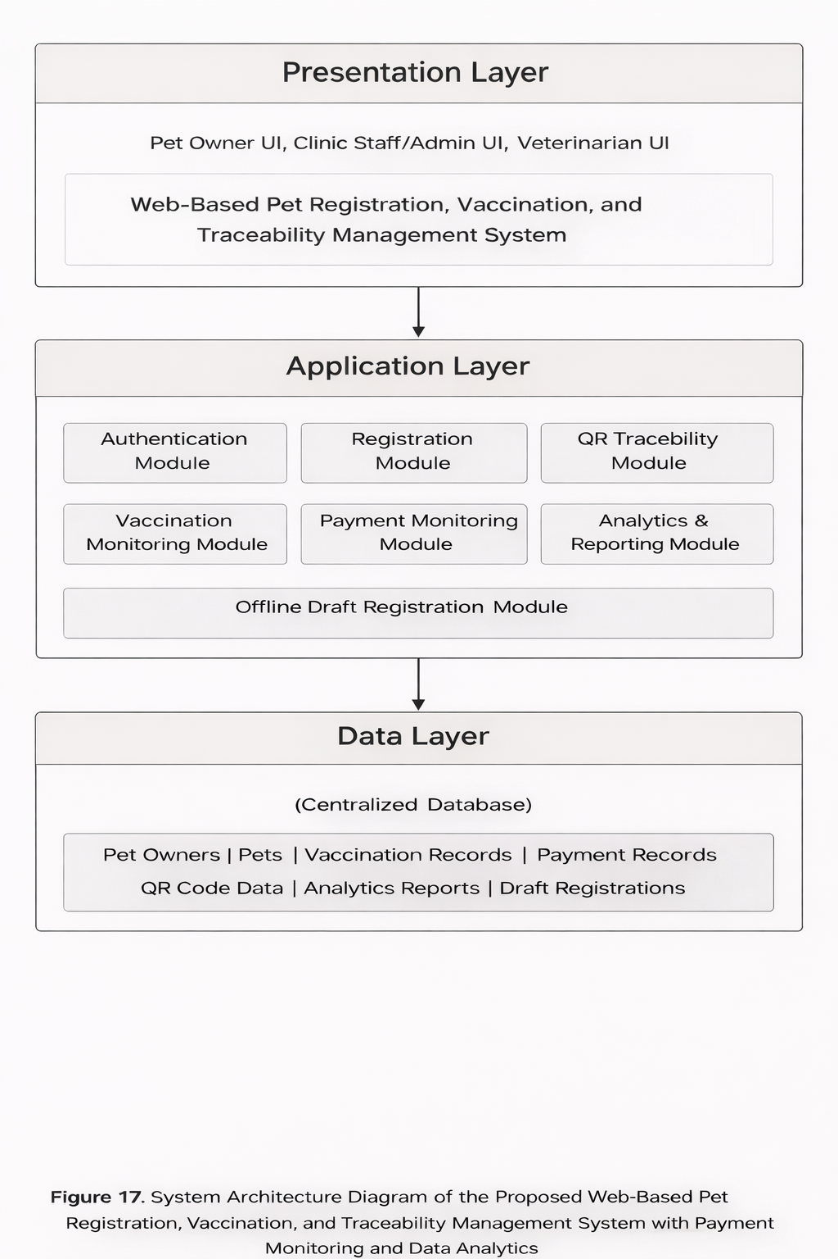

Figure 17. System Architecture Diagram

Data Flow Diagram Level 0 covers all the activities involved in the movement of data within the system, that is the Web Based Pet Registration Vaccination and Traceability Management System together with Payment Monitoring and Data Analytics System. This diagram represents the interaction between the system and the external entities.

In this figure, the system process is represented by one entity, referred to as the “Web-Based Pet Registration, Vaccination, and Traceability Management System.” The external entities that communicate with the system process include the Pet Owner, Clinic Staff/Administrator, Veterinarian, and Treasury. Data input from the Pet Owner includes the registration information and the registration information draft, both supplied using the Pet Owner or the Clinic Staff/Administrator entity.

The Treasury Department plays an important role in authenticating the transactions in terms of payments. Right away after inputting the OR number, the system will request OR Number Validation from the Treasury Department and the result will be transmitted back into the system. The use of a third-party validator is meant to emulate the practice of the real financial world, hence eliminating inconsistencies in data entry.

The system accesses numerous databases such as D1 Owner and Pet Data, D2 Vaccination Data, D3 Payments Data, D4 QR Codes Data, and D5 Reports/Analytics Data. This is where the centralized databases come into play, showing where all data for the system is stored. Users access data from these databases constantly as they work on the system [37], [38].

In the Level 0 DFD, the system is depicted as a whole system that comprises three different aspects of it, including user inputs, external

validation, and centralization of databases. The system demonstrates interaction of diverse elements within the process while keeping data at an advanced management level.

Figure 2: Level 1 Data Flow Diagram of the Proposed System
In the Level 1 DFD, the process in the Level 0 DFD has been further broken down into more processes, and their interactions have been depicted in greater detail to show how the data flows in the system under certain actions.

Firstly, the 1.0 Process of Managing the Registration Process deals with the registration process wherein the Pet Owner supplies the information for the pets' registration in the system. The information supplied by the Pet Owner will then be encoded into the system and stored in D1 Owner & Pet Records.

The second process, the 2.0 Process of Managing the Payment Monitoring Process, deals with collecting the data pertaining to payments. The Clinic Staff/Admin will supply the OR Number for the payment to be verified by the system. The verified payment information will be stored in D3 Payment Records. The vaccine or registration information could also be updated in D2 Vaccination Records.

Process number three, 3.0 Generate and Retrieve QR Code, involves generating and managing the QR code identification of pets. After successful registration and payments, the system will generate the QR code of the pet records that will be stored in D4 QR Code Records. This QR code can be retrieved anytime, facilitating the speedy retrieval of information related to the pet. Modern-day technologies commonly use QR

codes for identification because of the increased traceability and convenience in accessing data [38], [39].

The fourth process, 4.0 Generate Reports and Analytics, deals with the analysis of the stored data into useful reports and statistics. This process pulls the data from different data repositories such as registration, vaccination, and payment details, and outputs the data as summary reports and analytics. These findings will then be saved in the database, D5 Reports and Analytics Data, which is accessible to Clinic Staff/Admin or any other user. This helps in making sound decisions regarding the operations and activities within the system [39], [40].

Moreover, the system also has the D6 Draft Registration Records, which consist of partial or interim registration records created by the users. The purpose of this process is to make sure that there will be no loss of data, and that these data may be completed at some other time.

In summary, Level 1 DFD gives an illustration of how the system breaks down complicated operations into smaller processes that handle different tasks within the system. It shows how data moves from one process to another and then to data stores and external entities. The process also illustrates the best practice on designing information systems, whereby the system is composed of modules of processes and data flows [36]-[40].

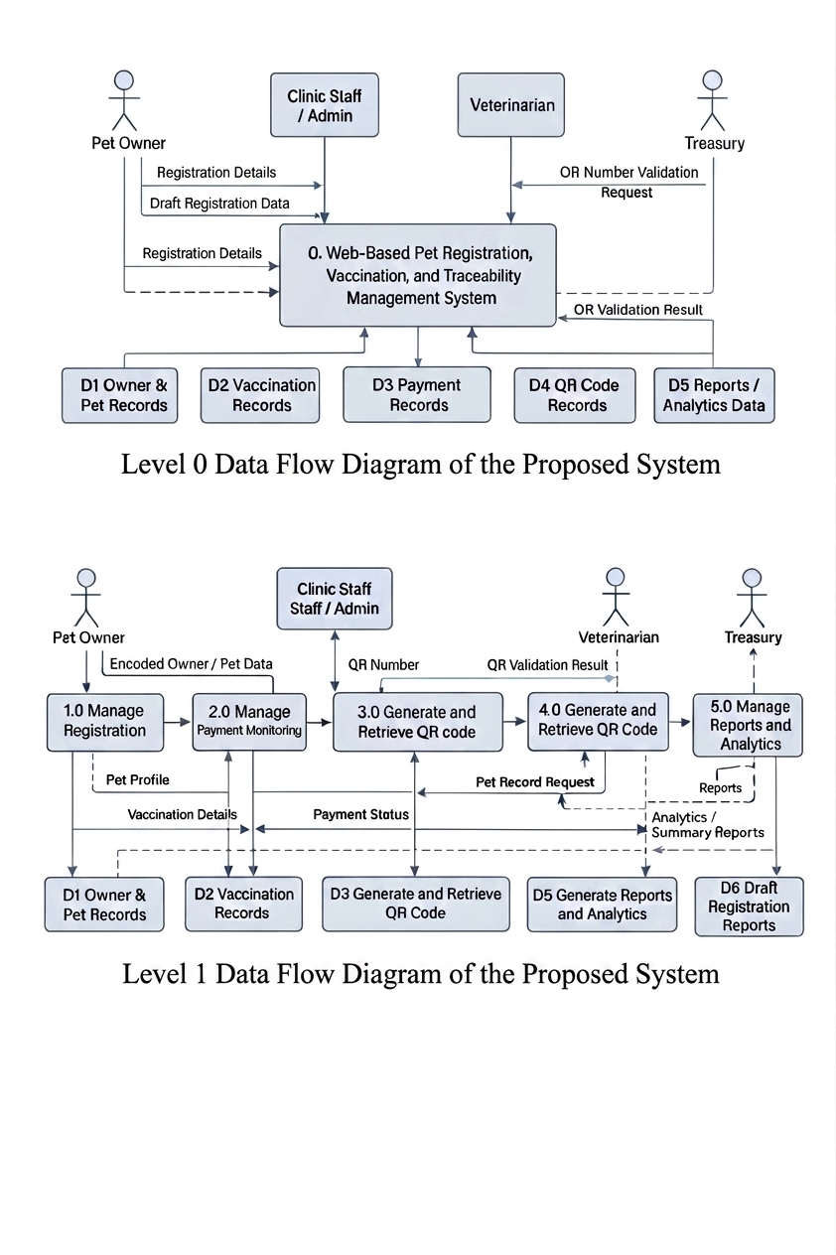

Figure 18. Data Flow Diagram

The Entity Relationship Diagram (ERD) for the Web-Based Pet Registration, Vaccination, and Traceability Management System with Payment Monitoring and Data Analytics shows how the database system of the proposed system will be organized. It reveals the relationship among the main entities involved in order to facilitate the process of pet registration, vaccination, payment monitoring, QR traceability, consultation, prescription management, and reporting. For any information system involving data management using a database, having a good ERD is crucial since this makes sure that the records are stored logically and interconnected, hence making data retrieval easier [20], [32].
At the heart of the schema lie the entities of pet_owners, pets, and users, as these comprise all the vital data that would help run the clinic. The pet_owners entity contains the data on pet owners' identification details and contact information, whereas the pets entity holds all the profiles of registered pets, i.e., pet code, animal species, breed, gender, color, birthday, registration date, and status. There is a one-to-many relationship between these two entities since one pet owner can register several animals, but one pet is always registered to only one owner. In other words, the structure corresponds to the logic of real registration process in veterinary clinics [20],[33].

In contrast, the users entity houses accounts used for system login purposes, whereas the roles entity determines the user’s role or level of access, such as Admin, Staff, or Veterinarian. This is important for ensuring the implementation of role-based access and operations in the system [33].

To facilitate proper animal categorization in the system, the pets entity will also be tied to the species and breeds entities. Consequently, each pet will be associated with a pre-defined species and breed instead

of having the information provided via a free-text field. This not only ensures the accuracy of the data entered but also enables easier generation of reports related to pet classifications. The implementation of structured reference tables that include species and breeds information serves as a standard method used in relational databases because it decreases data duplication while enhancing data protection [20], [35].

In regards to the administration of vaccines, the ERD will consist of the two entities, namely vaccines and vaccination_records. The vaccines entity will have information related to the list of available vaccines such as the vaccine’s name, manufacturer, and the recommended interval between two doses of the same. On the other hand, the vaccination_records entity will have records regarding the administration of the vaccines to pets. In this way, the relationship established will be such that one pet can have many vaccination records but only one vaccine will be recorded in relation to each record. This will enable tracking of the date of administration, next date, status, and any other comments on each pet’s vaccinations.

In addition, the proposed database model can provide support for clinical care documentation using the consultation_records, prescriptions, prescription_items, and medicines entities. The consultation_records entity is used to store the diagnosis, treatment plan, consultation date, and follow-up date for each consultation of the pets. On the other hand, the prescriptions entity is used to keep track of the prescriptions made at that particular time. The prescription can have several medicines in it and these are stored in the prescription_items entity along with the quantity, dosage, frequency, duration, and instructions. These items are then referenced in the medicines entity that keeps track of all medicines present in the system.

Another notable attribute of the research project is payment tracking with the use of OR numbers issued by the treasury, which can be seen in the ERD with the payments and payment_types tables. The payments table will have fields including the ID of the pet owner, pet ID, payment type, official receipt number, payment amount, payment date, payment status, validation status, and creation date. In such a way, each payment transaction will be associated with the pet owner and the pet being registered or serviced. The payment_types table will define the types of payments available and the default amount for each. Such design makes payment tracking possible, especially since such systems are usually dependent on external validation of OR numbers [22], [23].
For the traceability of QR, the ERD involves an entity called “qr_codes,” which is directly connected with the entity called “pets.” A record of each QR code includes the QR token, image path, issue date, status, and the time of creation. As a QR code is always linked with the respective pet, the information related to the pet can be retrieved through the process of scanning the QR code. This is one of the main goals of the study that can be achieved with the help of QR codes.

This database also contains the entity draft_registrations for making registration offline-capable. The fields include temp_reg_info, device_id, payload, sync_state, sync_date, and create_date. This makes it possible to first save registration data as draft and then synchronize it after restoring connection with the main system. It is relevant to consider the inclusion of this entity in the ERD since the current research is particularly intended for capturing temporary offline data in case of network interruptions. Drafting data into the system separately from completed information will make it possible to retain data consistency and ensure the continuity of services [20],

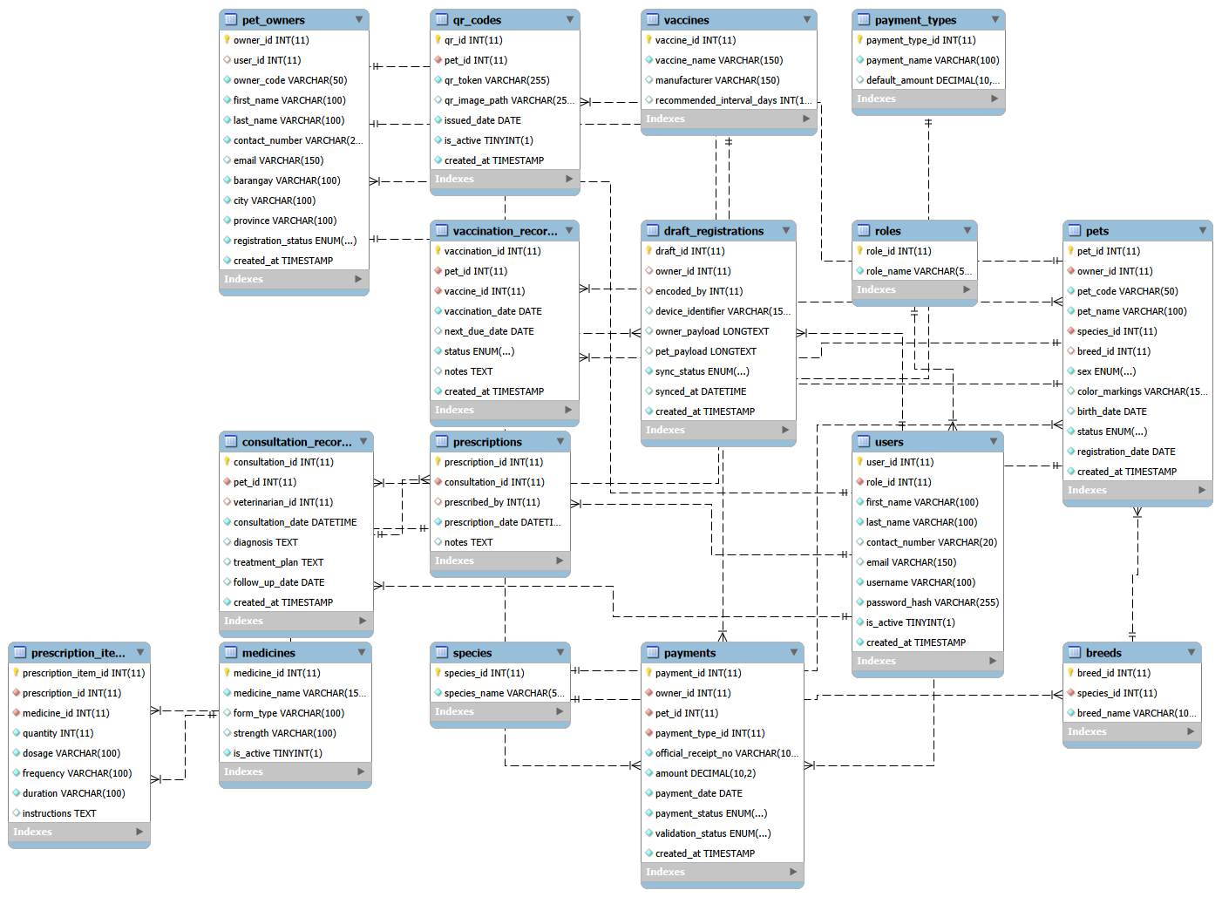
All in all, based on the ERD, it can be seen that the database at hand is relational and integrated since all major components and functions of the database are related through their proper association via the use of entities. Thus, owner records, pet profiles, vaccination histories, consultations, prescriptions, payment transactions, QR codes, and analytical data are interconnected rather than stored separately from one another, which helps facilitate data extraction, tracking, and analysis. The system operates like contemporary veterinary databases which maintain all records in one location to support their decision-making processes as demonstrated in studies [20] [24] [31] [33].

Figure 19. Entity Relationship Diagram

UI/UX Wireframe Proposed Design

Analytics and Reports Page provides an overview of the information contained in the system in order to assist in monitoring and decision making. It contains indicators such as the total number of registered pets, valid registrations, outstanding vaccinations, and outstanding payments. This will enable one to analyze the general status of the system.
There are also graphs which provide an overview of how many pets there are depending on their sex, whether they are vaccinated, whether they have paid and whether their registration is valid. This will help in analyzing the information without going through each pet record individually.
Furthermore, the generated reports section provides information which is useful for report generation purposes. This page helps in enhancing the system since the stored data will be transformed to useful information which assists in decision-making.

The homepage of the proposed Web-Based Pet Registration, Vaccination, and Traceability Management System with Payment Monitoring and Data Analytics is actually considered as the primary landing page of the whole system. The design of the homepage is intended to introduce the system itself, through providing information about the system name, its purpose, and primary services offered. Users can locate some of the important functions of the website, such as Registration, Vaccination, QR Records, and Analytics, due to the presence of the visible navigation bar.

In the middle part of the homepage, the primary function of the system is made evident, particularly in the form of the main heading that says: "Web-Based QR-based Pet Registration for City Vet Cabuyao." Below the title, users will find the short description of the scope of services provided in the site, namely, pet owner and pet registration, QR registration, vaccination, clinical and medicines record keeping, payments monitoring based on OR number, traceability, and analytics. Thus, it is clear that the system does not provide just one service, but several ones instead.

Another significant component of the homepage is the introduction of three portals, including Pet Owner Portal, Clinic Staff Portal, and Admin Portal. There is a description of each feature offered within each portal. This allows users to identify the user role they play within the system and know what actions they can take within the platform. Due to that, the homepage performs two roles – it works as an introduction page as well as a guide page.

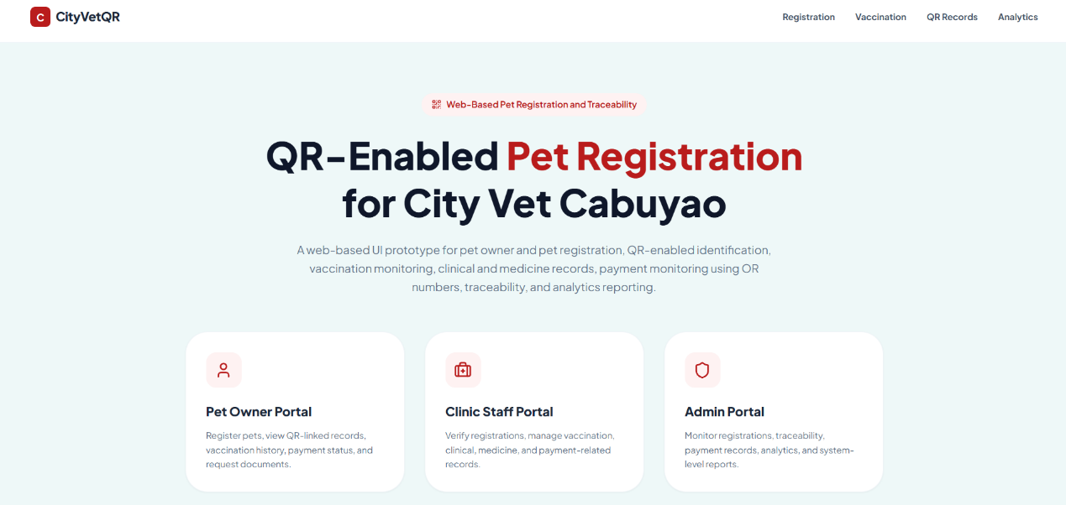
Figure 20. Homepage

The Pet Owner Login Page will be used by the registered users as the gateway to the system. It is designed to assist registered users in gaining entry into the system through the process of keying in their credentials, i.e. their email address and passwords, to allow them access to the personal dashboard of the system. Two major elements are included in this particular webpage; the first is a nice-looking graphic that introduces the objectives of the system, while the second is the login area that enables users to perform this task.

This login element is very easy to use as it contains the input boxes for users to enter their credentials and a button for signing in. There are also other buttons that will assist users in navigating on the site such as "Back to Home" and "Create an account".

The design of this page is meant to create a user-friendly interface to both first-time and existing users. It features an attractive layout that will encourage first-time users to register themselves on the system.

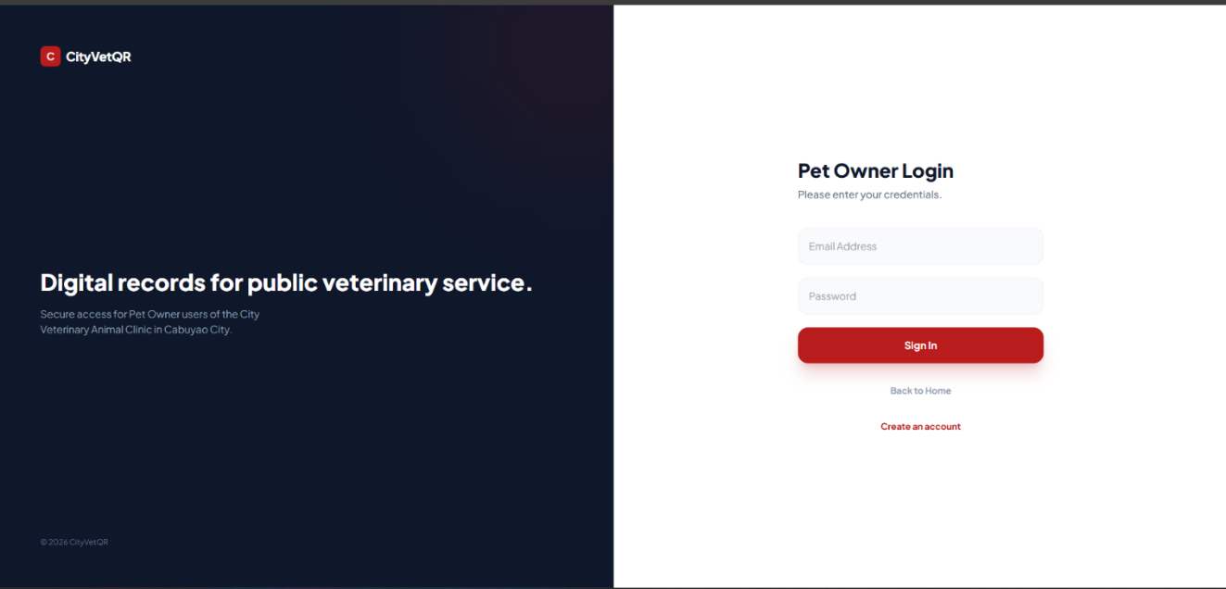
Figure 21. Pet Owner Login

Pet Owner Dashboard provides the primary platform on which the users are able to keep themselves updated about the information regarding their pets. Once the user logs in, they will see the welcome message, as well as summaries of essential data, such as the number of pets registered, verified records, vaccinations required, and unpaid bills.

On the left-hand side, the navigation panel is included, and it helps the user go through different sections, such as Pet Registration, Draft Registration, My Pets, QR Records, Vaccine history, Clinical and Medication, Payment, and Request Records. In this way, the user is able to access different functions within the application easily.

The central section of the Pet Owner Dashboard contains action cards that help users take the necessary steps, including Pet Registration, Draft Registration, and Request Record Cards. Moreover, there is a Recent Pet Summary Table in which the user can find all the significant information

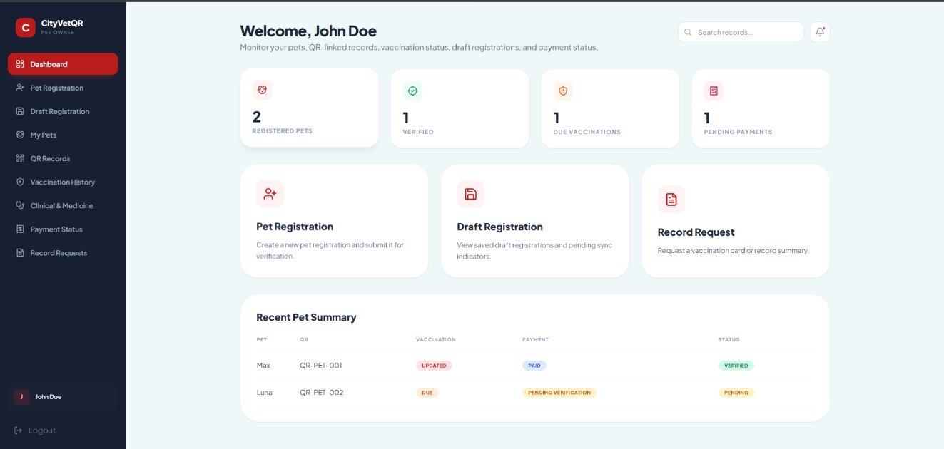
about his or her pet, including QR Codes, Vaccinated, Paid, and Verified Statuses.
Figure 22. Pet Owner Dashboard

Pet Registration Page: This form aims to help pet owners enter the details regarding their pets so that their details could be registered at the clinic through this platform. Fields for entering names, species, breeds, sexes, ages, colors, or markings of pets are included in this form for capturing all the required details in an orderly fashion.

Draft/Submit functionality is one of the most valuable features that can be seen on the Pet Registration Page. The feature allows users to either create drafts for further editing or send their completed entry into the system for further processing. It should be mentioned that indicators like offline draft and pending sync inform users about the status of the entry in case of internet problems.

Finally, it should be noted that the Registration Flow section on the right side helps users learn more about the procedure, including the creation of a QR code and connecting of payment and medical details with pet profiles.
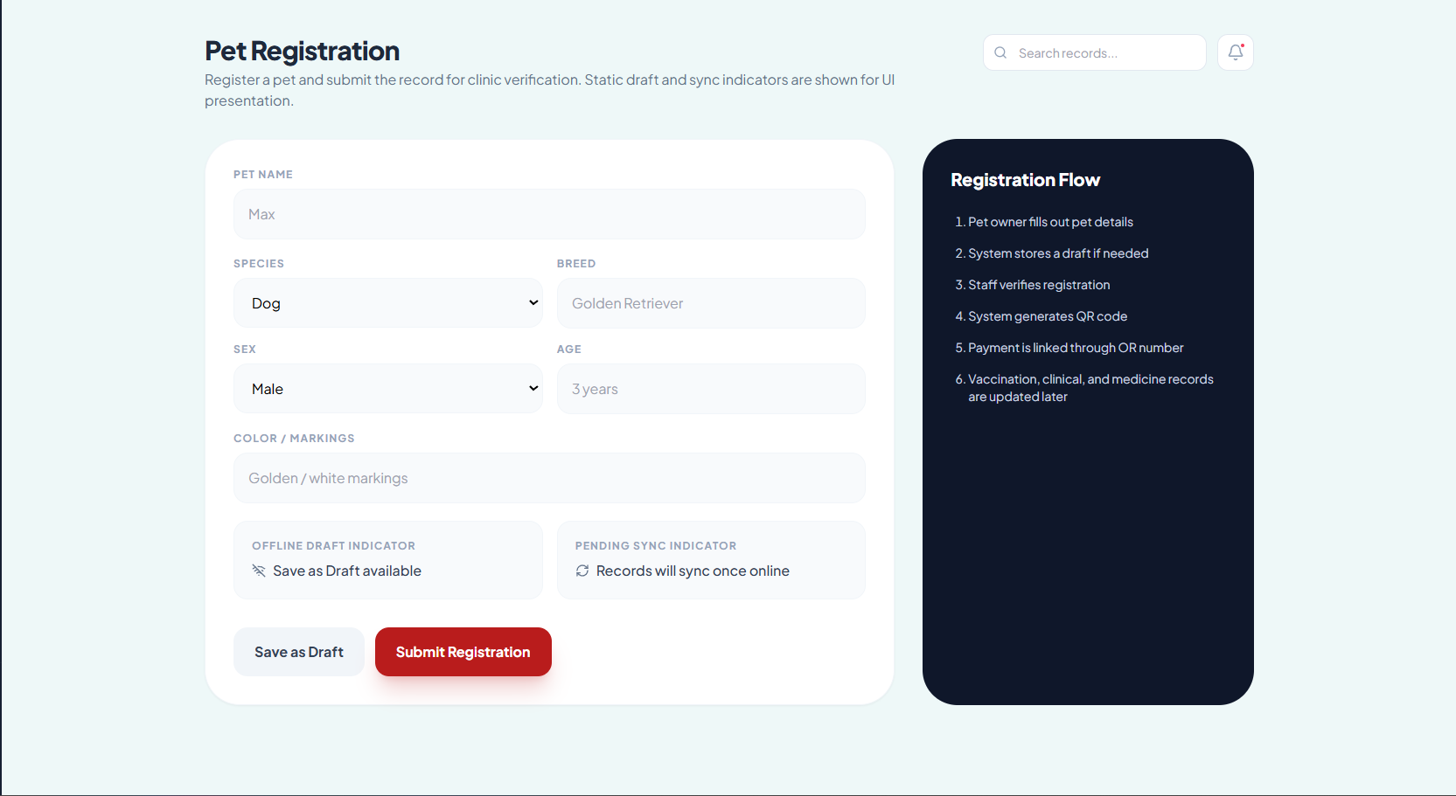

Figure 23. Pet Registration

Draft Registration Page offers the facility to users to check and manage their registered pets' data before actually submitting them. The main purpose behind having this page is that some users might want to save their entries but do not complete the registration process at one go. Therefore, using the Draft Registration Page, they will be able to see the list of all their entries using parameters like draft ID, pet name, date when entry was saved, and its status.

The statuses of all drafts are shown with labels such as Draft or Pending Verification. Users can use these labels to distinguish between unfinished drafts and ones which have been submitted. This makes it easier for them to identify their submissions.

Moreover, Sync Drafts will help those entries which have been saved off-line. This way, once the user gets an Internet connection, he/she will be able to sync his/her entries successfully.
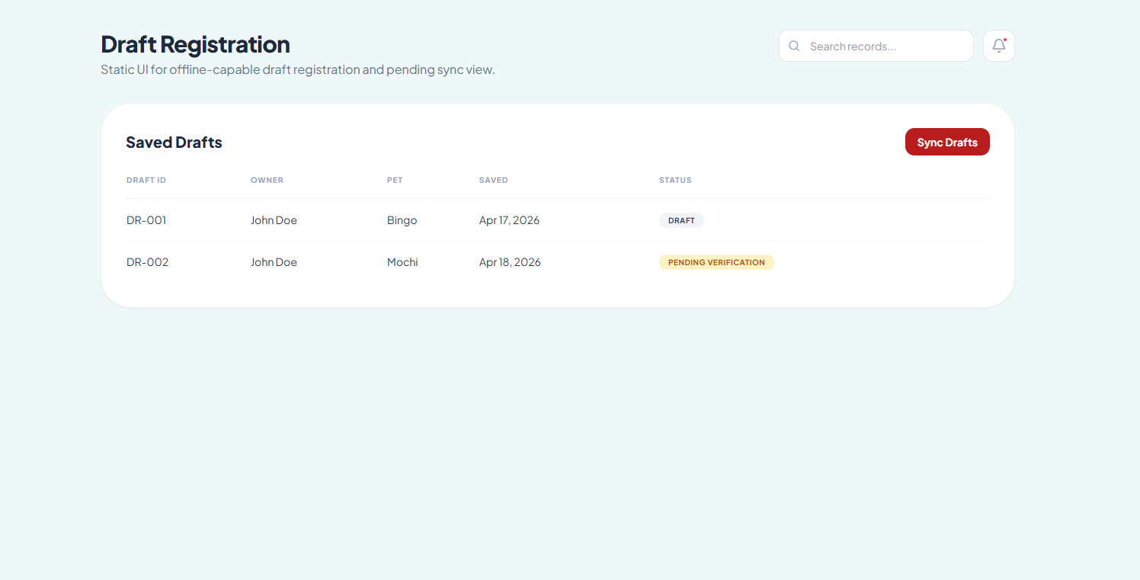
Figure 24. Draft Registration
With the help of the My Pets Page, pet owners will be able to see all their pets and the related records they have made. The data is provided in a card form and shows the pet’s name, type, breed, age, and status. This feature makes it simple to identify and distinguish one pet from another.

In addition to these features, each card presents other data about the pet, including the QR Code that was given, vaccine, payment, and clinical

records’ status. This information gives an insight into what the status of the record is in order to check for any pending changes.

Moreover, there are action buttons that can take users to different pages. With the QR Record and Records buttons, one can explore further into the records and learn more about their pets.
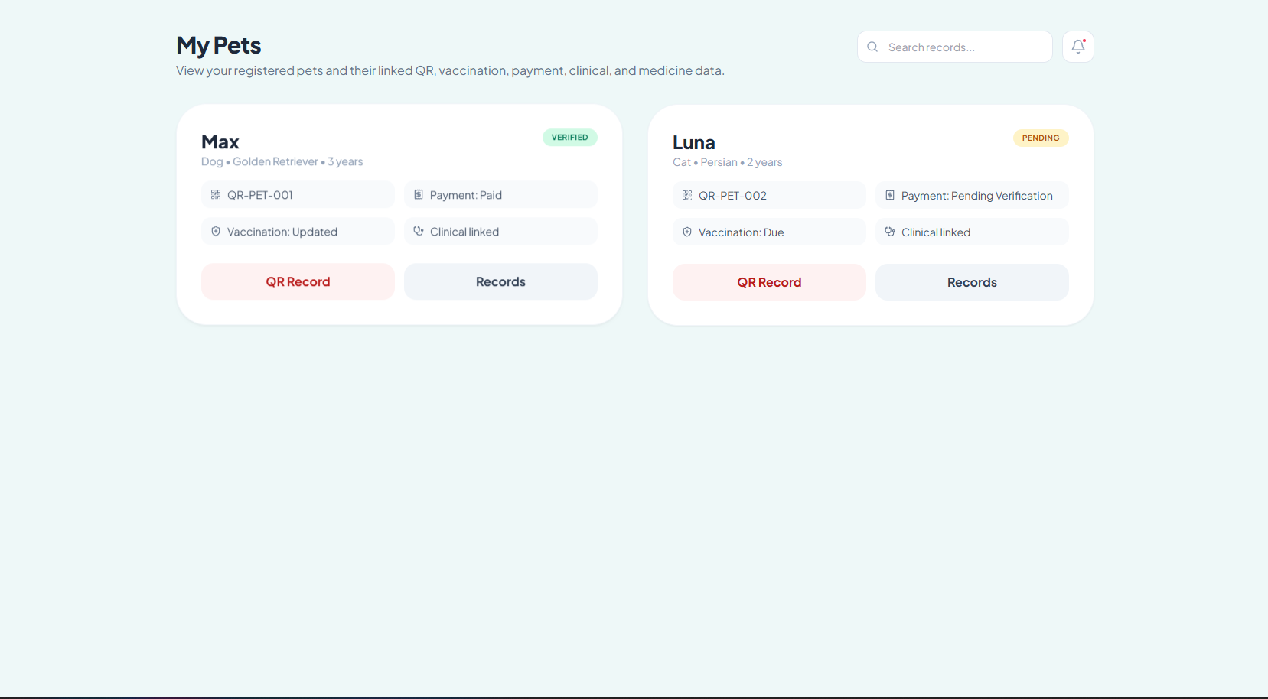
Figure 25. My Pets

Under the QR Record Page section, a pet owner can be able to see all the QR codes associated with the individual pet accounts that the owner might have on the system. The pets’ names, their QR codes, as well as their statuses, either pending or verified, are indicated under the pet section. By this, it becomes easy to tell whether the QR linked to a particular pet has been generated or not.

The QR code seen in the individual cards is the digital identity of the pet and links to some useful aspects such as the pet's profile, vaccinations, payments, as well as its clinical and medical records. These records allow

easy access to any information concerning the particular pet.
Other useful information such as the current stage of registering the pets' QR record is indicated here. Action buttons such as Download QR and Print QR are very useful in generating a physical copy of the QR.
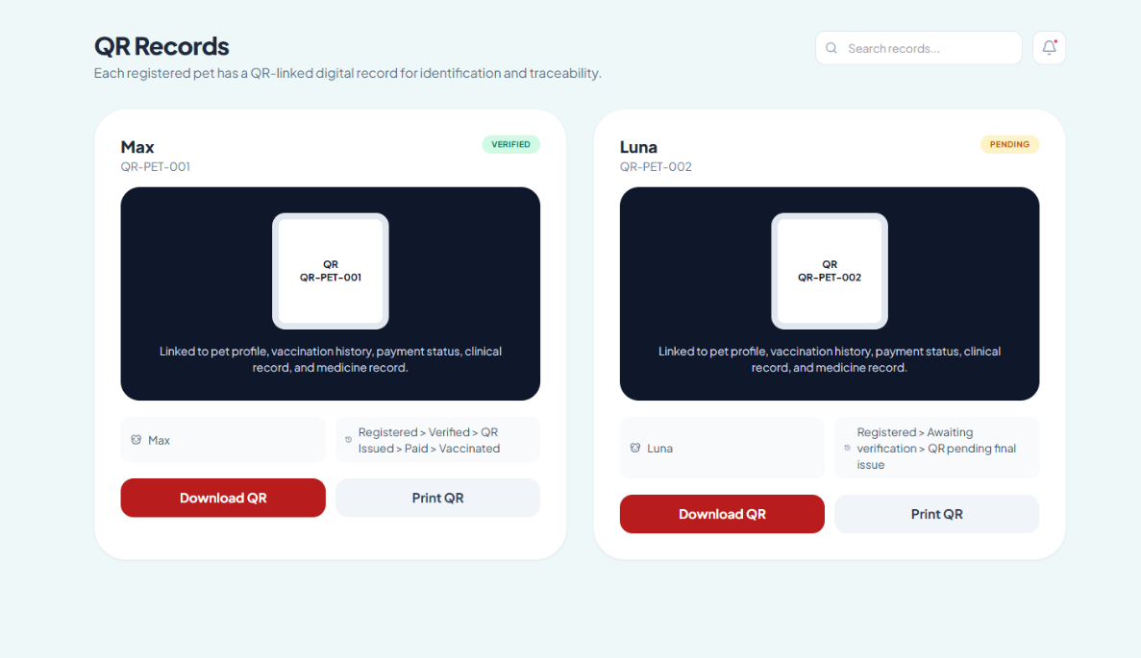

Figure 26. QR Records

The Vaccination History Page enables the registered pet owner to keep track of their pet’s vaccine status. It gives a presentation of each pet, its current status, the last update date and the next due. In doing so, it is easier for users to tell whether their pet has its vaccinations up-to-date or not.

In each pet, the page gives a clear status of the pet using terms such as Updated or Due. Using these status messages, a user can tell which pet

needs vaccination. For instance, a user will be able to distinguish pets that are currently due or updated without much trouble since the statuses are clear and visible.

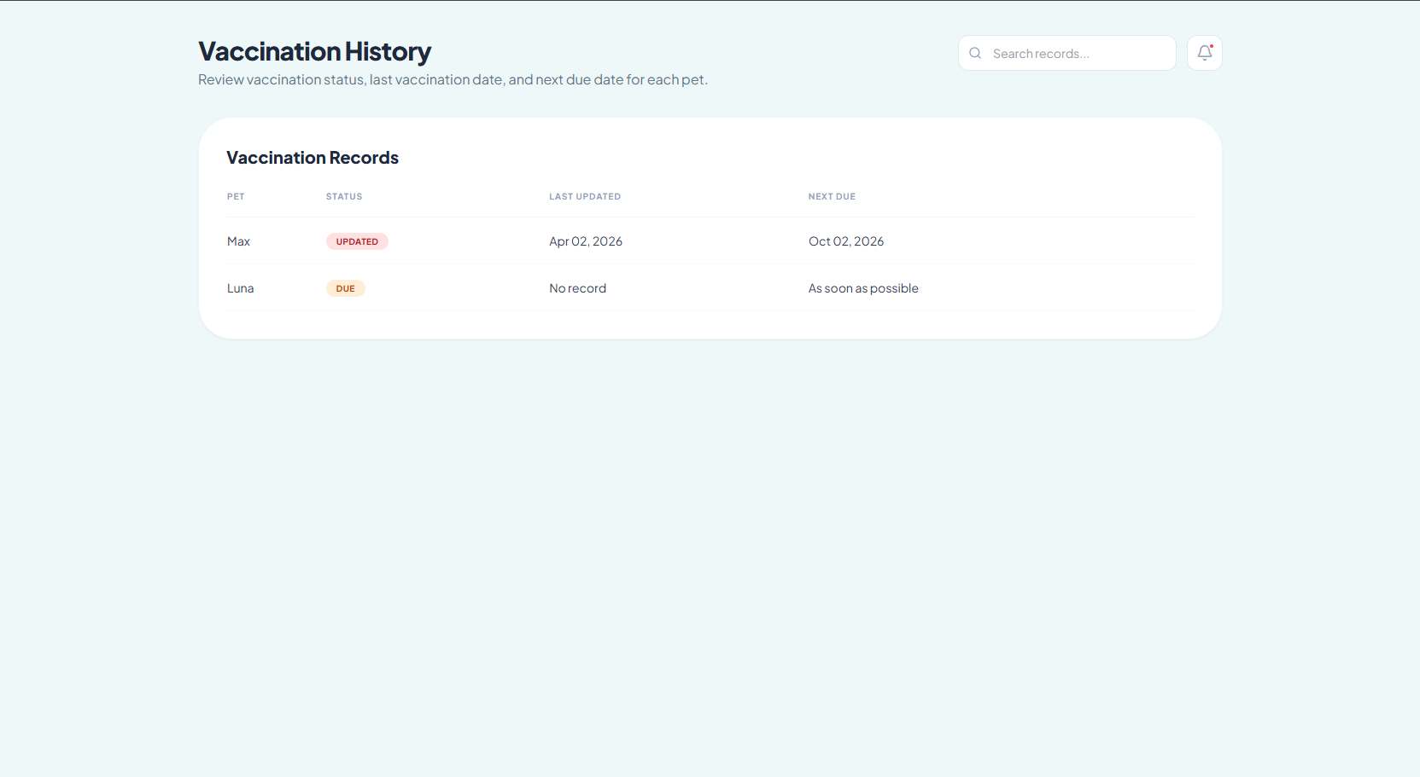
The page clearly indicates some key dates such as the next due date and other critical details about each vaccination including "As soon as possible". This way, the page enables users to plan ahead and make necessary decisions based on the given information.

Figure 27. Vaccination History

Clinical and Medicine Records Page allows registered users to have access to their pets’ clinical and medicine records. This information is presented in a very easy way by presenting them in tables that show all the necessary details about each pet, along with their clinical information and medicines. In other words, registered users can see the relevant health information in one place.

This page includes detailed information about the treatment of the pets, either for a diagnosis or a follow-up session. This might include the medications and the time required for it. Consequently, users will be informed about the kind of treatment given to their pets.

In case there are no records for a particular pet, users will be notified of the fact that there are no clinical and medicine records for their pet. This will prevent any kind of misunderstandings on behalf of users regarding their pets.

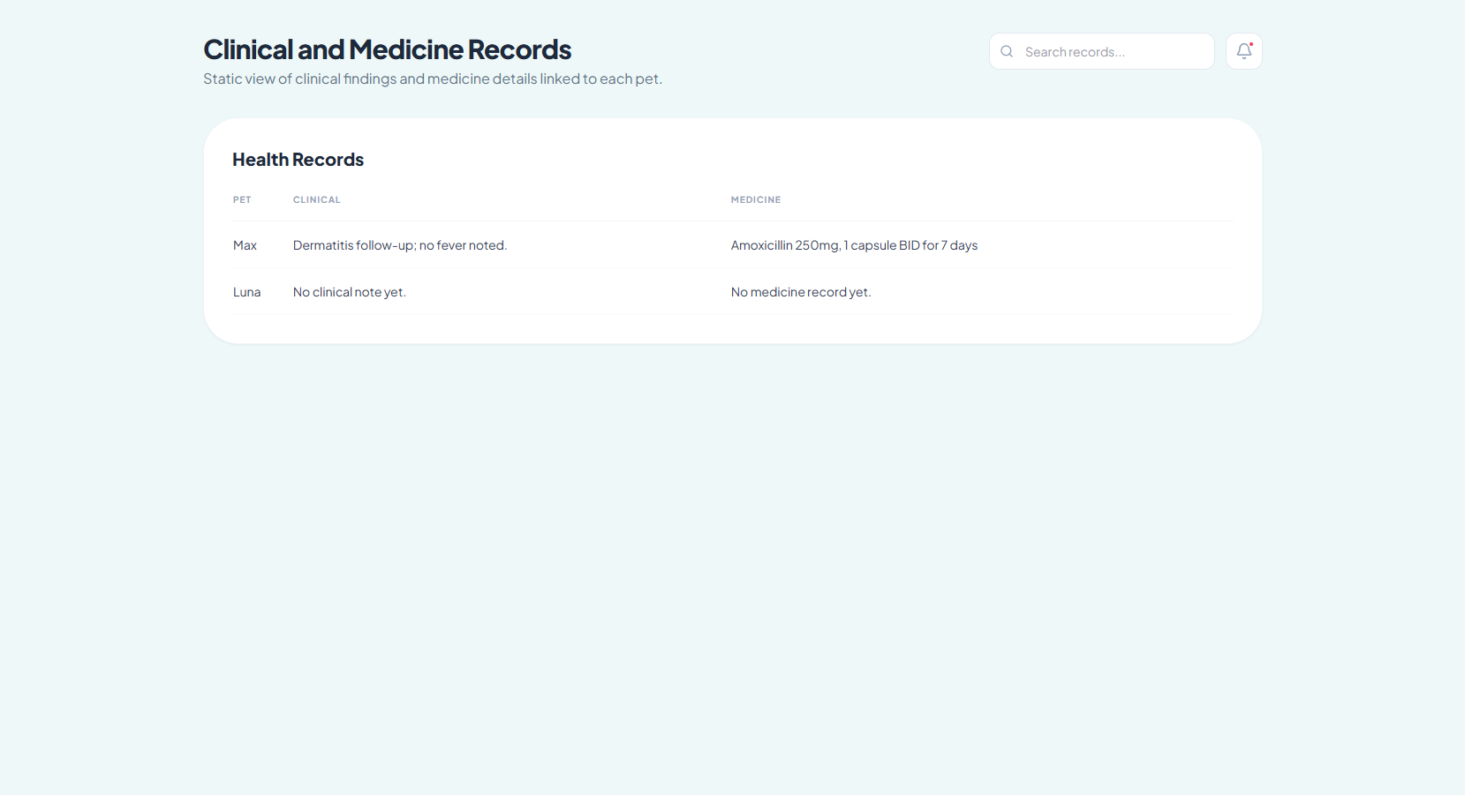

Figure 28. Clinical and Medicine Records

The Payment Status Page allows the pet owner to view and confirm the payment history linked to his/her registered pet. The payment history is listed in a tabular form indicating the name of the pet, OR number (official receipt), payment status, and other notes. The payment status could be either Paid or Pending Verification.

By checking the status of the payment, the pet owner will know whether he/she needs to make another payment or whether the transaction was already completed and verified by the clinic. Notes like "verified by clinic staff" and "pending verification" can help explain the status of the payment history.

In cases wherein there is no OR number found in the payment record, it serves as a reminder for the user to perform the needed action to link the payment with the OR.

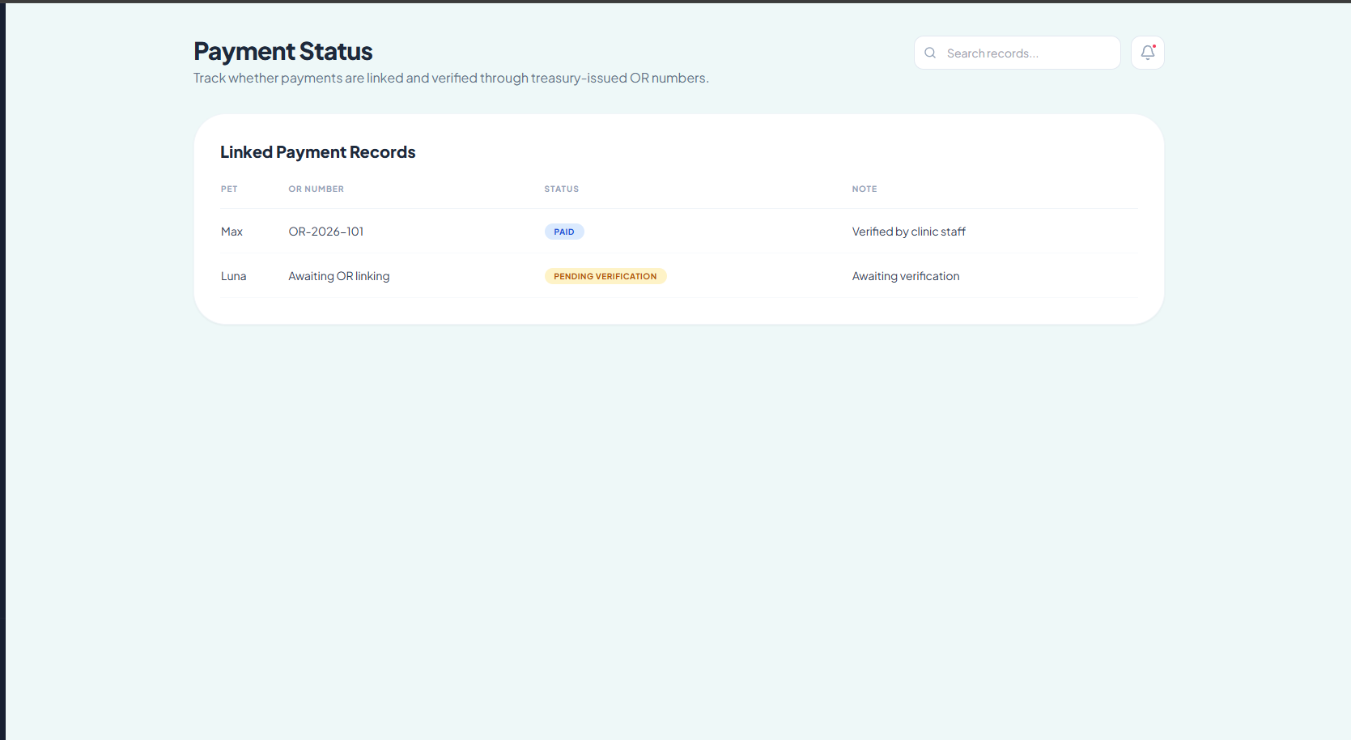
Figure 29. Payment Status

The Record Requests Page allows pet owners to send in a request for any official document concerning their pets. The form gives users an opportunity to specify the pet for which the documents are required, the kind of request, the purpose, and the format of the document. Using the information provided, users get well-prepared and organized requests.
An explanation of the request-based issuance system informs users that the system uses a request-based document issuance system, which means that the documents will be issued based on the request by the user. In other words, the system does not print unnecessary documents, making record management easier for all the users.

On the bottom left side of the page, there is an option called "My Requests," which shows users a summary of their previous requests alongside the information of each individual request. Information such as request number, pet name, purpose, and status of the request is clearly shown.

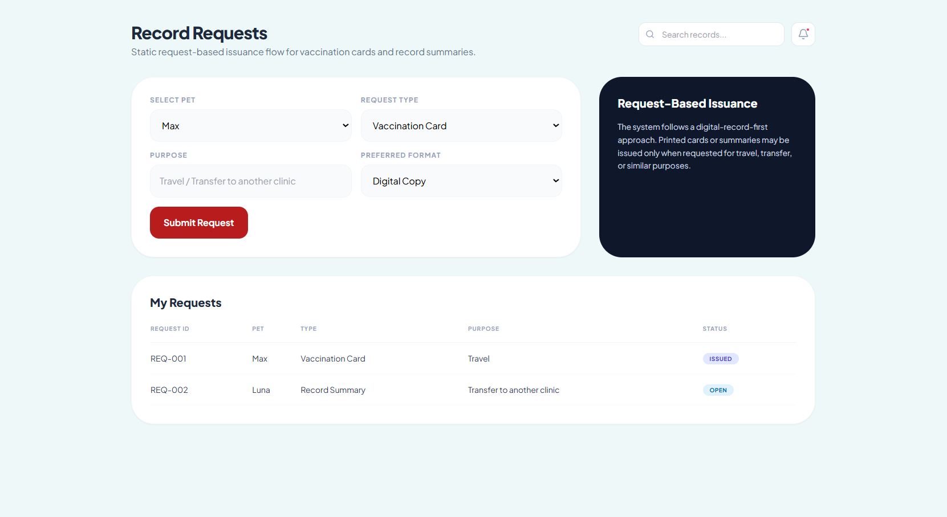
Figure 30. Record Request

The Clinic Staff Login Page acts as the access portal that allows legitimate staff members to log in to the system. It provides a space where staff can key in their email addresses and passwords to enable them to

gain access to the functions of the system in terms of registration confirmation, vaccine administration, clinic files, and payments.
It comprises two main sections, which include an illustrative presentation on the left side explaining the importance of the system in handling digital veterinary records and the login box on the right side. The latter section is purposely designed to make the authentication process easier for users. For example, it includes clearly labeled spaces where users can type their emails and passwords and a Sign In button.
In addition, there is a feature called “Back to Home” that allows users to navigate easily back to the home page if necessary.
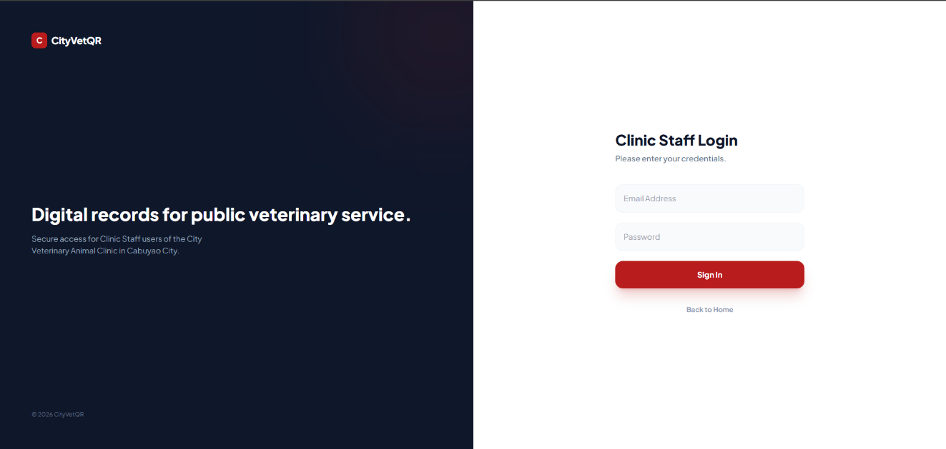

Figure 31. Clinic Staff Log In

The Staff Dashboard will be the primary hub for tracking and managing the system operation. The system will have summary cards showing pending tasks like registration, vaccination, payments, and request for records. This will ensure that the clinic personnel can track all these activities and ensure timely actions on their behalf.

Under the overview card, the Quick Access Card will be available for the clinic personnel to perform other vital functions. The Quick Access Card will include functions such as verification of pet registrations, vaccinations, payments, and issuance of requested documents. Each task will have a brief description for easy identification by the personnel.

The dashboard will facilitate the efficiency of work by integrating monitoring and performance into one interface. This will make it convenient for the personnel to monitor the system's performance and take necessary actions.
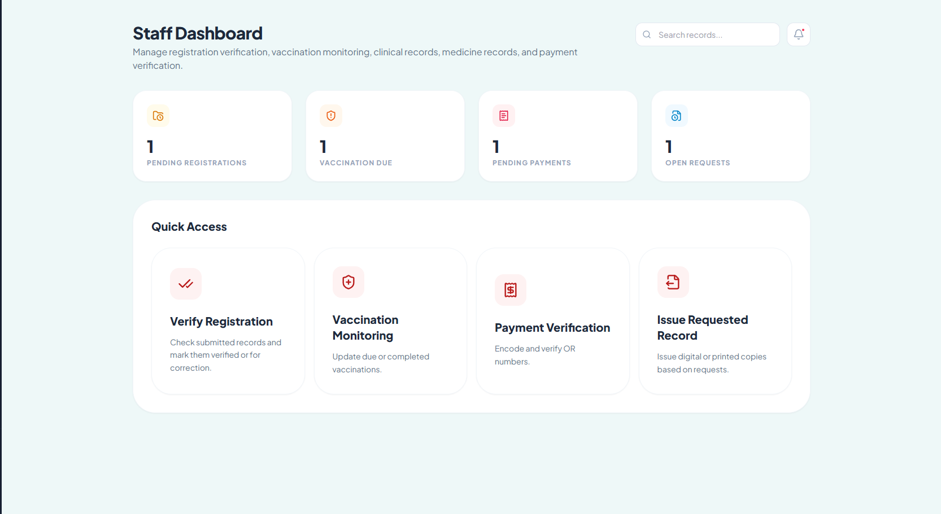

Figure 32. Staff Dashboard

Pet Records page represents a consolidated list of pets registered in the system. Clinic personnel can view all records, filter them, search for any particular pet as well as its owner and breed.

The table includes vital pieces of information like Pet ID, Pet Name, Owner, Breed, Status, etc., helping to understand the situation with each record at a glance. Status is an important indicator showing if the particular record has already been verified by the clinic personnel or needs to be processed further.

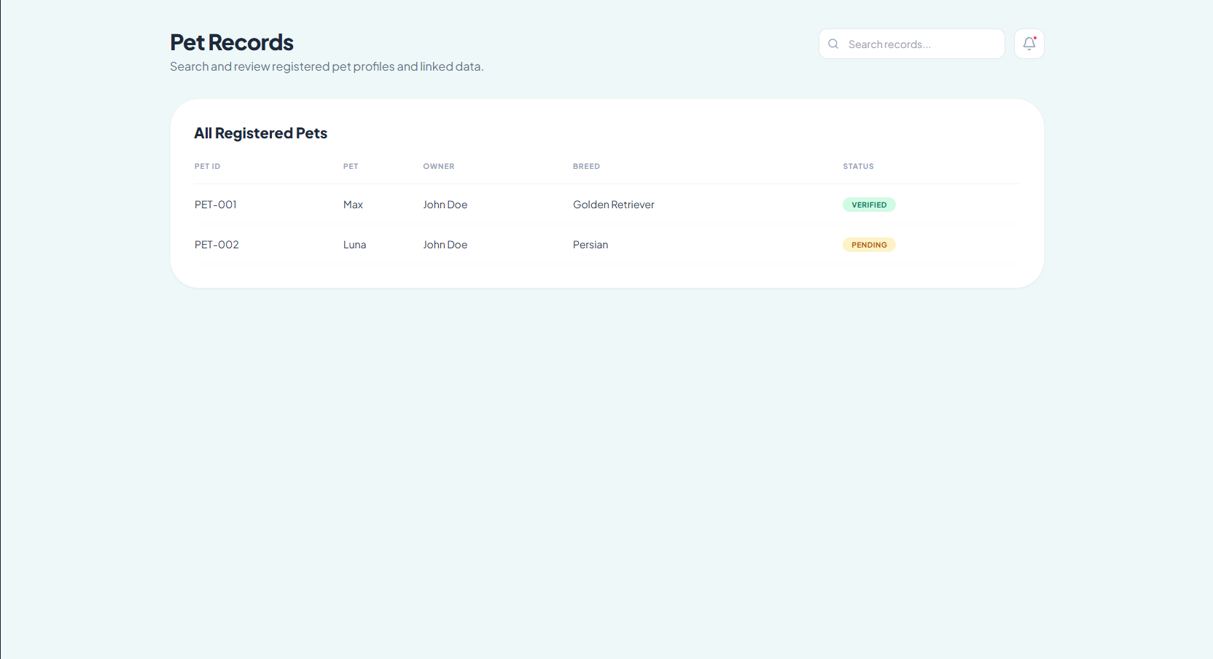
With regard to systems thinking, the Pet Records page should not only show the information but act as a means to filter out inaccurate data. With correct thinking, you will realize that all other modules of your system depend on having valid pet records. Therefore, its main function should be to prevent any erroneous or incomplete data from going to other features.
Figure 33. Pet Records

Verify registration serves as a control check point within the application, allowing for an examination and validation of newly created pet registrations before their acceptance.

The Registration Verification Queue contains all newly added records with pet's name, its owner, generated QR code, and current status. In this way, staff can easily see which records have already passed verification and which still require staff attention. The presence of a QR code makes sure that every record has its unique identifier, thus making pets' identification possible after the verification.

Status is a key feature of the Verify Registration page as it highlights which records still require attention and which have already been verified. The Action
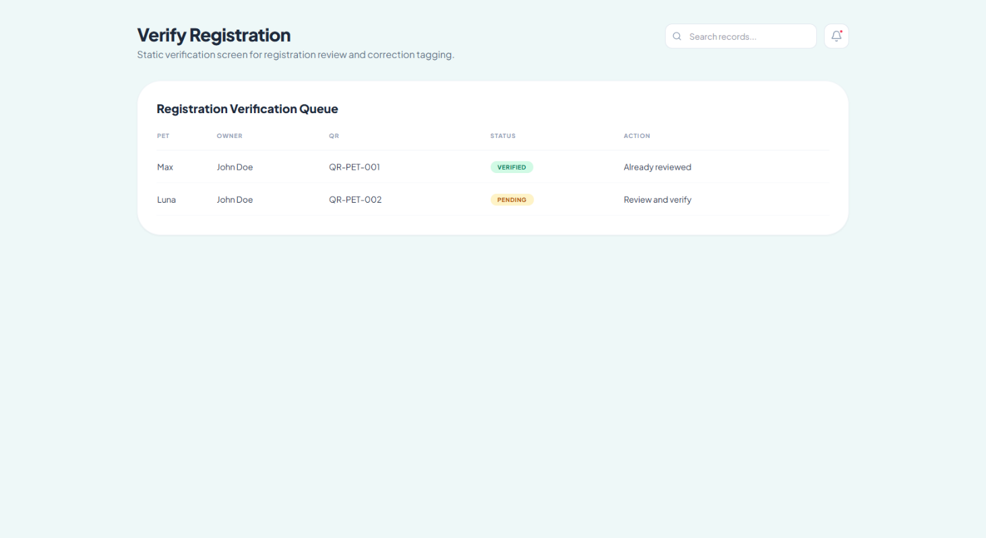
Figure 34. Verify Registration

The Vaccination Monitoring page serves as a tool for the clinic personnel to monitor the vaccination status of all registered pets and make sure the necessary vaccinations are up to date.

Vaccination Monitoring Table includes essential information like pet name, vaccination status, date of the latest vaccination, and date when it is due. It makes it easy to distinguish whether the pet already needs no updates or the vaccination is due soon. Labels of statuses (like “Updated” or “Due”) serve as hints to make it easier to understand what requires attention.
Action is an essential aspect of work with the table. If the vaccination was completed successfully, the action needed is none. If the vaccination is not found or not yet done, the action required is to update its status. Thus, there is a simple flow for the user from the monitoring process to performing an action.

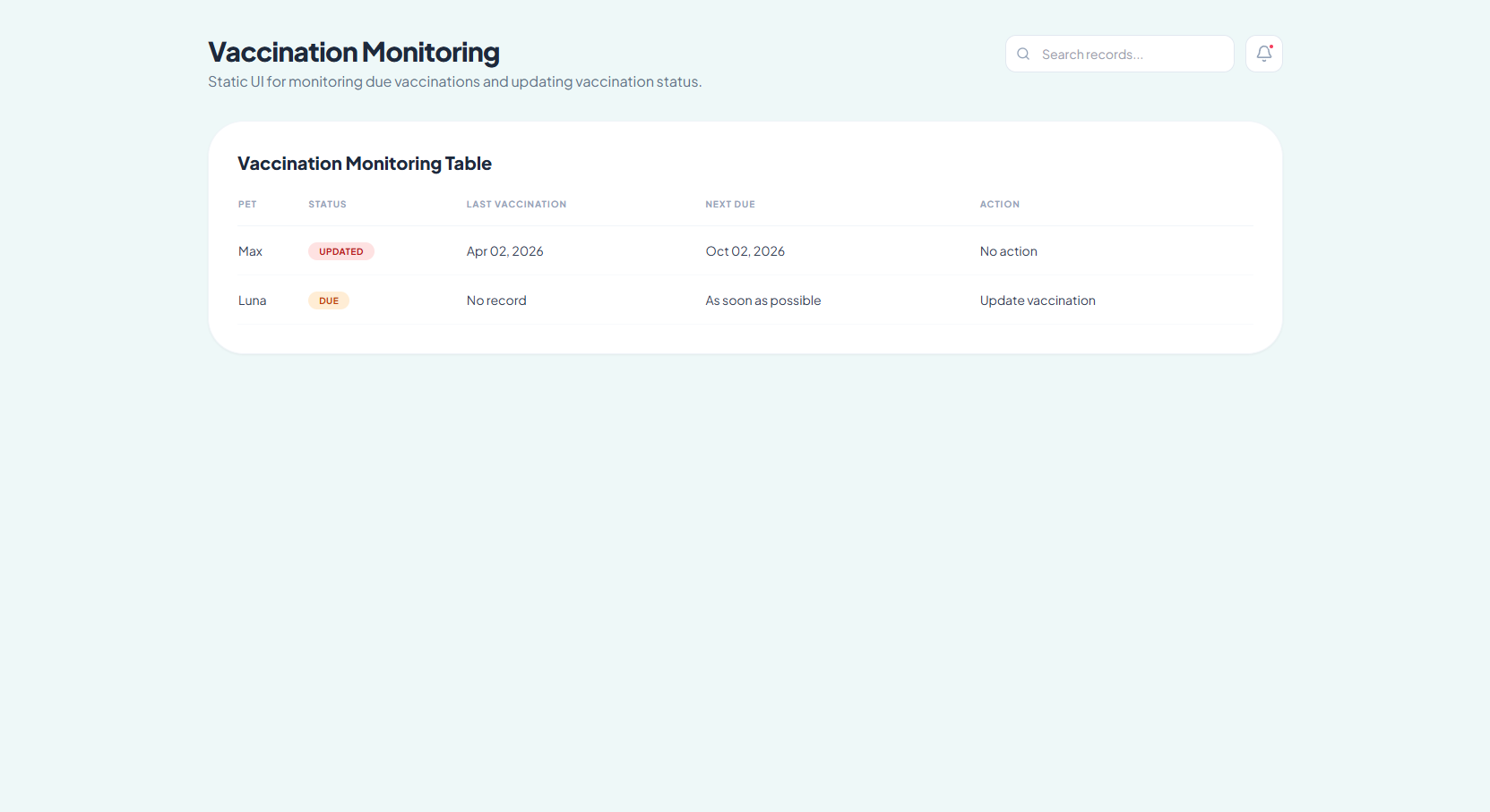
If we analyze it even further, it turns out that it is not only a monitoring process but rather preventive care management because you need to perform actions before something bad happens.
Figure 35. Vaccination Monitoring

Clinical Records is the page where all the data concerning medical observations and notes are stored for each particular registered pet. Clinical findings are represented in an organized form through the data recorded during consultations and subsequent check-ups.

Clinical Record Entries show us information about the name of the pet, clinical notes, and the date of the last record update. This way, one can easily find out the medical history of each specific pet and whether any conditions exist or need to be examined in the future. For example, such information as the presence or lack of symptoms helps one better understand the current state of the pet.

If analyzed from another point of view, this page can be considered the medical memory of the system. All consultations, diagnoses, and other observations are registered here. Therefore, even if some other person is dealing with the pet in the future, one can refer to these records.
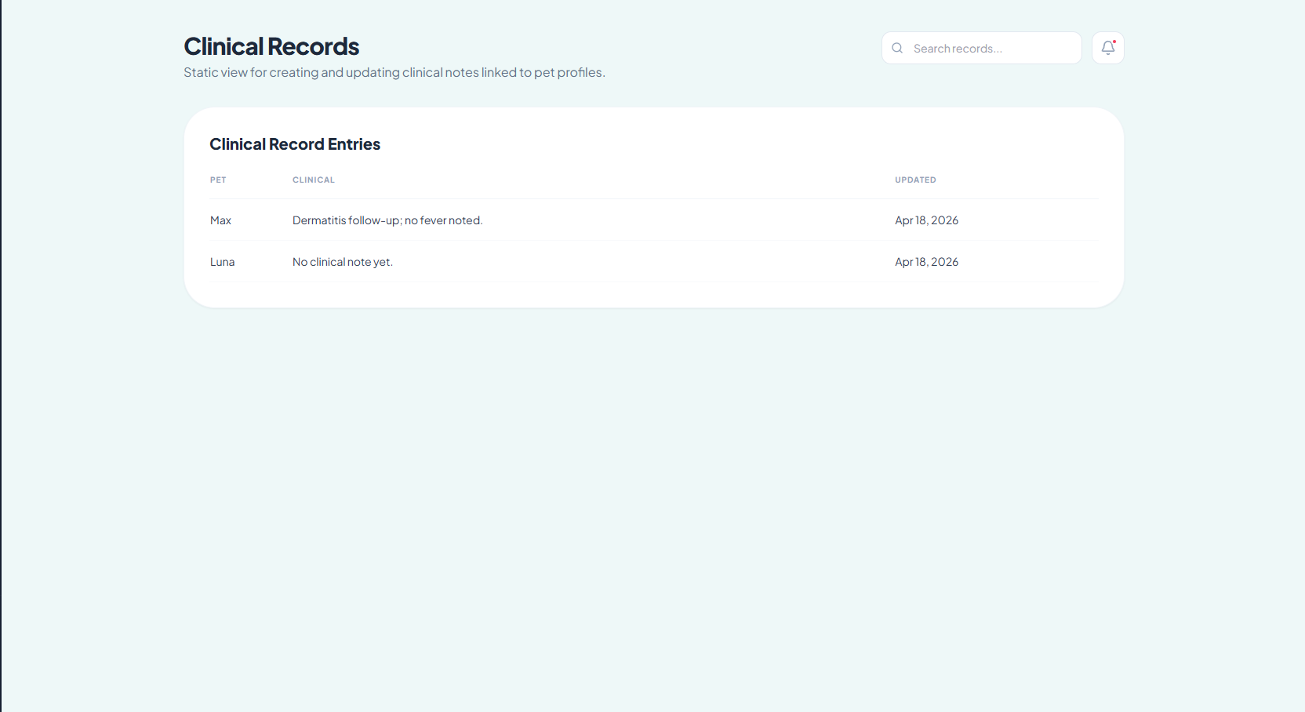

Figure 36. Clinical Records

The Medicine Records section of the website allows for documenting and reviewing prescribed medication of pets. With this section, one can obtain an overview of the treatment that is related to clinical findings.

The Medicine Record Entries form contains such information about the prescription as pet name, medication name, dosage information, period of time, and recommendations on administration. Thus, it allows for easily finding out what drugs were prescribed to a particular animal. Complete forms show full details about drug doses; empty forms mean that no medication was prescribed yet.

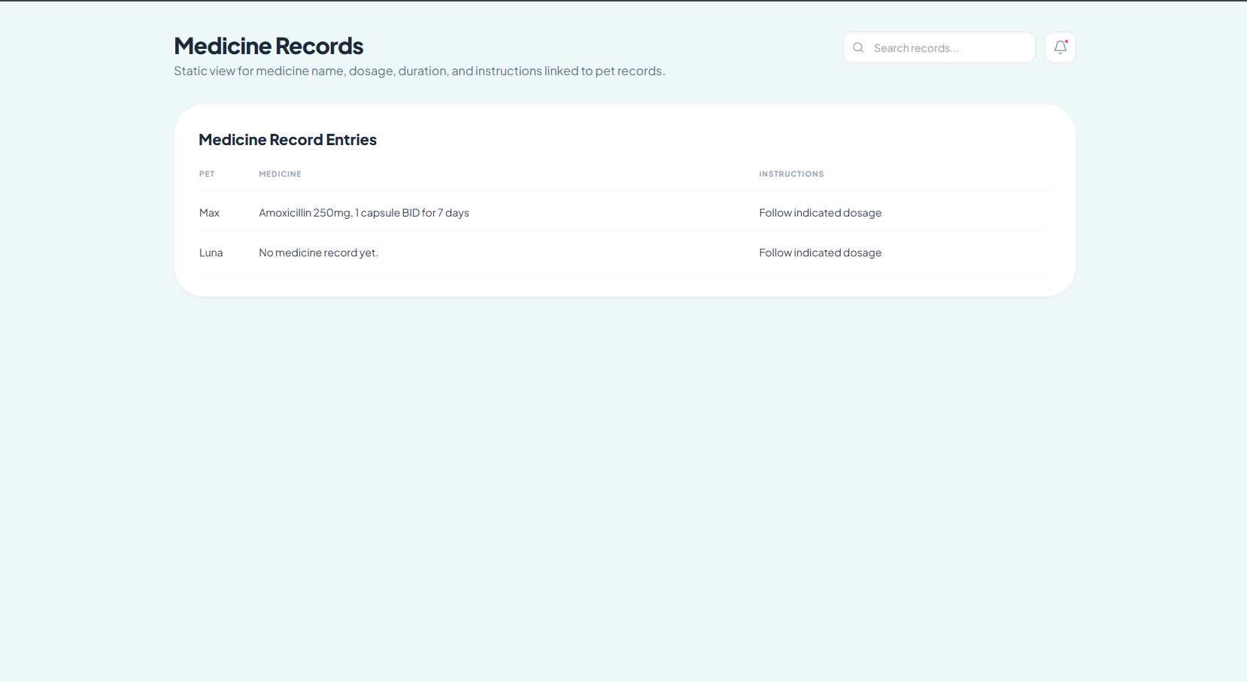
Taking into consideration a more profound analysis, the Medicine Record page should be regarded as the layer of the treatment record management of the application. In other words, it is tightly connected to clinical records; thus, there is a connection between diagnostics and the suggested treatment of a patient.

Figure 37. Medicine Records

The Payment Verification page enables employees at the clinic to verify the payments against their registered pets by means of using OR numbers generated by the treasury.

At the top part of the page, there are boxes where the employee needs to enter the details of the pet or the owner together with the appropriate OR number and the status of the payment. Such an approach helps establish whether the payment has actually been made and documented. Finally, pressing the “Verify Payment” button helps conclude the operation of linking payment.

Further below on the page there is the Payment Verification Table which includes all the payment records with the pet’s name, the owner’s name, the OR number, and the current status of each payment entry. In such a way, it is possible to see what payments have already been verified, and what need to be verified yet. Payments that say “Awaits OR linking” are examples of incomplete transactions which need to be handled.
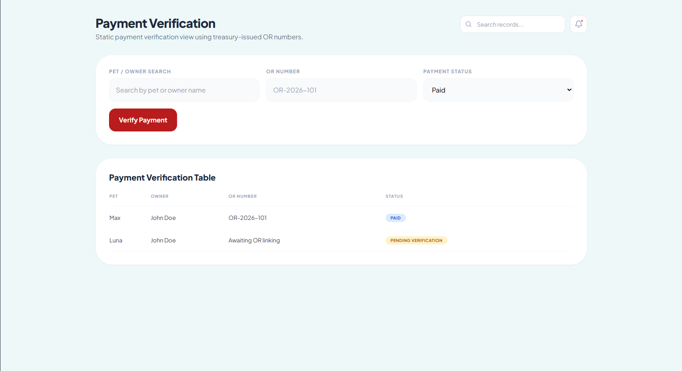
Taking everything into account, one can see that the page under analysis performs a kind of financial controlling function within the system.
Figure 38. Payment Verification

The Issue Requested Record screen is accessed by the clinic staff to issue the requested documents, such as vaccination cards or record summaries.
The Open Requests list contains all the requests that have been submitted, together with their corresponding details, such as the request ID, the owner, the pet, request type, and the current status. It makes it possible for the staff members to identify whether the request is OPEN or has been ISSUED.

From the point of view of the system, this screen is considered the last phase in the delivery of services. Following the steps of registering, verifying, tracking the vaccinations, and confirming the payments, this is the stage where the system will produce an output for the users.
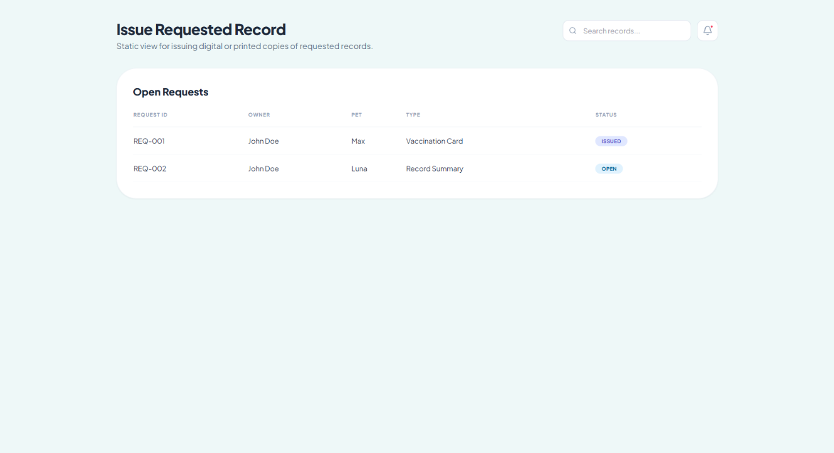

Figure 39. Issue Requested Record

The Admin Login page is where admins who run the whole system can log in. This is because it provides the ability for secure access to sensitive parts of the system like data handling, system monitoring, etc.
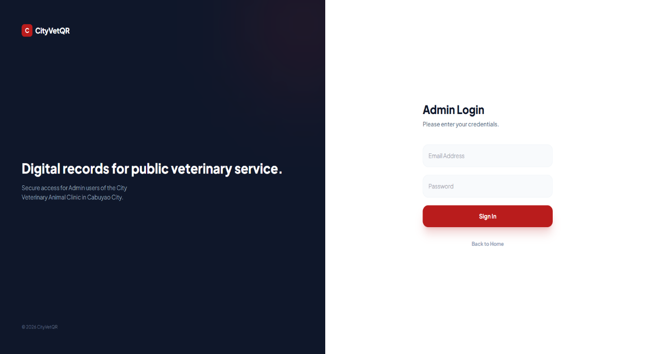
This page comprises two halves. In the left half, there is information regarding the system. Here, it clearly indicates the purpose of the application i.e., managing the veterinary records digitally. The right half consists of the log in panel where the admin logs in by providing his/her email id and password.This page from the perspective of a computer science application is one of the primary ways to ensure authentication. In simple terms, the system will not allow anyone access until and unless it verifies the person using the system. This avoids the risk of unauthorized usage of sensitive details like pet record, payment details, and much more.
Figure 40. Admin Login

System Overview gives an overview of the entire system, allowing the administrator to be able to see how the system operates currently.

Starting from the top part of the screen, the dashboard will show essential information such as the total number of pets, the number of males and females, and the amount of paid records. The summary cards provide a quick view of the system's data without having to go to each module.

Beneath it is the System Snapshot which provides the more detailed indicators of the system such as the total number of registered pets, total number of verified pets, total number of vaccinations due, and total number of pending payments. This allows the admin to know how much has been achieved and what should be focused upon, for instance, incomplete verifications and unverified records.

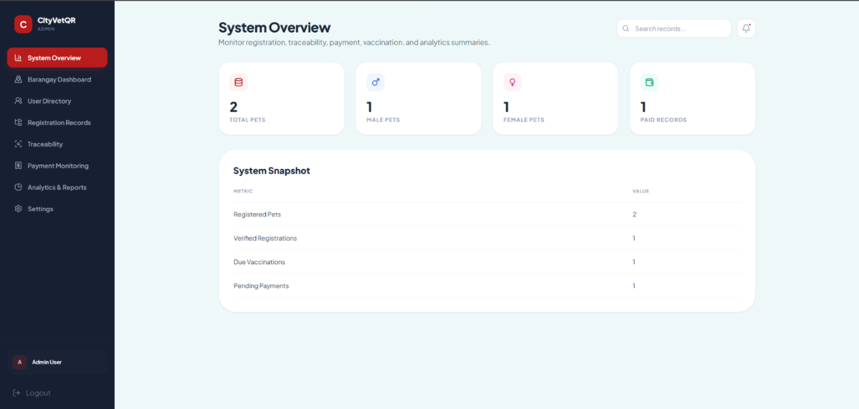
The sidebar menu located on the left is also crucial because it gives access to other modules like the barangay report, users, registration record, traceability, and reports.
Figure 41. System Overview

The Barangay Dashboard is used to study and monitor the registered pet records based on their barangay. This dashboard enables the admin to understand the source of registrations as well as the distribution of records among various barangays.

The summary cards located at the top provide the total number of registered pets per barangay as well as the total number of barangays having record details. Such details help the admin gauge the extent of their activity among various barangays.

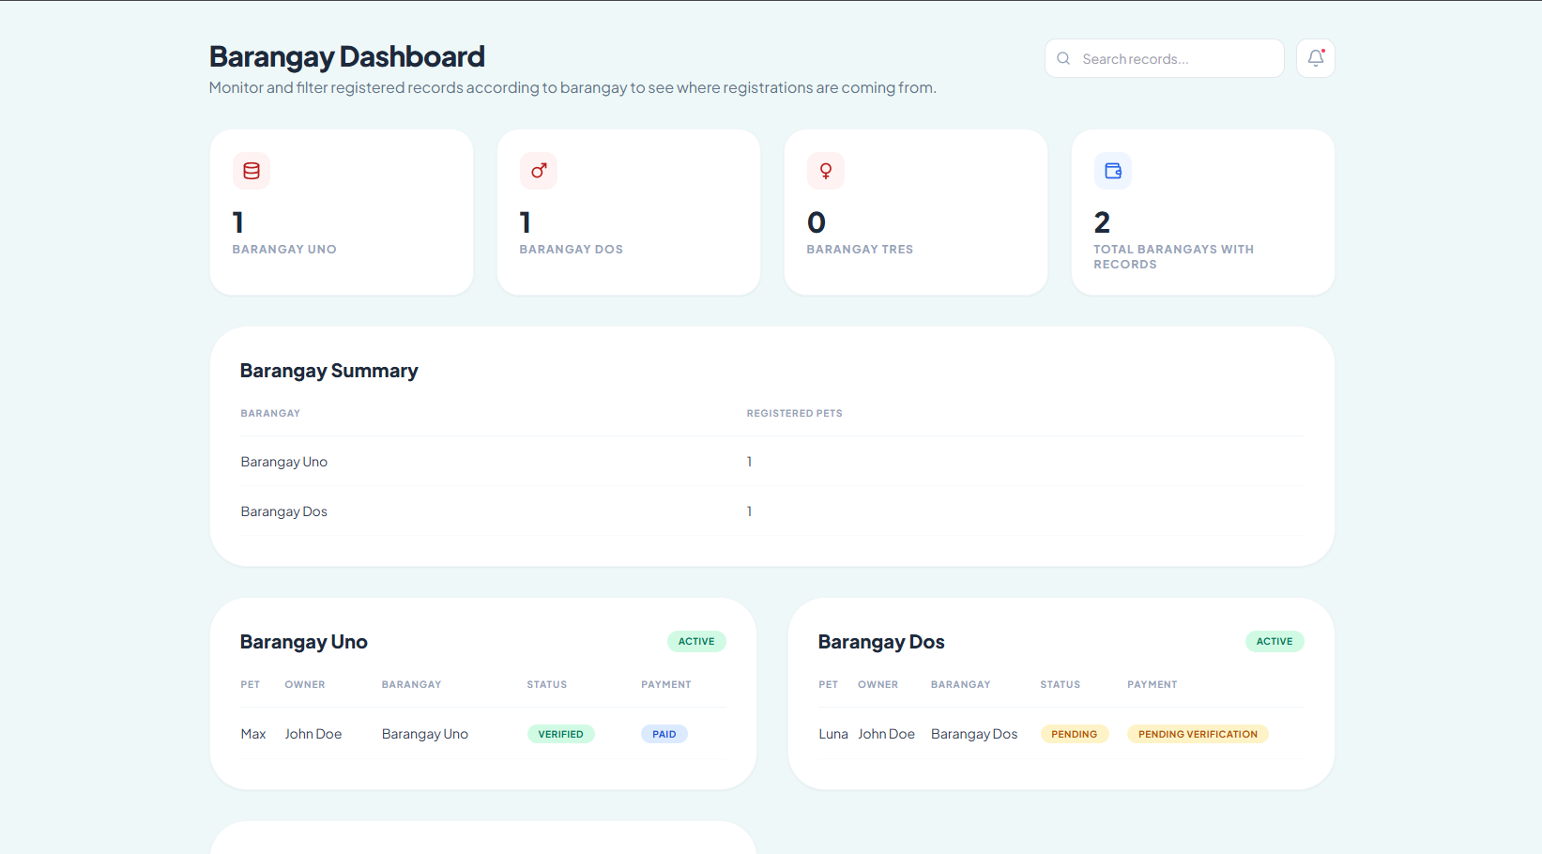
The Barangay Summary displays an easy-to-read list containing all the barangays together with their registered pets. Such details enable comparison among the various barangays for analyzing their trends. The details of each barangay follow below in tabular form, providing information regarding each record. It contains pet names, owner details, status, and payment details of each record.
Figure 42. Barangay Dashboard

This particular page serves as the centralized place for listing all the users in the system, from pet owners to the clinic staff and the admin. It enables the admin to monitor the access and manage the users of the application.
The table called System Users is used to present important information about users such as their names, roles and statuses. By analyzing this information, we can find out if any particular user is active at the moment and what role he plays in the system. The role is important as it determines the functionality available to the particular user.
On a more profound level, one should consider the following: this particular page may be considered as the part responsible for the access management in the system. It enables the separation of responsibility in that only owners can view their personal data whereas the rest of the people can do everything else with the system data.

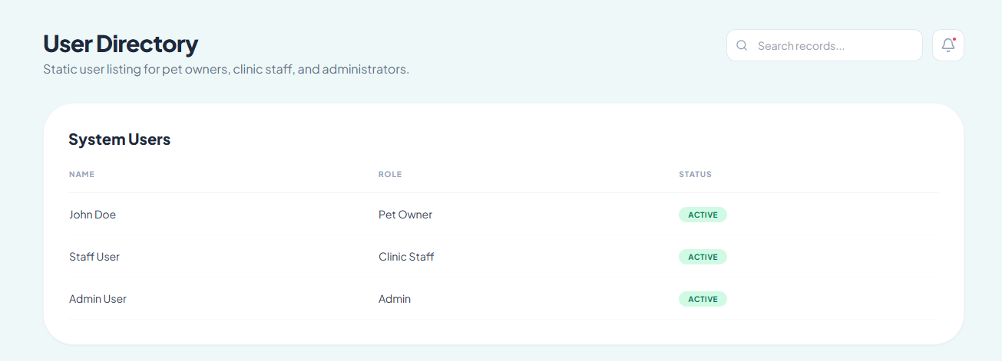
So, what you need to know is that this page serves as the access control feature of the system since without appropriate monitoring, one can give unnecessary access to certain functionalities to users which should be avoided.
Figure 43. User Directory

The Registration Records page serves as a tool for tracking all pets that have been registered, and monitoring their progress in the system.
The Registration Monitoring table provides essential information such as the name of the pet, its owner, the verification status, the generated QR-code, and the payment status. Thus, one can observe the entire process of a pet registration in the system, including its verification and payment processes.

By using such attributes as the status indicator and payment status, one can determine whether the process was completed or not yet. The fact that the pet registration has the status 'verified' but no payment verified means that the process is still not completed.

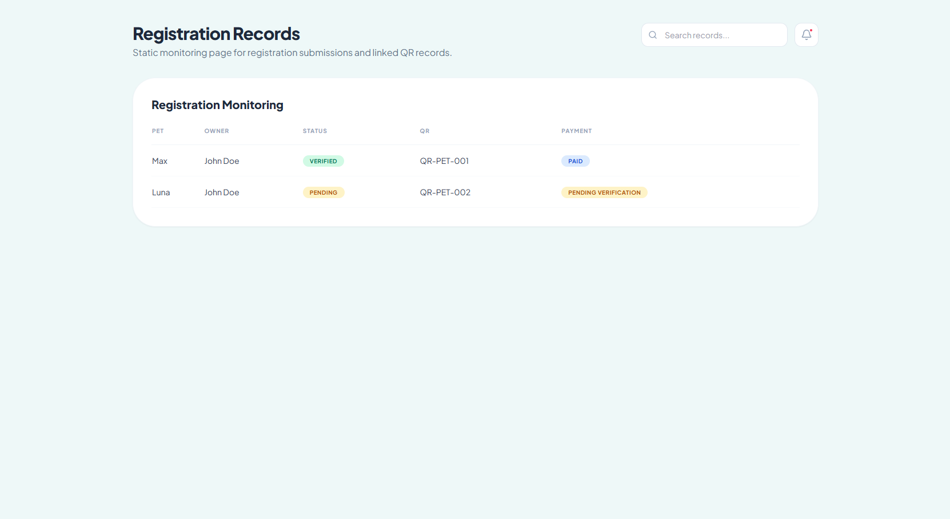
In other words, the Registration Records page serves as a process tracking level of the system, which combines all separate levels (verification, payment, QR generation).
Figure 44. Registration Records

The Traceability Page shows the movement of each pet record from its beginning in the system until its completion. Rather than having just one status label per record, it shows all the stages involved from record creation and registration, verification of record, QR code allocation, linking to payments, and maintenance of the health record of pets. Thus, users can see where they stand with regard to each pet record in the process.

There are also some indicators showing statistics for number of records that have been issued with QR codes, linked with payments, updated vaccinations, and pending records under review. Beneath these indicators, the user gets to see each individual pet's record along with all its status labels and lifecycle stages.

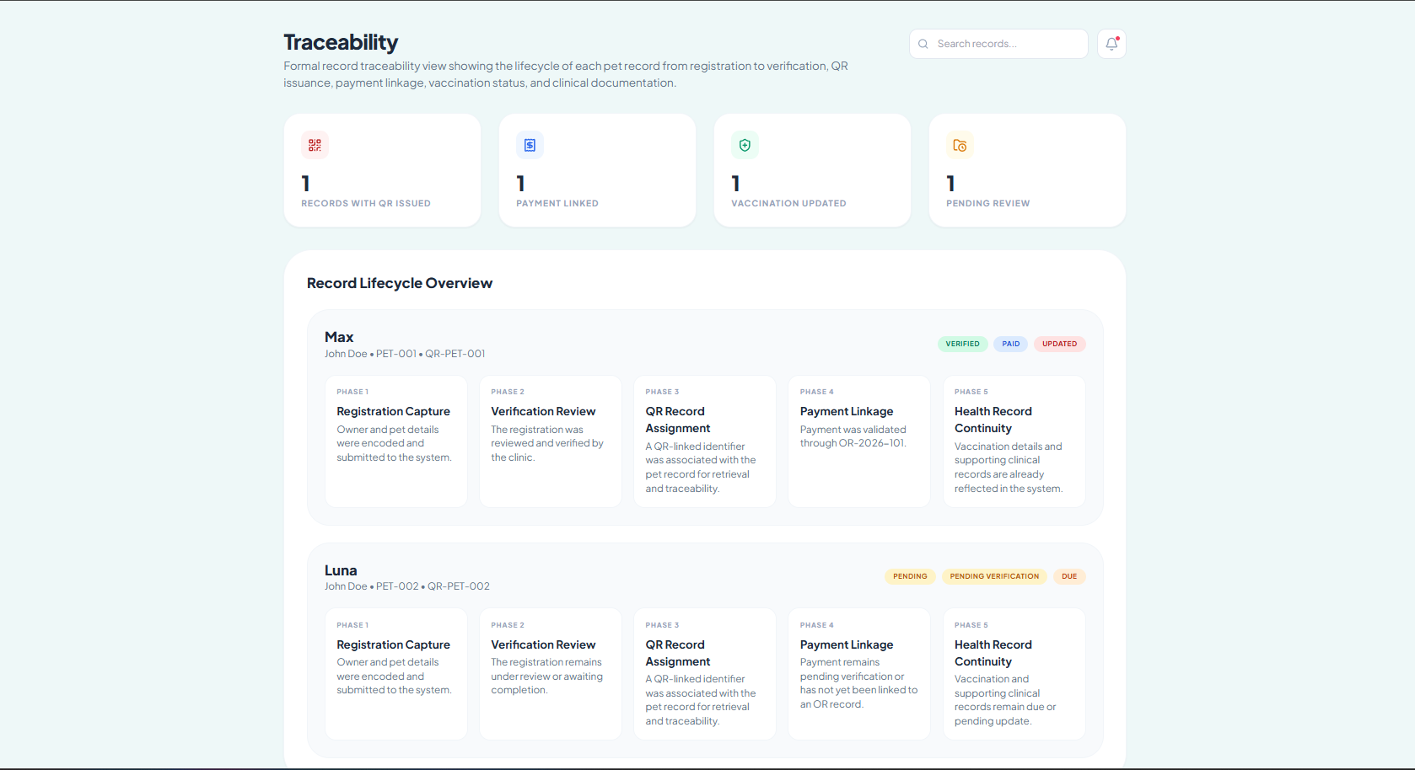
In general, the Traceability Page provides an effective means of tracking the movement of each record, right from its entry into the system up to medical and payment details.
Figure 45. Traceability

The Payment Monitoring Page gives information about all transactions regarding payments made. The page has a table which has the pet name, its owner, the payment status, and the OR number linked to the payment.

From this page, administrators will be able to determine which transactions have already been paid for, those which have yet to be verified, and whether the OR has been correctly attached to the transaction.

In general, this page facilitates the process of accurately monitoring all payments, and avoids inconsistencies in the payment process.
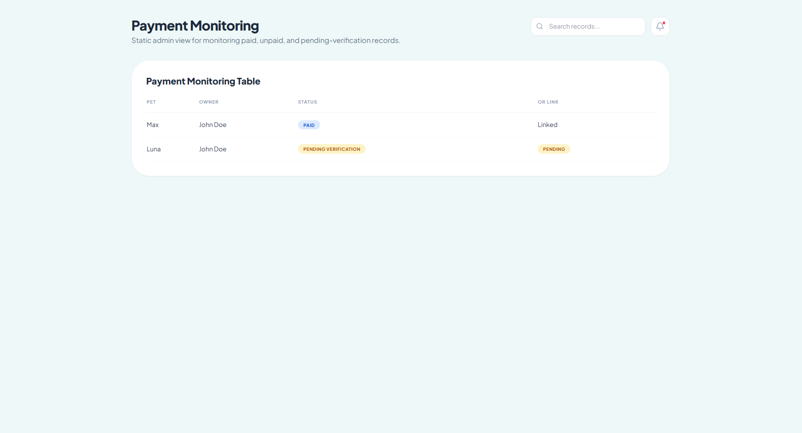

Figure 46. Payment Monitoring

The Analytics and Reports Page is designed to summarize the data stored in the system and present it in a form that is easier to understand, monitor, and use for decision-making. Unlike pages that focus on encoding

or viewing individual records, this page provides a broader overview of system activity by converting stored data into visual summaries and report outputs.

At the top of the page, summary cards display key indicators such as the total number of registered pets, verified registrations, due vaccinations, and pending payments. These cards serve as quick-reference metrics that allow the user to immediately identify the general condition of the system without reviewing records one by one. This is important because administrators and staff often need a fast overview of system performance before deciding which area requires attention.

Below the summary cards, the page includes graphical representations of important data categories. The Pets by Sex chart shows the distribution of registered pets according to sex, while the Vaccination Status chart presents how many pets are updated and how many are still due for vaccination. The Payment Status chart summarizes whether records are paid or still pending/unpaid, and the Registration Status chart shows the proportion of verified and pending registrations. These charts are valuable because they make patterns easier to recognize. Instead of reading long tables, users can immediately see balances, gaps, and possible issues through visual comparison.

This is the main reason the page is important: it helps the clinic move from simply storing records to actually analyzing operations. For example, if the chart shows many pending registrations, the clinic may need to improve verification workflow. If due vaccinations are high, it may indicate the need for follow-up actions. If pending payments remain high, it may signal delays in payment verification or OR linkage. In this way, the analytics page supports monitoring, planning, and operational control.

The Generated Reports section further strengthens this function by listing prepared report outputs such as Registered Pets by Sex, Vaccination Status Summary, Payment Status Summary, and Registration Verification Summary. This shows that the system is not limited to displaying analytics on-screen but can also organize them into report-ready outputs. This is important for administrative review, documentation, and future reporting needs.

Overall, the Analytics and Reports Page serves as the analytical center of the system. It gathers data from registration, vaccination, and payment modules, transforms them into understandable summaries, and supports better decision-making. Its importance lies in helping the clinic not only maintain records, but also evaluate trends, detect pending issues, and plan actions based on actual data.
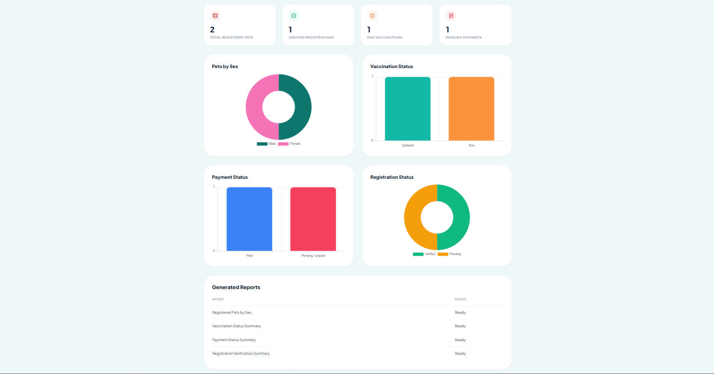

Figure 47. Analytics and Reports

Ethical Consideration

The research team will uphold all ethical requirements in carrying out this research. Before conducting the research, approval will be sought from the City Veterinary Animal Clinic of Cabuyao City, Laguna. Consent will also be obtained from all eligible participants who will participate in the study. The participation in the study is purely voluntary, and each respondent will be told about the purpose of the study, the nature of their role in it, and the fact that they can choose not to participate in the study.

Confidentiality of information will be upheld for all information obtained through respondents and the client institution. All information that will be collected, which may include personal information, pet owner information, and clinic information, will be kept confidential and will only be used for the purpose of academic work and system development. Necessary measures will be put in place to prevent any unauthorized access and use of data.

Furthermore, the research will comply with the regulations stipulated in Republic Act 10173, or Data Privacy Act of 2012, where personal and sensitive data collected from the respondents and client organization will be processed in a fair, lawful, and appropriate manner solely for the purpose of conducting research. The collection of data shall be confined to the information which would suffice for the execution of the research. The handling, storage, and protection of such information shall be done following the principles of transparency, legality of purpose, and proportionality under the provisions of the Data Privacy Act.

In addition, the researchers will apply principles of fairness, objectivity, and honesty when collecting, analyzing, interpreting, and

presenting data. All data will be truthful and honest, and no fabrication or alteration of data will take place. The researchers will see to it that the process of system development and evaluation is done in such a way that participants' rights, welfare, and privacy are respected.

References

[1] A. F. Rosmani and M. H. Mokhtar, “An Online Scheduling Platform for Veterinary Appointments,” Jurnal Intelek, vol. 18, no. 2, pp. 16–26, 2023.

[2] S. J. Cachuela, D. M. Matias, R. J. Jose, and J. Altura, “Navigating Veterinary Practice in the Digital Age: Implementing a Web-Based Information Management System at Animals’ Choice Clinic,” Psychology and Education: A Multidisciplinary Journal, vol. 37, no. 5, 2025.

[3] V. J. Diego, J. C. Bacol, J. V. Ratunil, G. Sat-ao, D. K. Santo, and M. Romero, “Veterinary Clinic Management System,” International Journal of Innovative Science and Research Technology, vol. 10, no. 12, pp. 2308–2315, 2025.

[4] M. J. Palmones and V. Maravilla, “Evaluating Danao City’s Transportation Sector: Towards a QR Code-Based Online Payment System,” Psychology and Education: A Multidisciplinary Journal, vol. 44, no. 4, pp. 446–452, 2025.

[4] Quezon City Government, “How to Link On-Premise Pet Registration to the QC Vet System,” Quezon City Government, Philippines, 2026.

[5] Taiwan Ministry of Agriculture, “Pet Registration Information System,” Taiwan, 2026.

[6] A. F. Rosmani and M. H. Mokhtar, “An Online Scheduling Platform for Veterinary Appointments,” Jurnal Intelek, vol. 18, no. 2, pp. 16–26, 2023.

[7] S. J. Cachuela, D. M. Matias, R. J. Jose, and J. Altura, “Navigating Veterinary Practice in the Digital Age: Implementing a Web-Based Information Management System at Animals’ Choice Clinic,” Psychology and Education: A Multidisciplinary Journal, vol. 37, no. 5, pp. 466–473, 2025.

[8] V. J. Diego, J. C. Bacol, J. V. Ratunil, G. Sat-ao, D. K. Santo, and M. Romero, “Veterinary Clinic Management System,” International Journal of Innovative Science and Research Technology, vol. 10, no. 12, pp. 2308–2315, 2025.

[9] I. L. C. Malbataan, N. M. Hipolito Jr., M. V. Capilitan, and S. L. Arisapa, “MMPIMS: Patient Information Management System with QR Authentication for Metromedics,” Philippine E-Journals, 2025.

[10] M. J. Palmones and V. Maravilla Jr., “Evaluating Danao City’s Transportation Sector: Towards a QR Code-Based Online Payment System,” Philippine E-Journals, 2025.

[11] S. Chua, J. Alis, and M. J. Oria, “Web-Based Veterinary Clinic System with Notification Support”
[12] D. Helminski et al., “Development, Implementation, and Evaluation Methods for Dashboards in Health Care: Scoping Review”

[13] A. Alshehri and M. Drew, “Role-based access control in web applications: A systematic review,” IEEE Access, vol. 8, pp. 123456–123468, 2020.

[14] S. Elmasri and R. Navathe, Fundamentals of Database Systems, 7th ed. Pearson, 2021.

[15] J. Smith et al., “Digital vaccination record systems: Improving healthcare monitoring,” IEEE Access, vol. 9, pp. 98765–98778, 2021.

[16] K. Sharma and R. Gupta, “Secure digital payment tracking and audit systems,” IEEE Transactions on Information Forensics and Security, vol. 17, pp. 2345–2356, 2022.

[17] L. Chen et al., “QR code-based identification systems in healthcare applications,” IEEE Access, vol. 10, pp. 45678–45689, 2022.
[18] L. von Bertalanffy, General System Theory: Foundations, Development, Applications
[19] B. Martínez-López, “Advancement in Veterinary Services through Digitalization”

[20] S. Chua, J. Alis, and M. J. Oria, “WEB-Based veterinary clinic with email and SMS notification,” in Proc. 9th Int. Conf. Business and Industrial Research (ICBIR), 2024, doi: 10.1109/ICBIR61386.2024.10875747.

[21] D. Helminski, J. B. Sussman, P. N. Pfeiffer, A. N. Kokaly, A. Ranusch, A. D. Renji, et al., “Development, implementation, and evaluation methods for dashboards in health care: Scoping review,” JMIR Medical Informatics, vol. 12, e59828, 2024, doi: 10.2196/59828.

[22] N. Fareed, J. M. Wilkins, M. P. Arrieta, et al., “Lessons learned from developing dashboards to support decision-making for community stakeholders: Mixed methods and multisite study,” JMIR Human Factors, vol. 11, e51525, 2024, doi: 10.2196/51525.

[23] H. Vornhagen, S. Barrett, C. Carroll, L. K. Iladiva, G. Martin, D. McKeown, and J. Martin, “Design practices for data dashboards in health care: Scoping review,” Journal of Medical Internet Research, vol. 28, e77361, 2026, doi: 10.2196/77361.

[24] V. J. Diego, J. C. Bacol, J. V. Ratunil, G. Sat-ao, D. K. Santo, and M. Romero, “Veterinary Clinic Management System,” International Journal of Innovative Science and Research Technology, vol. 10, no. 12, pp. 2308–2315, 2025.

[25] Bangko Sentral ng Pilipinas, 2024 Report on the Status of Digital Payments in the Philippines, 2025.

[26] “Role of Integrated Digital Systems in Cash Transaction Monitoring and Traceability,” 2025.

[27] B. Martínez-López, “Advancement in veterinary services through digitalization,” World Organisation for Animal Health presentation/report, 2024.

[28] ASEAN+3 Macroeconomic Research Office, The Role of Technology in ASEAN's Regional Payment Connectivity Initiative, 2025.

[29] Bangko Sentral ng Pilipinas, 2024 Report on the Status of Digital Payments in the Philippines, 2025.

[30] A. Sabli and N. Hamid, “Theorising the Benefits and Challenges of QR Payment Systems: A Conceptual Analysis,” 2025.

[31] B. Martínez-López, “Advancement in veterinary services through digitalization,” World Organisation for Animal Health, 2024.

[32] S. Chua, J. Alis, and M. J. Oria, “Web-Based Veterinary Clinic System with Notification Support,” in Proc. International Conference on Business and Industrial Research, 2024.

[33] V. J. Diego, J. C. Bacol, J. V. Ratunil, G. Sat-ao, D. K. Santo, and M. Romero, “Veterinary Clinic Management System,” International Journal of Innovative Science and Research Technology, vol. 10, no. 12, pp. 2308–2315, 2025.

[34] D. Helminski, J. B. Sussman, P. N. Pfeiffer, A. N. Kokaly, A. Ranusch, A. D. Renji, et al., “Development, implementation, and evaluation methods for dashboards in health care: Scoping review,” JMIR Medical Informatics, vol. 12, e59828, 2024.

[35] B. Martínez-López, “Advancement in veterinary services through digitalization,” World Organisation for Animal Health, 2024.

[36] S. Chua, J. Alis, and M. J. Oria, “Web-Based Veterinary Clinic System with Notification Support,” in Proc. International Conference on Business and Industrial Research, 2024.

[37] V. J. Diego, J. C. Bacol, J. V. Ratunil, G. Sat-ao, D. K. Santo, and M. Romero, “Veterinary Clinic Management System,” International Journal of Innovative Science and Research Technology, vol. 10, no. 12, pp. 2308–2315, 2025.

[38] A. Sabli and N. Hamid, “Theorising the Benefits and Challenges of QR Payment Systems: A Conceptual Analysis,” 2025.

[39] D. Helminski, J. B. Sussman, P. N. Pfeiffer, A. N. Kokaly, A. Ranusch, A. D. Renji, et al., “Development, implementation, and evaluation methods for dashboards in health care: Scoping review,” JMIR Medical Informatics, vol. 12, e59828, 2024.

[40] B. Martínez-López, “Advancement in veterinary services through digitalization,” World Organisation for Animal Health, 2024.

APPENDICES

APPENDIX A. RESEARCH INSTRUMENT

